Additional Maths Activities
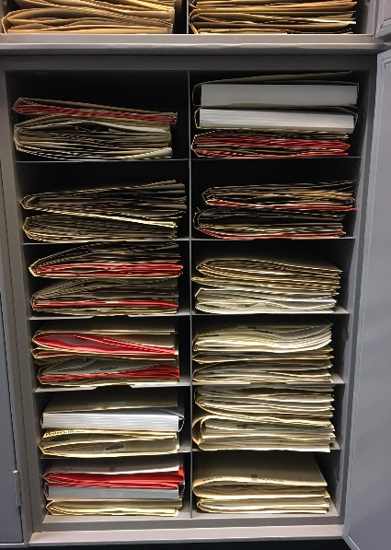
In the online lesson we assumed that all herbarium specimens are 1cm thick. However, not all herbarium specimens are the same thickness so the actual number of specimens in the cabinet pictured will depend on the type of plants being stored.

How many specimens would fit in a cabinet if the following plants were stored?
- Grass: 0.1cm thick ____________

- Gingers: 5cm thick _____________

If it takes Sally 2 minutes to digitise each specimen, would it be quicker, slower or take the same time for her to digitise a cabinet of grass compared to a cabinet of gingers?

_______________________
87cm
65cm

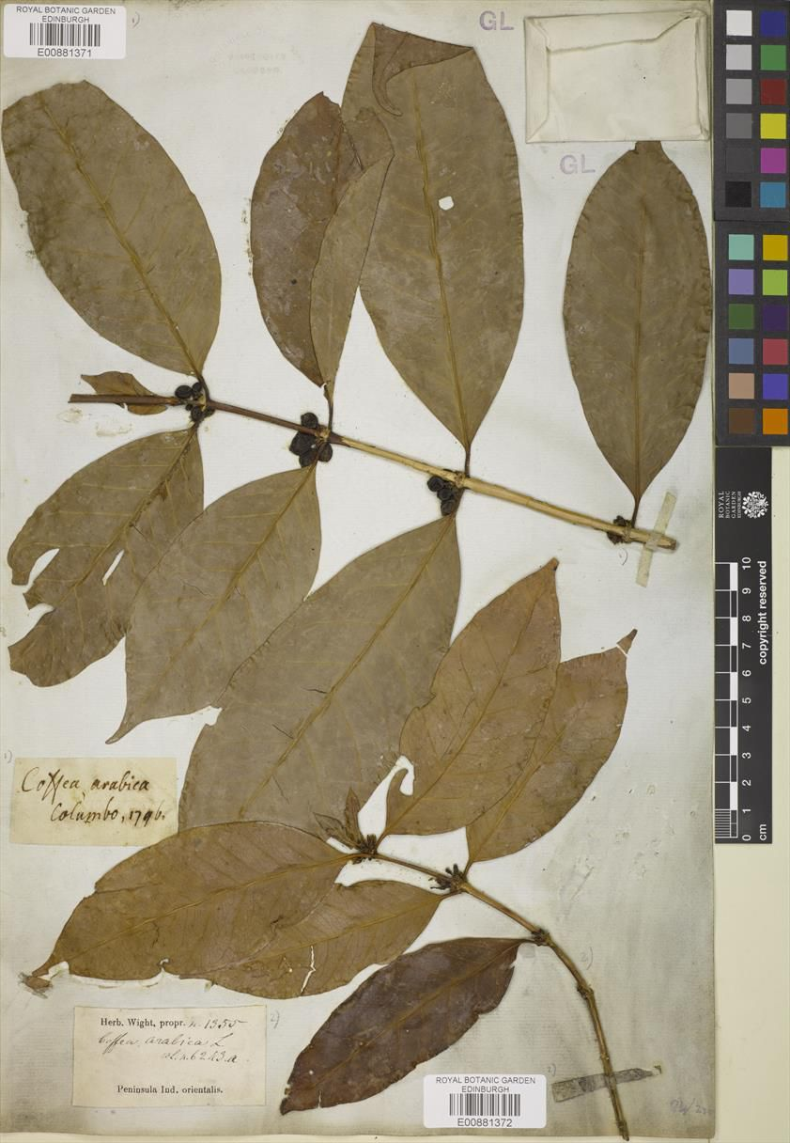
What is the leaf ratio of one of the leaves of the coffee plant specimen pictured?

________________

Remember, you can calculate the leaf ratio by dividing the long length by the shorter width.

Are all the leaves the same?

________________

Choose 5 leaves, calculate their leaf ratios and then calculate the average (mean) leaf ratio of the coffee plant.

In the live lesson we found the coordinates of the location where scientists from the Botanics were collecting plants. Can you find the coordinates of these other places in Indonesia?
The capital city – Jakarta
The highest mountain – Puncak Jaya
The largest Lake – Lake Toba
Prambanan Temple – 8th century Hindu temple, the most famous in Indonesia

Most active volcano – Mount Merapi

Komodo National Park – the most biodiverse place in Indonesia and the home of Komodo dragons

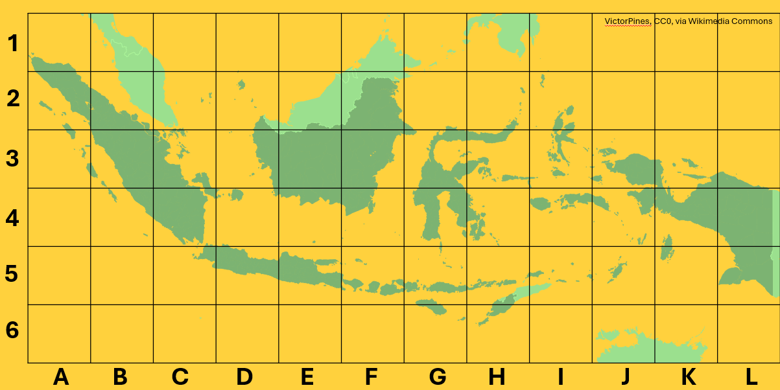

If you think any of these places sound interesting, you could do your own independent research to find out more about them!

Can you find pictures of each of these places?

Did they look how you expected?

Global Citizenship Methodologies
To be effective global citizens, learners need to be able to solve problems, make decisions, ask questions, think critically, communicate ideas effectively and work together. Using a range of engaging, participatory methods is central to leaners developing these skills. Below are 2 methodologies which explore themes from the Hidden Herbarium Live Lesson.
Issue Tree
Purpose: to encourage learners to explore the causes, effects and solutions to a given issue.
What to do:
- Working in small groups, learners can draw a large outline of a fruit tree onto a piece of paper, showing the roots, trunk, branches and fruit.
- They then write the given issue (see example on next page) across the trunk of the tree.
- Along the roots, learners can discuss and note down different root causes of the issue.
- Along the branches, learners can write the effects of the issue.
- On the fruit, they can write solutions or actions that have been taken.
- Learners can display and present their issue trees and share ideas with the class. They should listen and ask questions, adding in further ideas to their issue trees as they learn from each other.
This activity could be carried out after the Live Lesson to reflect on learning about how scientists have changed their values, attitudes and behaviours when collecting plant samples. You may wish to create one large, class issue tree together.

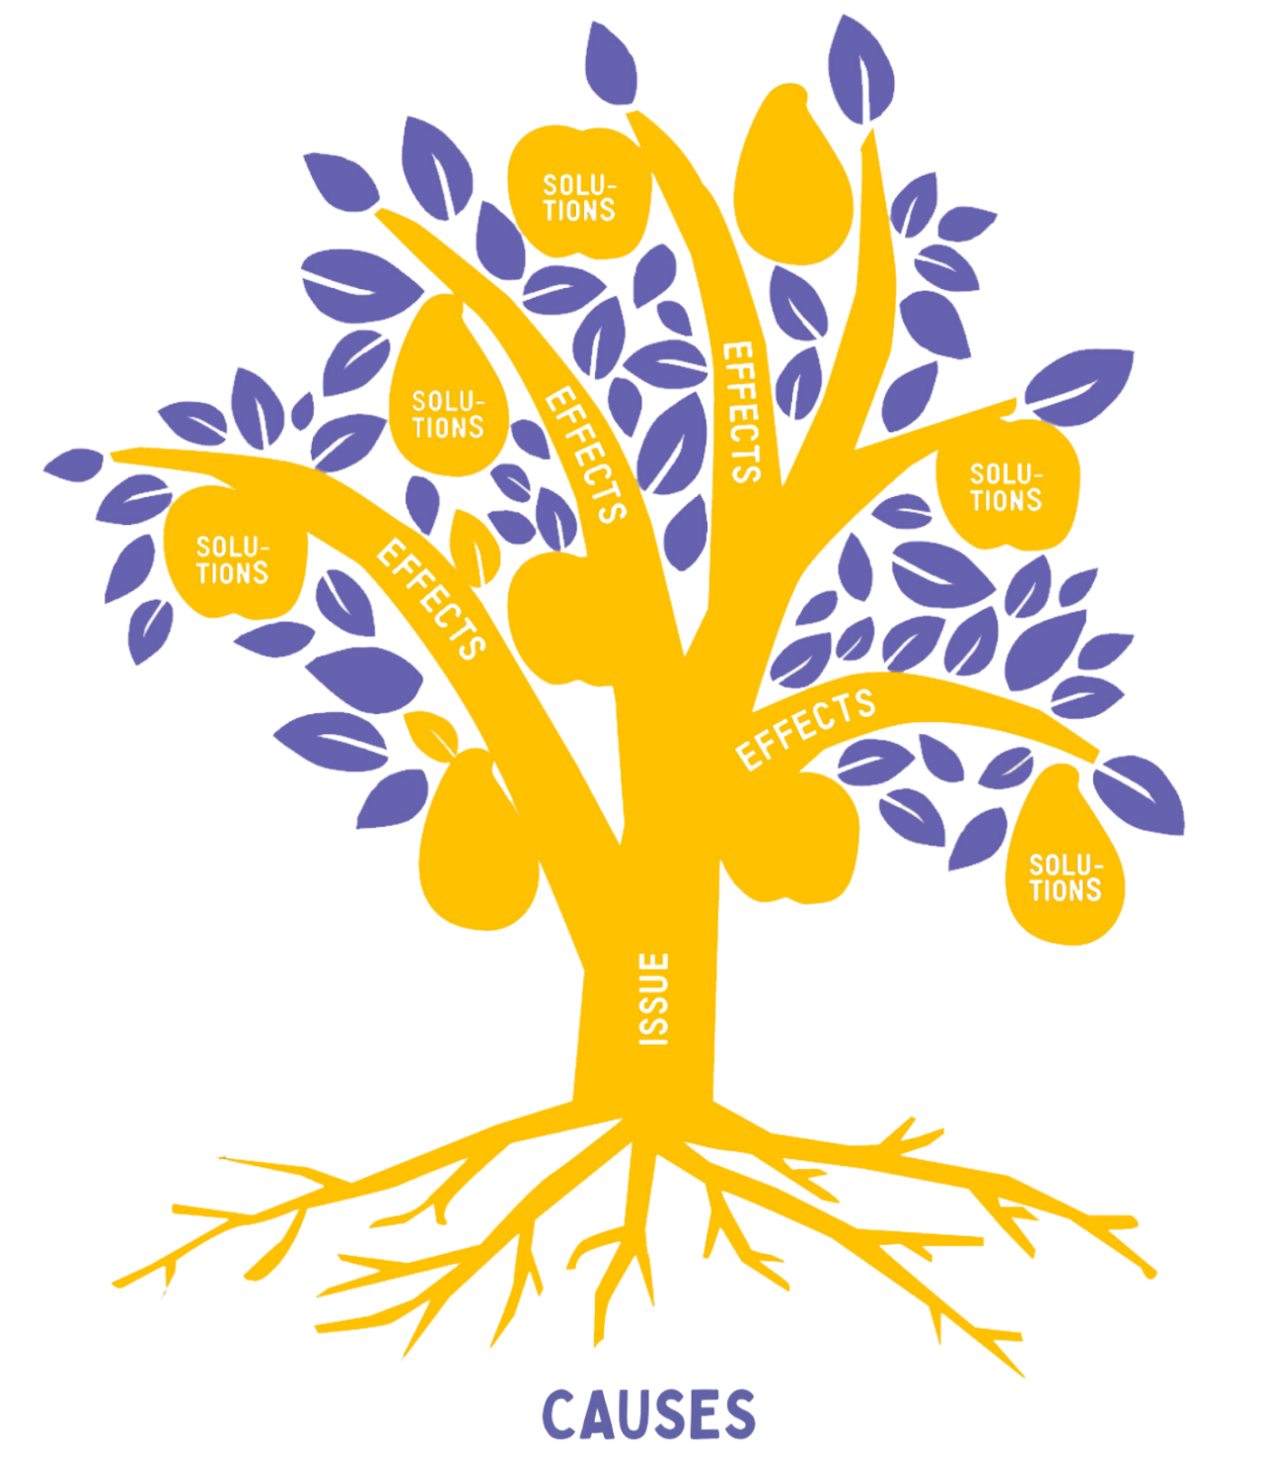
REMOVING PLANT SPECIMENS FROM COUNTRIES IN THE PAST
Using Images
Purpose: to encourage learners to question what they see in images, what is missing from images and challenge their own assumptions about them.
What to do:
Display the image for everyone to see or ask small groups to look at the image below found in the archive here.
Ask learners to create as many questions about the image as possible. They should think about what they already know, what they would like to know or anything that surprises them about the image.
To encourage learners to question their assumptions about the photograph, you could ask:
- Where is this place? Why do you think that?
- Who are these people? Why do you think that?
- Who is not in the photo? Why might this be?
- When do you think this photo was taken? Who took it?
- What are these people doing?
- What is happening beyond/outside the frame of the image?
- What do you think happened before the picture was taken and what might have happened after? Why do you think that?
- If you were in the photo, where would you stand? What would you be doing and thinking? What questions would you have and what might you say?
Learners can research and use the information on the image page to find answers to some of their questions.

George Forrest (1873-1932) – Botanics Stories
A Desperate Escape – George Forrest on the run in China, July 1905 – Botanics Stories

