

Career Taster: Plant Science
Welcome to this introduction to Plant Science!

This career taster is a great place to start to find out what plant science is all about and the opportunities available for a career in plant science.

Contents
Section 1: Plant science is…
Section 2: Plant science in action
Section 3: Plant scientist skills

Section 1: Plant science is…
What is plant science?
Plant science, often known as botany, is the most important thing you can possibly learn about. Why's that?
Watch this video below to hear Dr Greg Kenicer from the Botanics explain more.

Building a positive future for plants, people and the planet
At Royal Botanic Garden Edinburgh (RBGE) our work is guided by the United Nations Sustainable Development Goals. When you see the SDG15 symbol, read the information below it to find out how RBGE plant scientists are helping to achieve SDG 15, 'Life on Land'. (The first symbol is directly below!)
Find out more about SDG 15 goal here

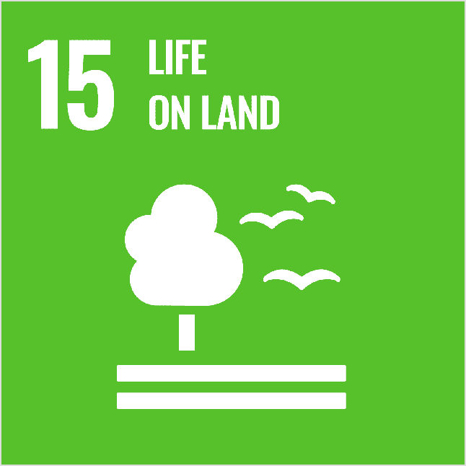
“If we can find out how many different species there are, and where they are, then that’s the fundamental thing we need to do to help conserve them.” - Dr Greg Kenicer, RBGE
Plant scientists help to protect unique habitats and rare species
Watch this video to see how Royal Botanic Garden Edinburgh (RBGE) supports Scottish biodiversity (no sound required).
Helping to conserve some of Scotland’s rarest plants.

What does a science career at RBGE look like? Go to the next page to find out…

Section 2: Plant science in action
RBGE plant scientists work with colleagues in Scotland and around the world to...

…observe plants and record their findings, 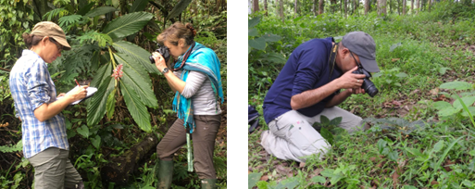

use microscopes to study plants,
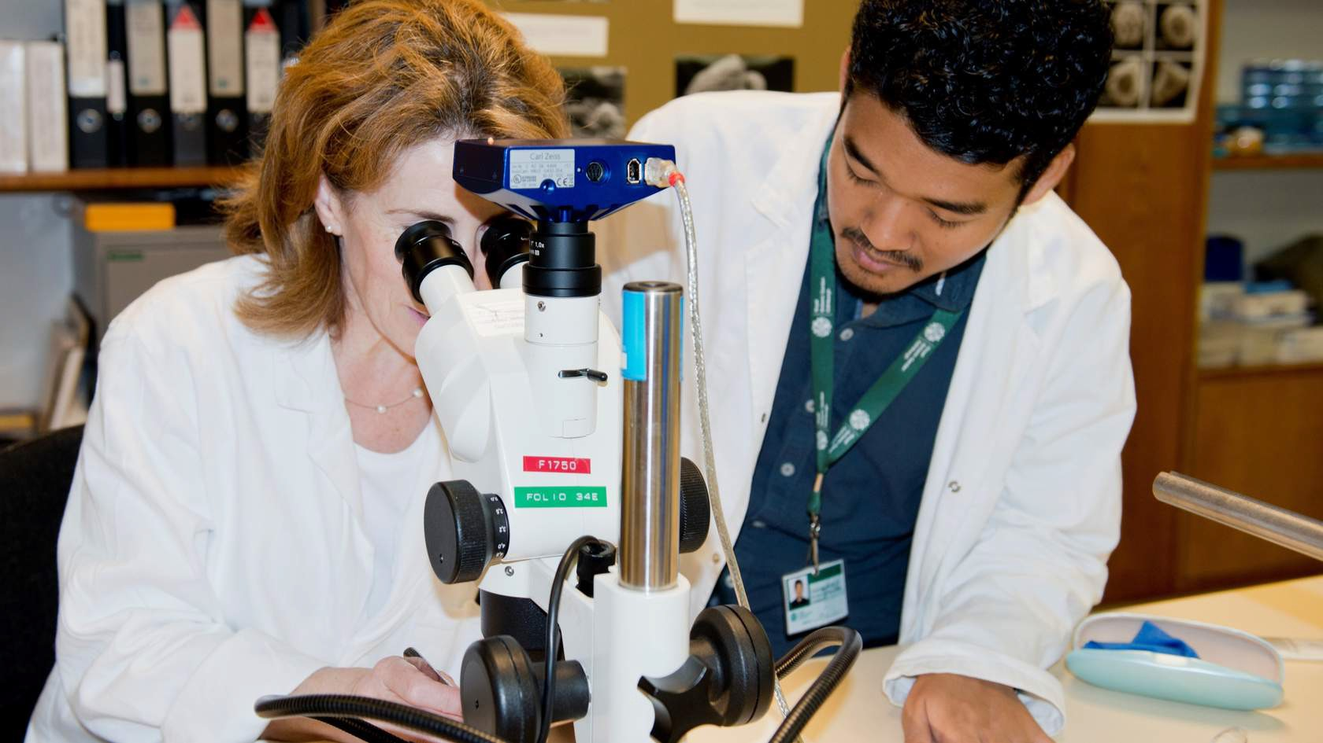

collect plant cells for research, 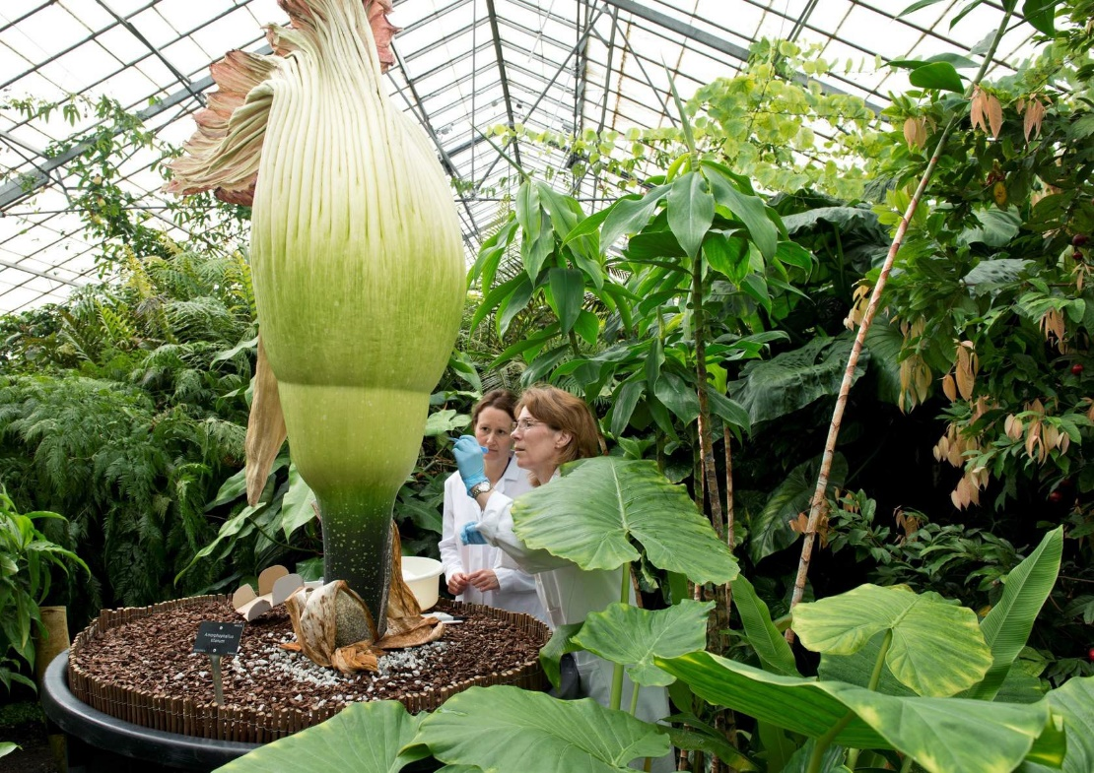

press parts of plants to record plant differences and identify rare specimens, 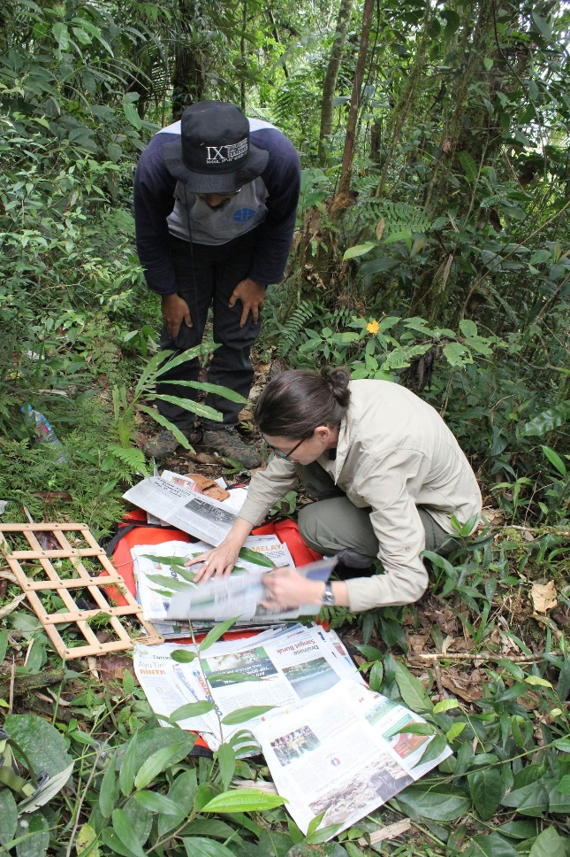

research plant diseases to protect plants and their habitats,
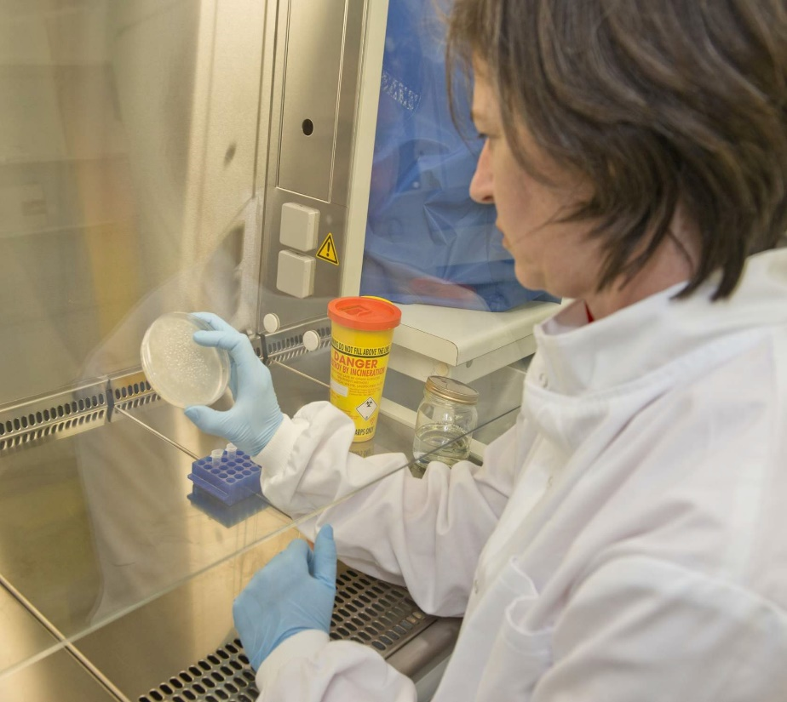

collect seeds to conserve rare plants,
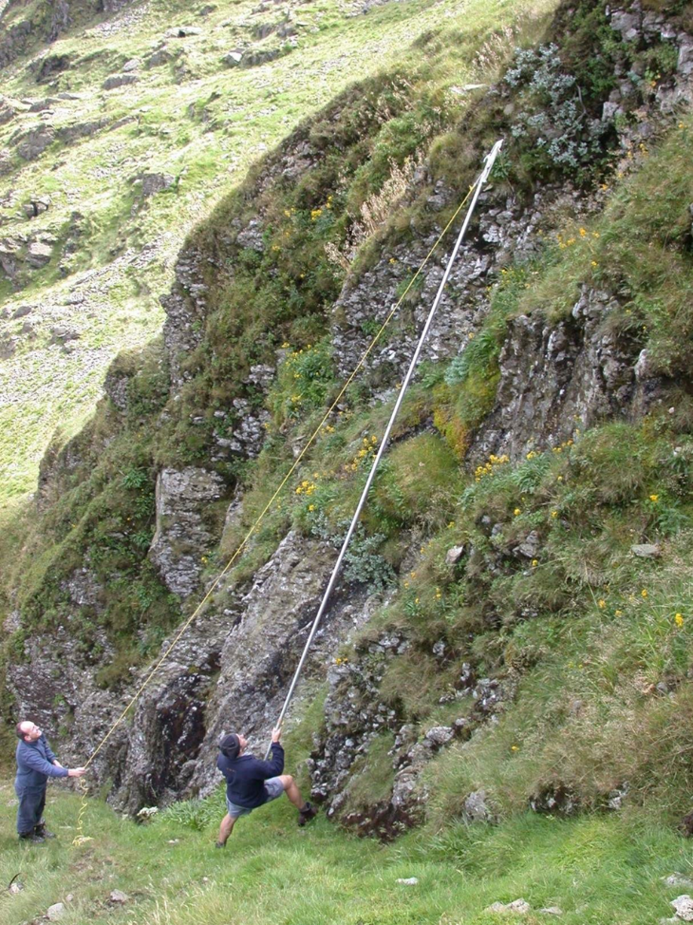

identify and name specimens to help decide which ones need most protection,
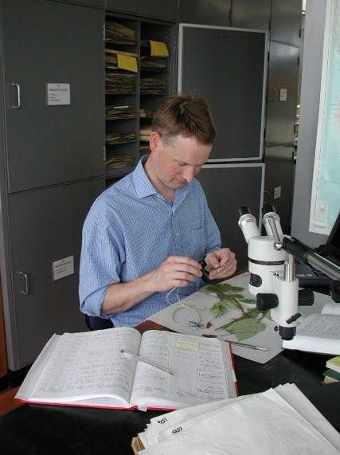

make illustrations showing details about the plants that are grown and studied by RBGE staff,
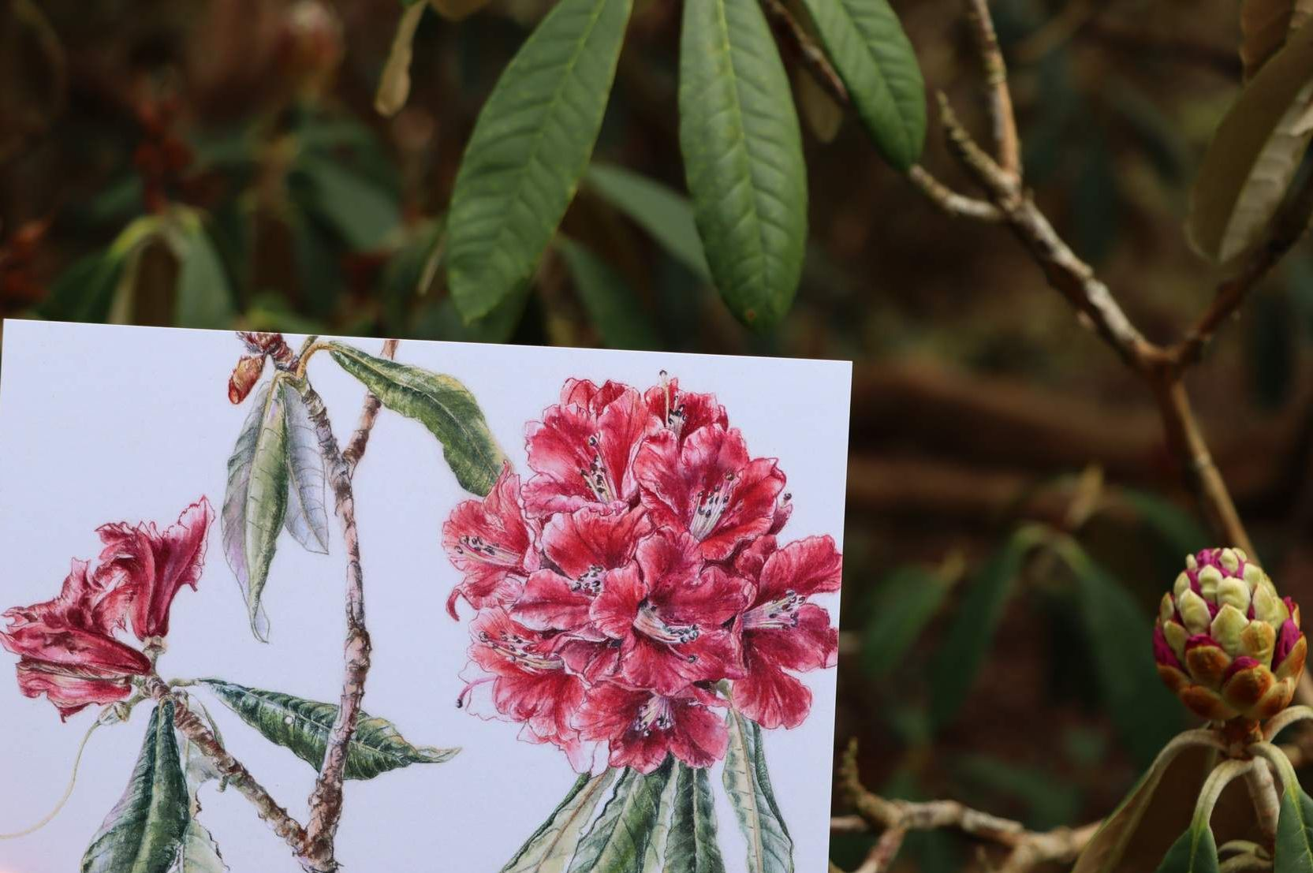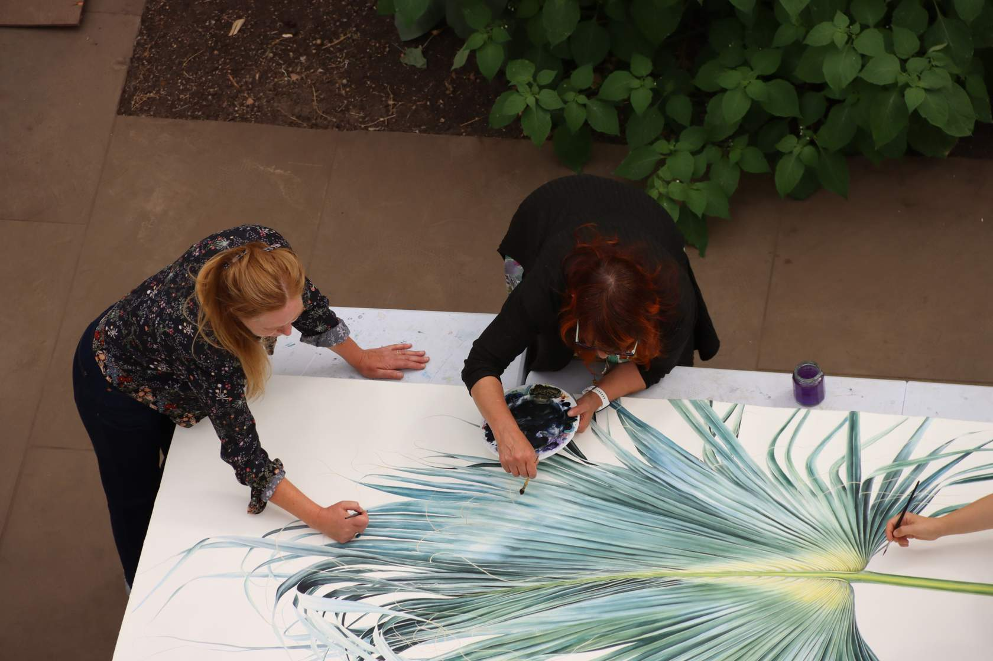

use technology to map and record changes in biodiversity over time,
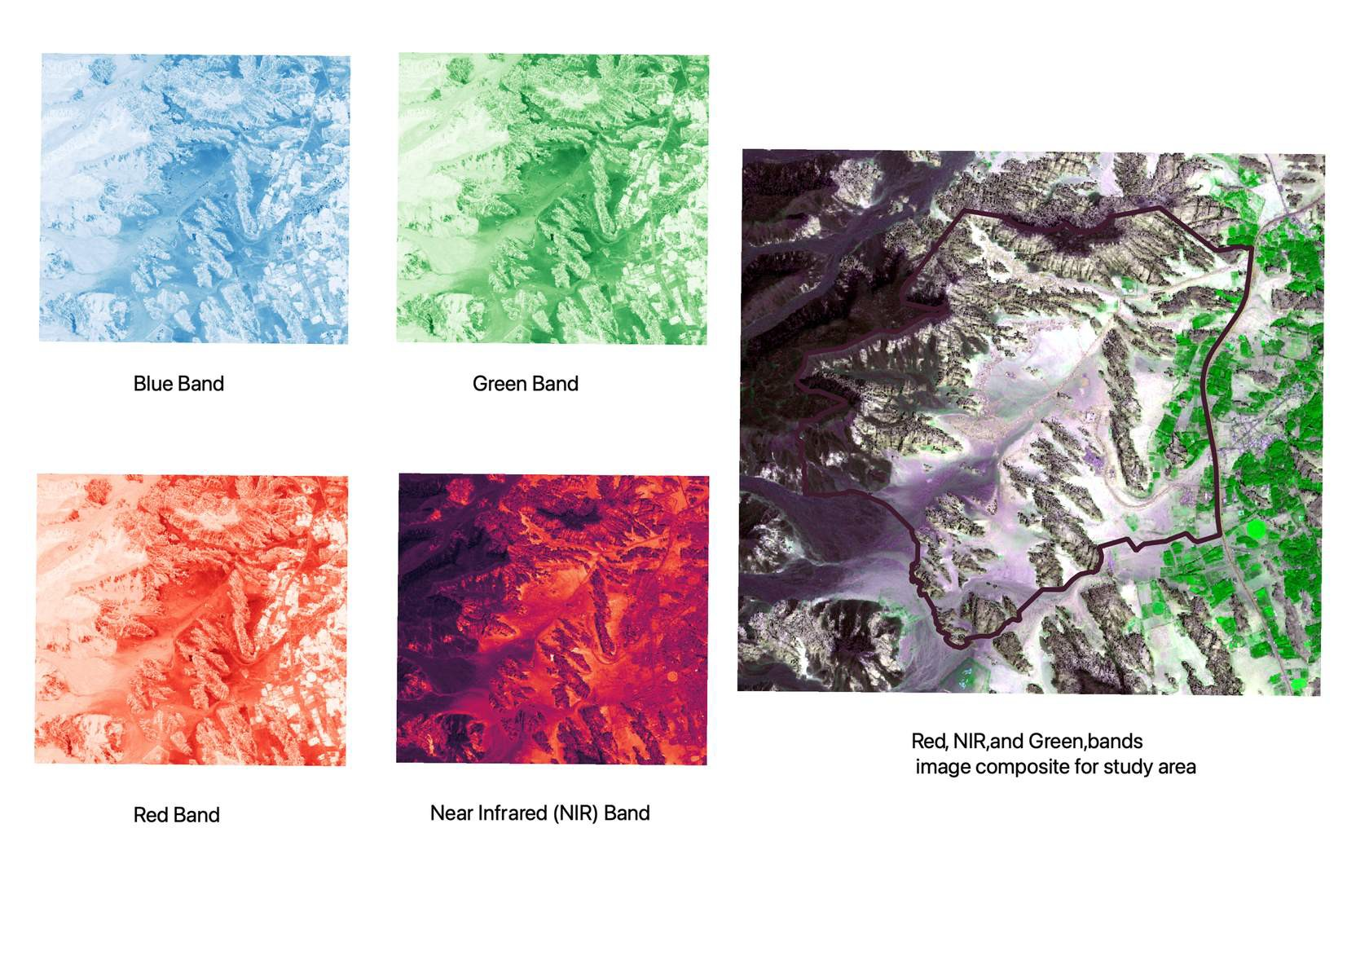
research plant genes,
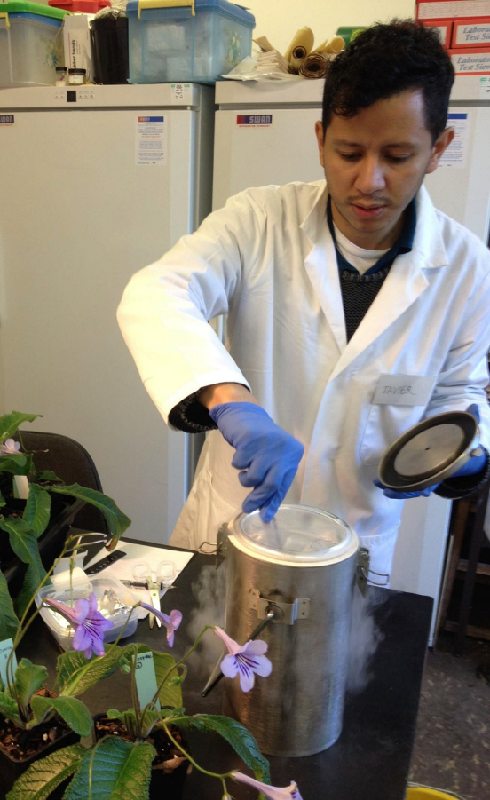

make digital copies of pressed plants to share the information with everyone,
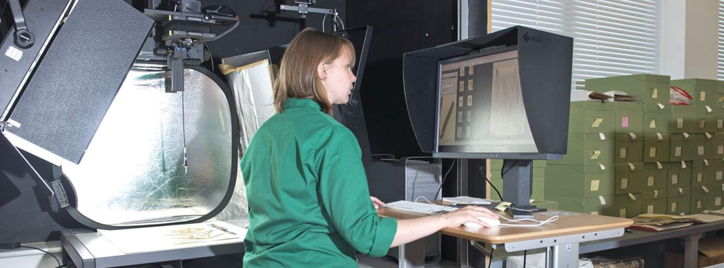

lead courses to teach others about plants,
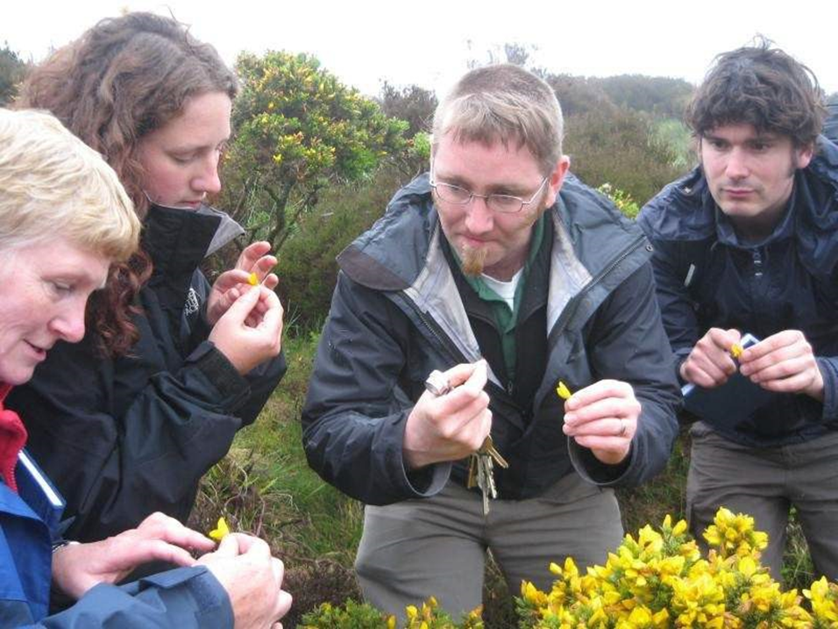

work with communities to create local jobs protecting rare plants in their home area.
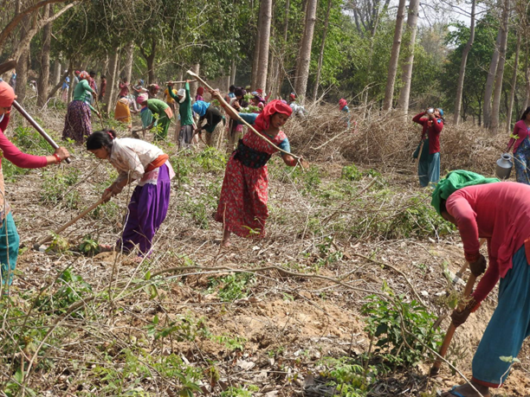

And much much more!

As you can see, there are so many different plant science roles and projects you could get involved with!
Let's now take some time to reflect and look at the skills needed for a career in plant science. Go to the next page to find out more.

Section 3: Plant scientist skills

We cultivate curiosity
In order to push the boundaries of our plant knowledge, our scientists need to be very curious!

What is curiosity?
Watch this video from Skills Development Scotland to find out more about curiosity.

Watch this short film to find out how one scientist was curious about different bamboo species and discovered that panda poo could help to protect panda habitats!

"Find out how best to conserve and restore giant pandas' habitat." - Dr Linda Neaves, RBGE

We work collaboratively
When Dr Linda Neaves travelled to Sichuan Province in China, she gained a lot of new knowledge by collaborating with a team of local people who had many different skills and experiences.
What is collaboration?
Watch this video from Skills Development Scotland to find out what collaboration means.

Look at these pictures from the video. For each one, think about the skills of different members of the team which all helped to make this project a success. Read the text below each image if you need some help.
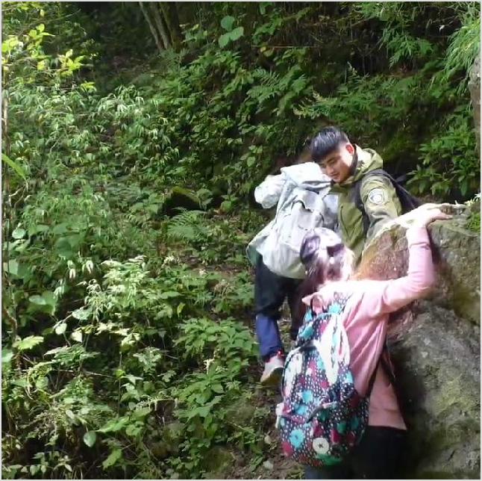
Some people know the area well and can find the best way through the dense forest.

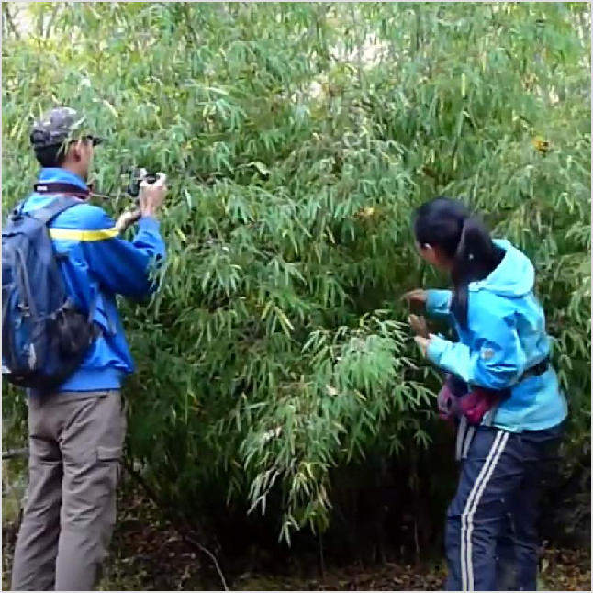
Some people can recognise many different species of bamboo.

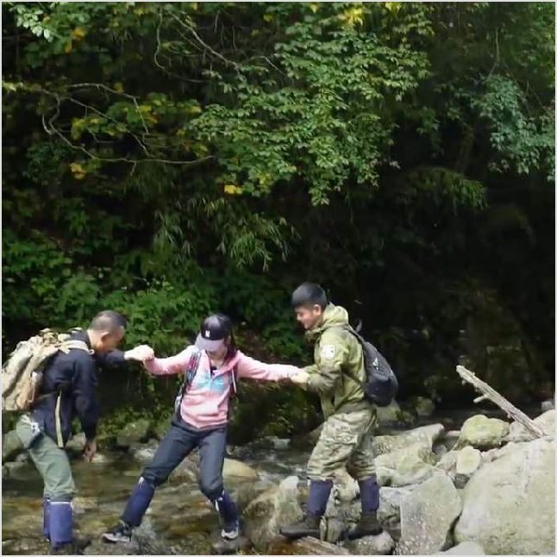
Some people know the best way to cross a river safely.
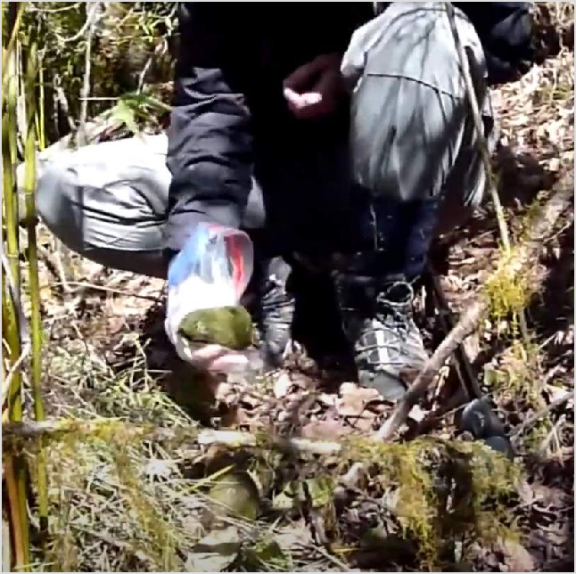
Some people know where to find panda poo.
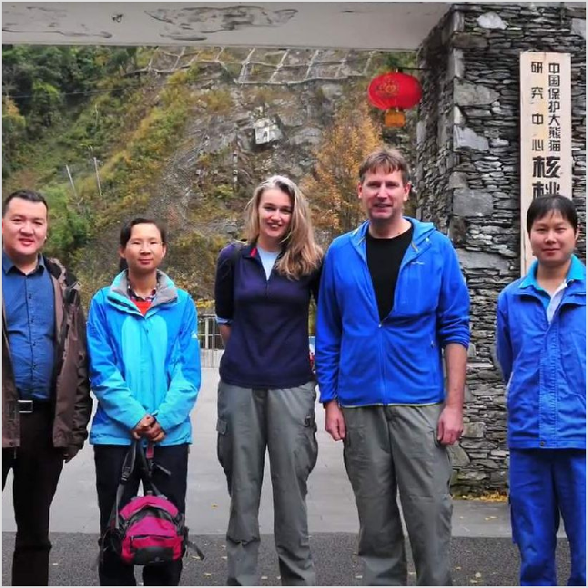
Some people know how to protect panda habitats.

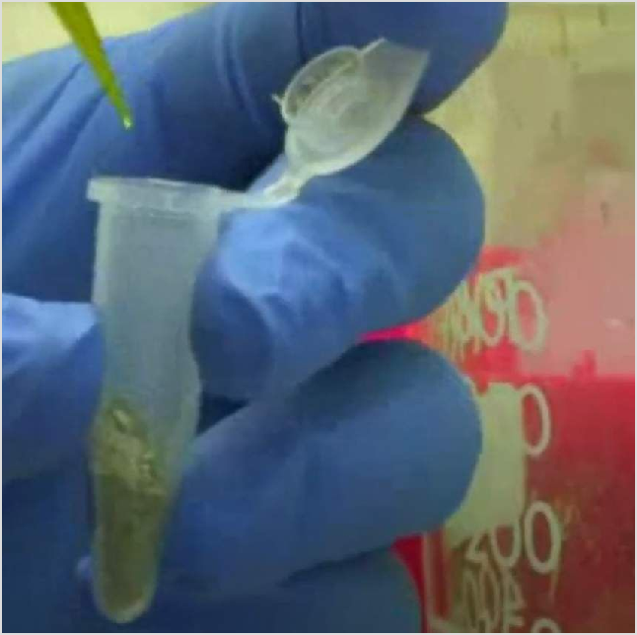
Some people know how to extract DNA from the bamboo samples.

Our scientists work with hundreds of partners around the world to exchange knowledge and share skills. Our focus is Scotland and countries where there are major threats to plant biodiversity.

RBGE benefits from the deep knowledge of people who live in the areas where projects are taking place. Some of this knowledge has been passed down through ancestors who have lived on the land for a very long time.

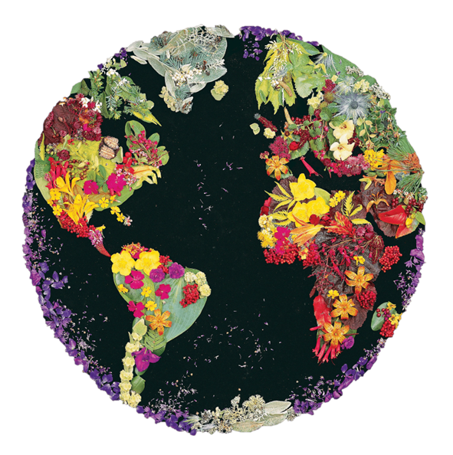

Read the bullet points to find out how we try to make our fieldwork as sustainable as possible and ensure fair and equitable benefits for our partners:
- Fair and equitable benefits for our partners
By building strong networks of scientists, people living in areas where there are major biodiversity threats have the support and resources to protect endangered habitats.

View the video in the interactive version of this resource for a short clip to hear about a collaboration between ForestAction Nepal, RBGE and community forest user groups in Nepal to protect the vital biodiversity of community forests. Select the full screen icon to have a better look!

- Sustainable field work
We encourage the use of rail/ferry where possible for shorter trips and plan field work carefully to minimise the use of long haul flights.

By digitising our collection where possible, we are reducing the need for researchers to travel to study plant specimens.

When we collect plant specimens to bring back to Edinburgh, we always leave a set in the local area for local research to continue.

- Where?
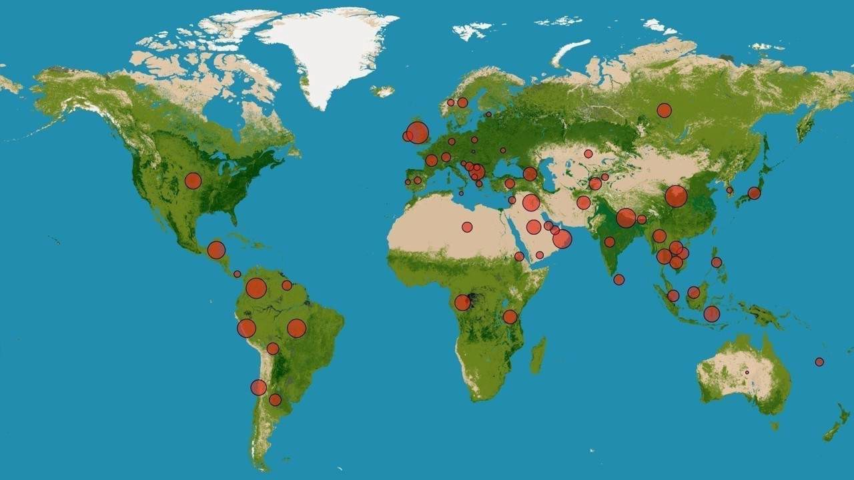
The countries where we have active projects, since 2009 (The bigger spots show that more projects have been carried out there).

Halt biodiversity and ecosystem loss.

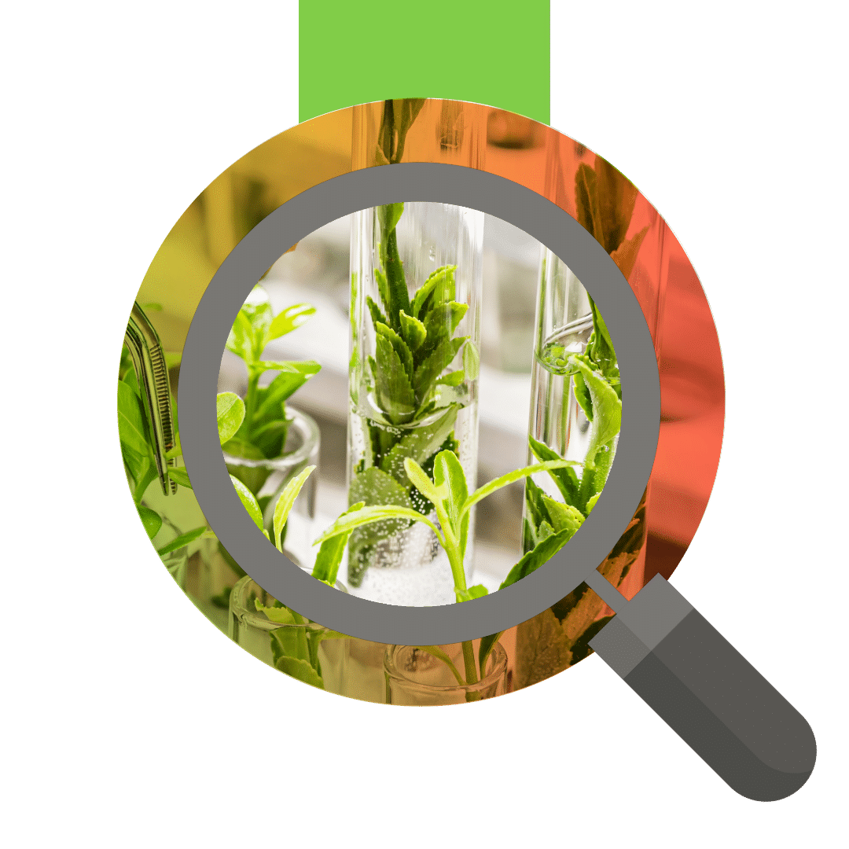Reflection Stop: Is it for me?
Does plant science appeal to you?
Were you surprised or interested by what these scientists do? Think about the different parts of the job and what kind of skills are needed. Can you think of any examples when you have been curious or have worked collaboratively?
Write your thoughts/examples in a career file or journal.

To find out more about some of these meta-skills visit the Skills Development Scotland website

That's the end of the career taster for plant science!
We hope you enjoyed it. If you are finished with this taster and would like to carry on exploring ‘Careers in Plant Science’ return to the online area on PropaGate Learning.

