Horticulture Practical Task:

help us move a tree!

Join the tree (arboriculture) team for the day and help us with some challenges as we carry out the tricky task of moving a large tree to another part of the garden.
If you take on this task you will:
- Meet the team and learn more about the work that an arboriculturist might do. Find out more about the task and how you can help.
- See how the team leader plans the task to make the most of the team.
- Use problem solving skills to make an assessment of the weight of the tree. Carry out a health and safety assessment of the site to keep everyone safe.
- Watch a video of the tree being moved and hear from the team leader to find out what happened.
Are you up to the job?!

Contents
Section 1: Meet the team
Section 2: Introducing the task
Section 3: Managing a team
Section 4: A problem to solve
Section 5: Health and safety – managing risks
Section 6: Final steps
Section 7: Summary

Section 1: Meet the team
Meet some of the Arboriculture team at the Botanics...
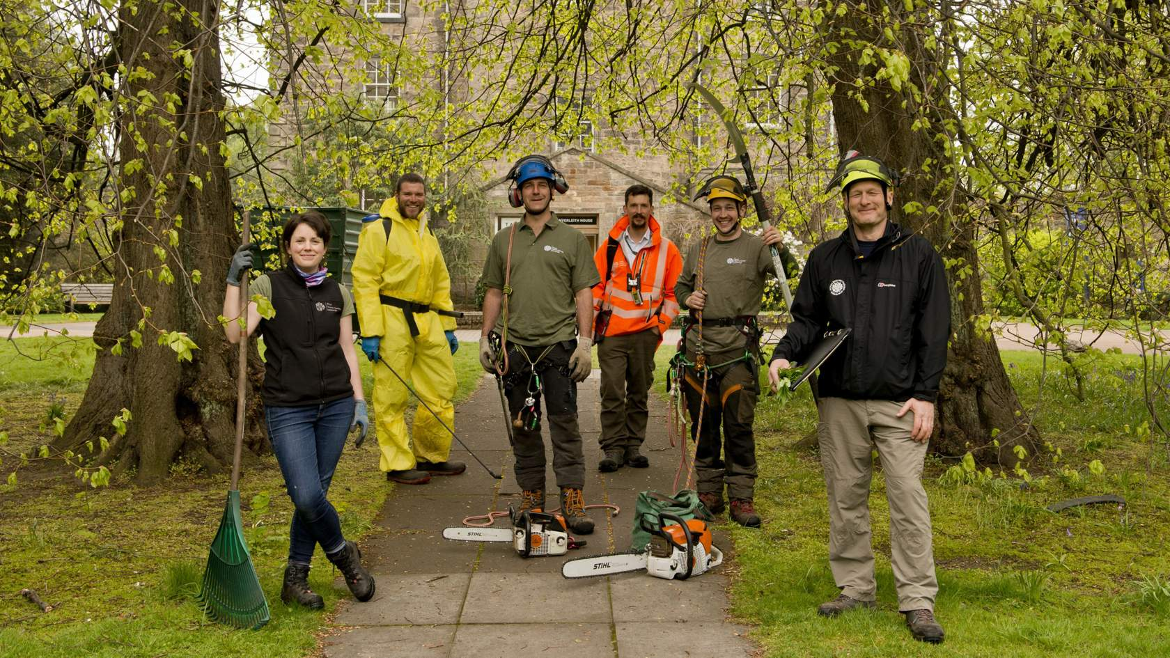
Arboriculturists can also be called 'tree surgeons' or 'arborists'- they have special training in tree care.

What does their role involve?
Take a look at each image and description to discover what the arboriculturist is doing.
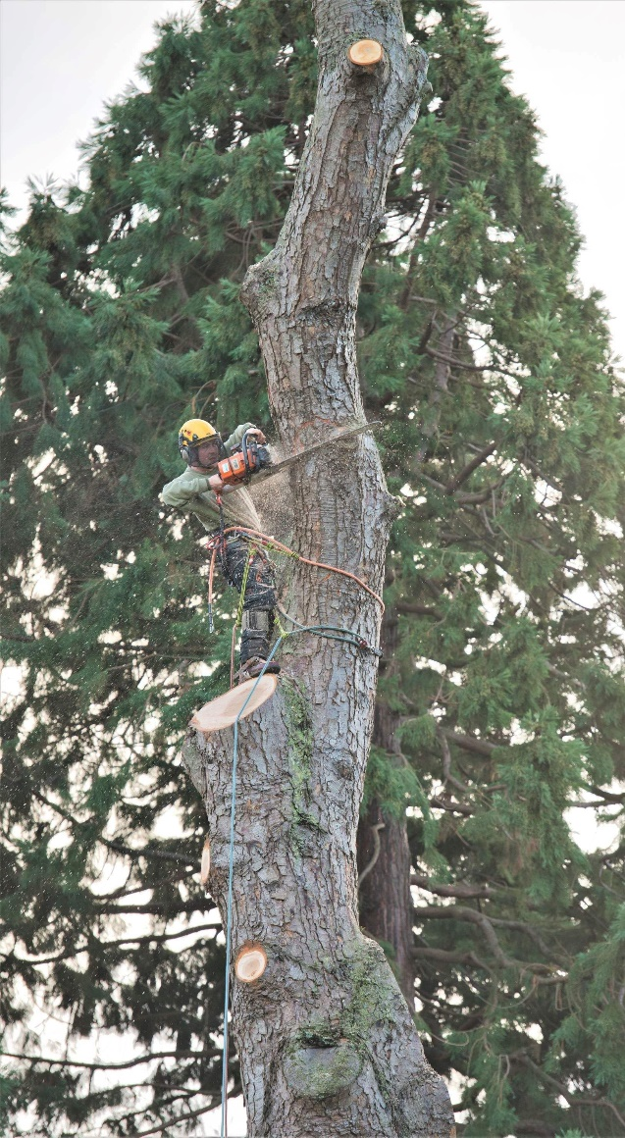
Tree climbing and using a chainsaw to cut down a dying tree

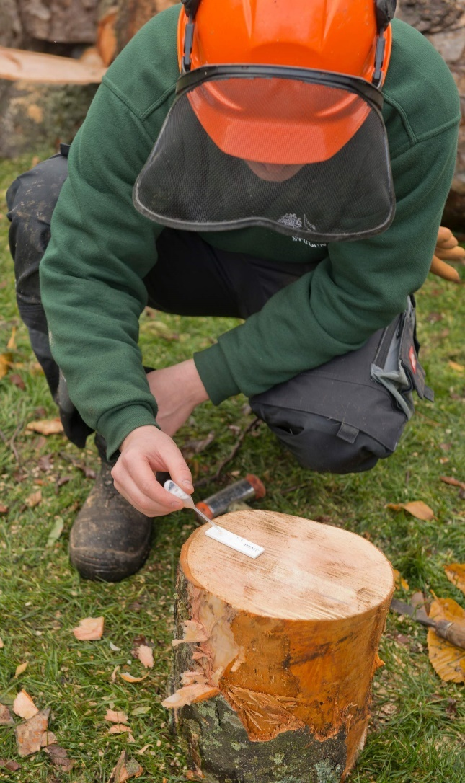
Testing for tree diseases

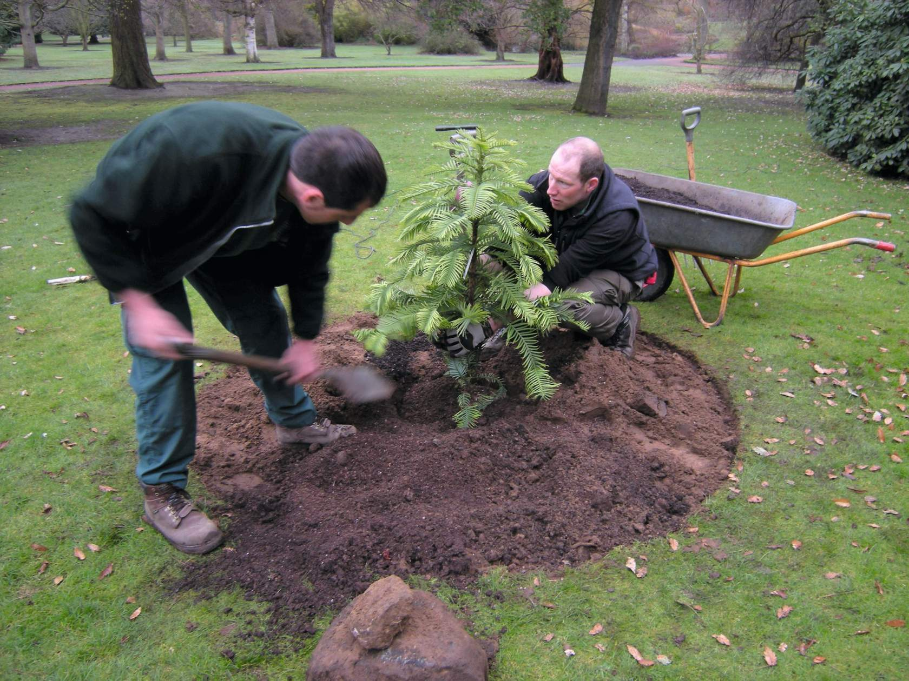
Planting trees
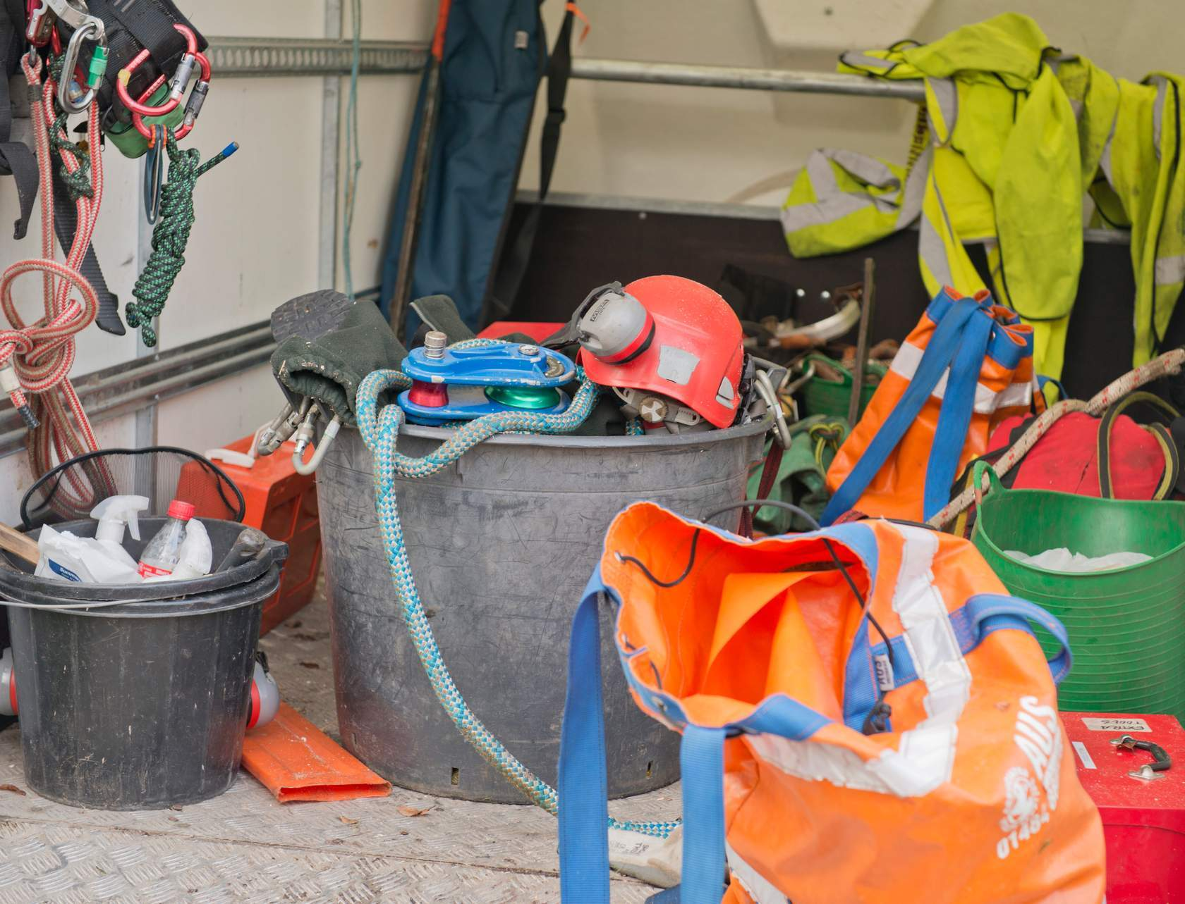
Checking and maintaining equipment such as climbing ropes and chainsaws

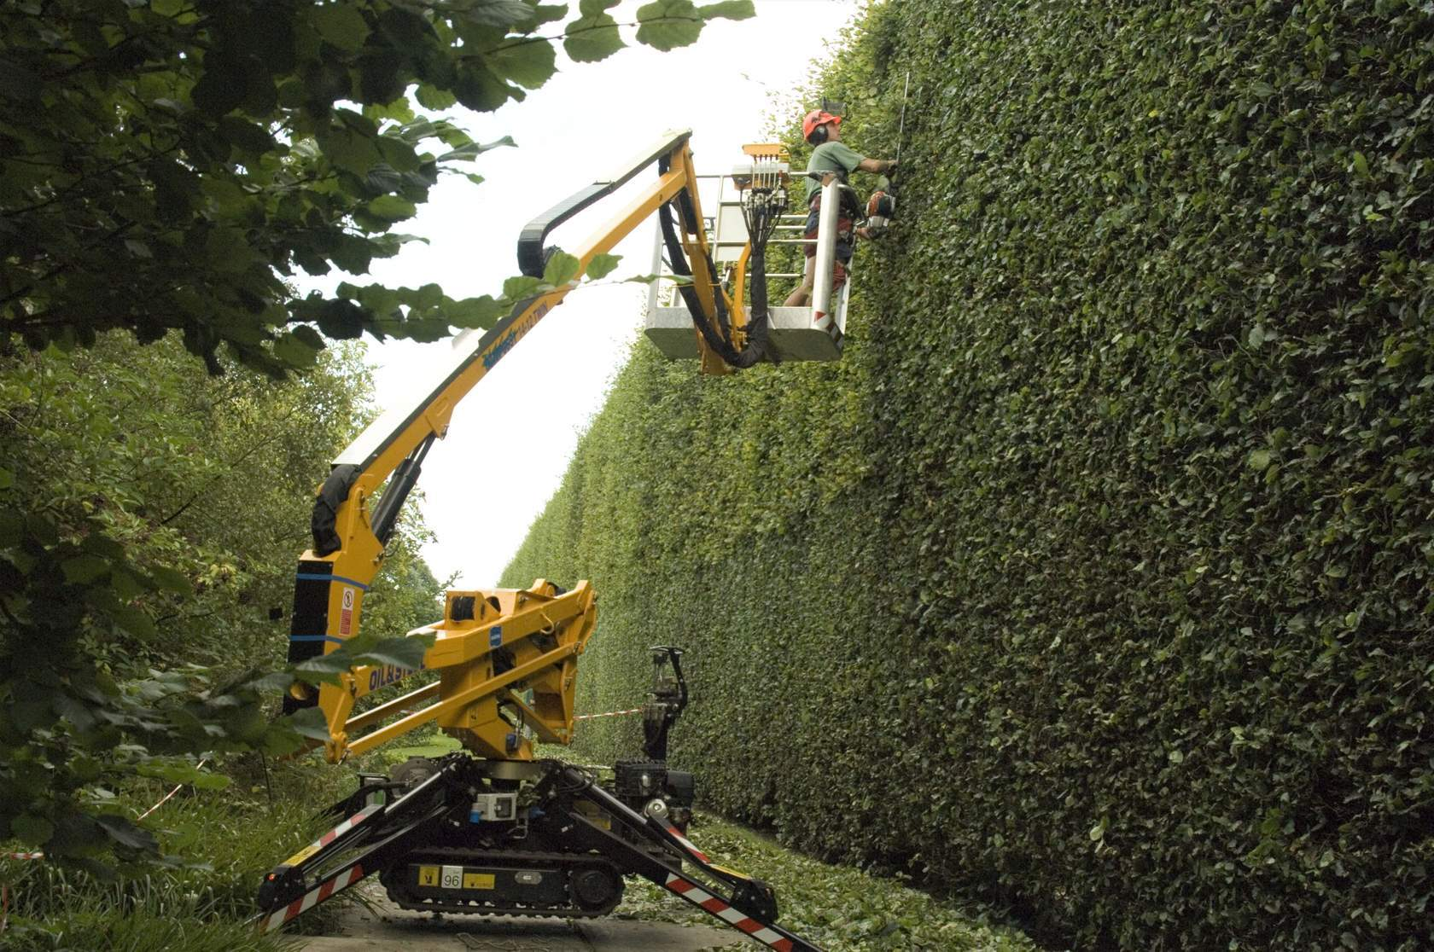
Trimming hedges

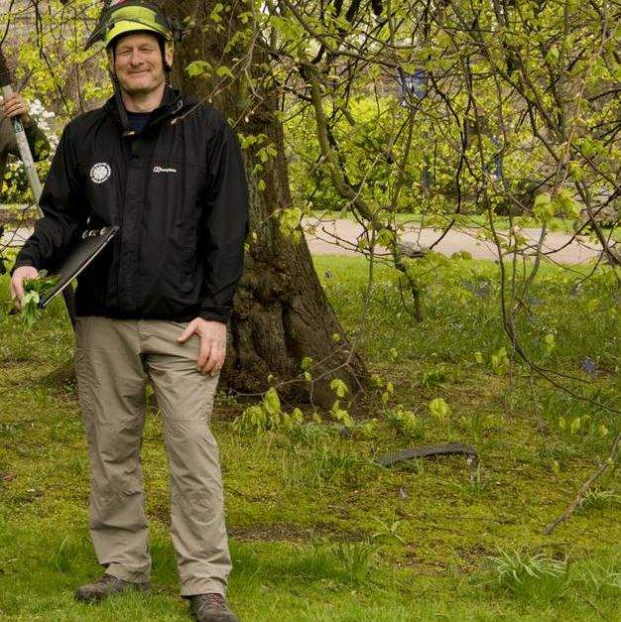
Checking trees for safety and health (surveying)

Throughout our career resources you will come to reflection stops. Here you can reflect on the information just covered. There are questions to help you think about whether this type of job is for you and to take note of which aspects you like or dislike.
Top tip: If you haven't already, start a careers reflection notebook to keep a note of your thoughts.

Reflection Stop: Arboriculture
Do any of these activities spark your interest?
What is it that appeals about the activity?

Section 2: Introducing the task

So, what is the task?
Read the email below that has just arrived from the head of the department and look at the attached map.

To: Arbteam@rbge.org.uk
Subject: Tree removal and replanting task

Hello,
We need to move the Acer griseum tree by the glasshouses as part of the preparations for the building work. Please see map of site attached.
Please could you make a plan and let me know by the end of next week when you and your team can do it? You'll need to get a costing for the crane hire.
Many thanks,
David
Curator of Living Collections | Royal Botanic Garden Edinburgh | 20A Inverleith Row | Edinburgh | EH3 5LR

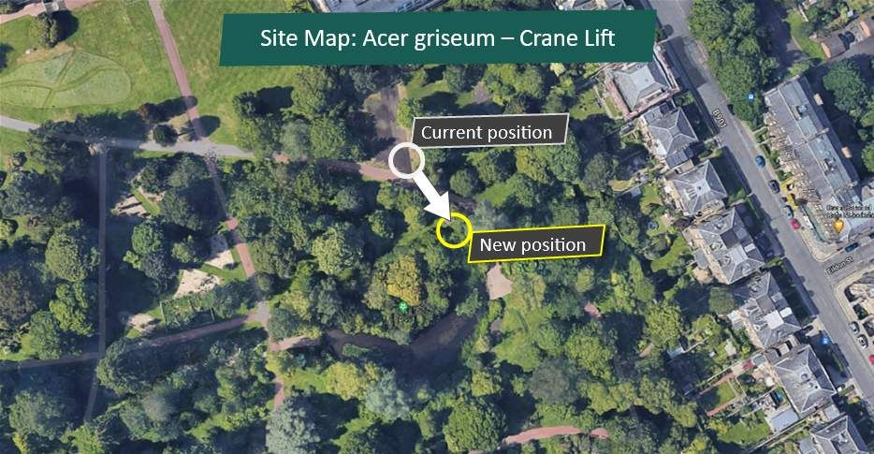

Meet the team leader
Now we know what the task is let's meet Will the team leader for this task - he's wearing the orange jacket in the photo. 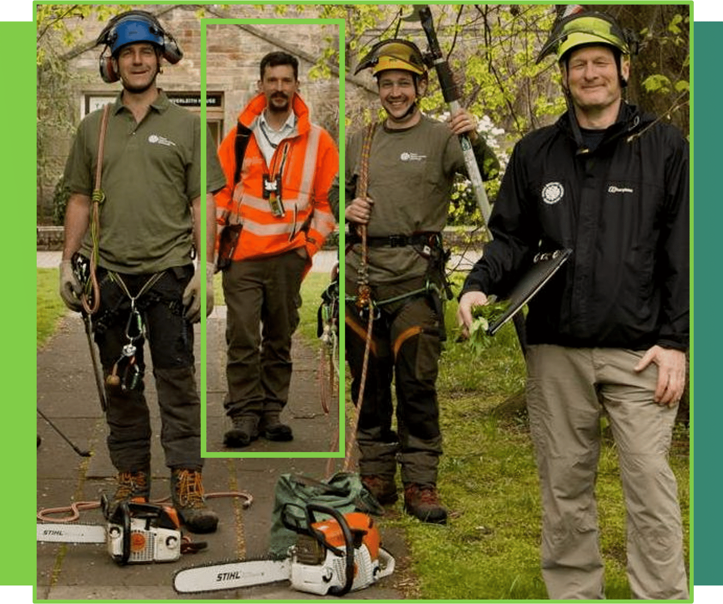
“Hi, I'm Will, and this is the Acer griseum - the paperbark maple that you've been looking at in your task. So, I'm the team leader for the Arboriculture team. We decided that we wanted to save this tree. It was going to be lost to a development, but by moving the tree we could keep it in the collection.

We want to keep it in the collection because as you can see it's a really interesting tree. It's got this lovely flaking bark, this lovely red colour. It's interesting as well as because of where it's from, so it's from Hubei which is a central Province in China and it's a really really good example of the species.”

Section 3: Managing a team
Congratulations welcome to the team!
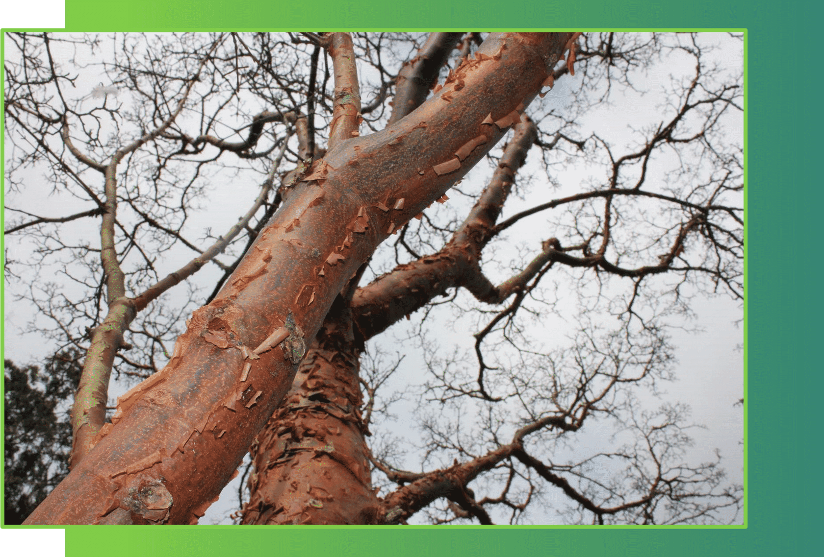
You are now part of the team selected by Will to move the tree in the picture.
The team leader has worked out the size and weight of the tree and has booked a crane for the day.
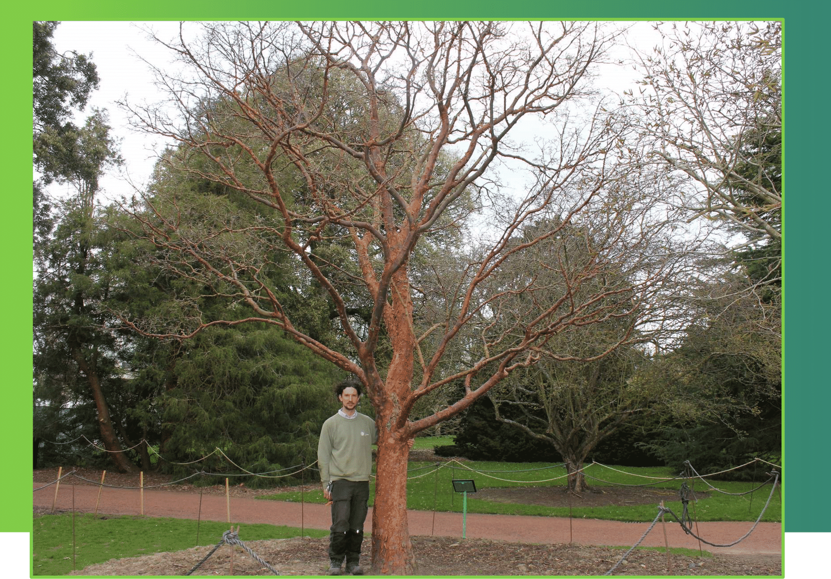
Now he will speak to the team to discuss what the best steps are to do the task safely and gather everyone's ideas.

Moving a large tree
See below to see the step-by-step method which splits the task into 5 main parts. This means everyone on the team knows what to do on the day of the lift.
- As you go through each make a note of which parts of the task you would like to do if the team leader asks for a volunteer.
- Make a record of any personal skills that you have that could help the team. Are there any things you would find difficult that you would need help with?

Step 1: Preparing the ground
Dig a trench around the roots of the tree with a digger and prepare the new planting hole as shown on the map.
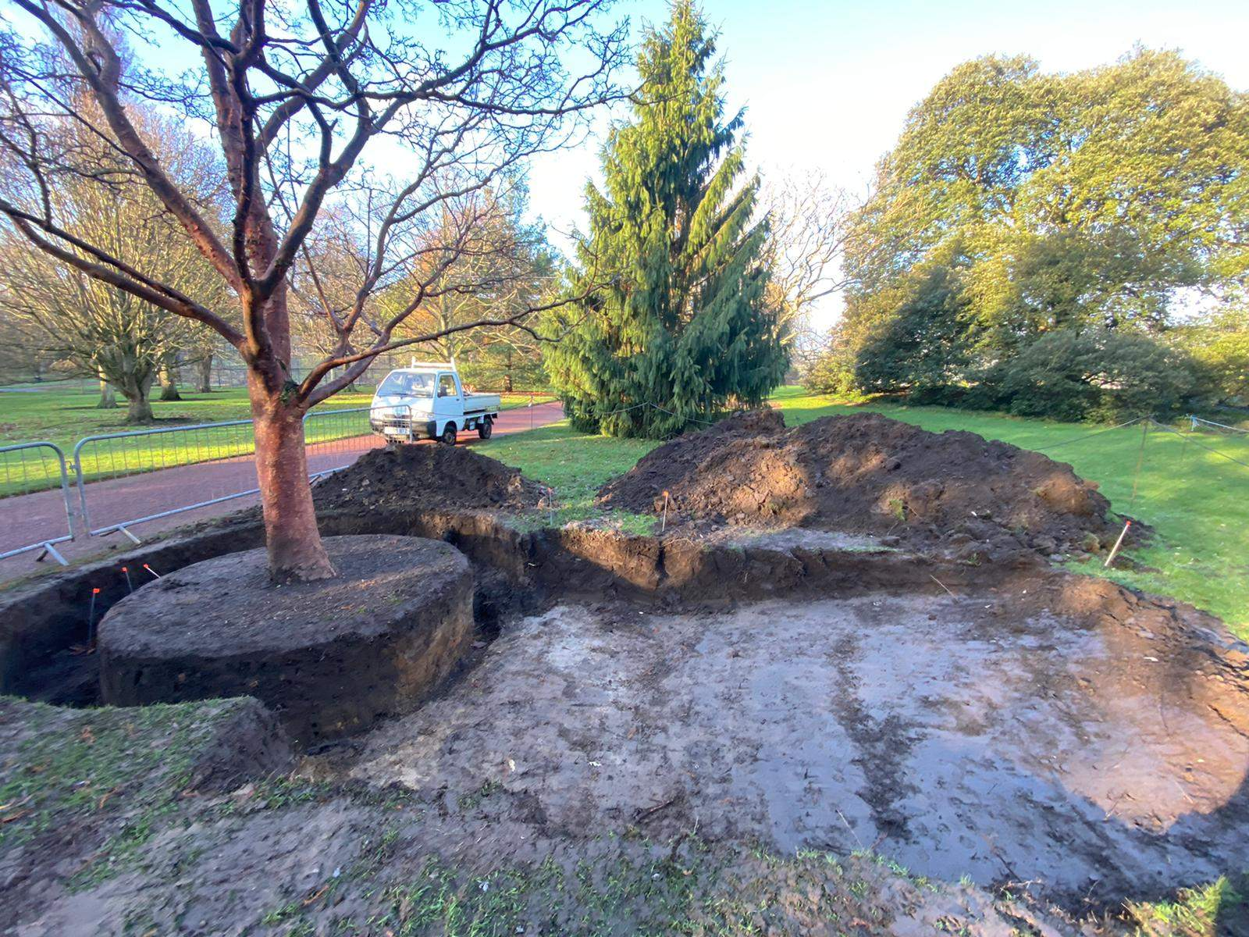

Step 2: Covering the root ball
Cover the root ball in protective fabric and tie it on firmly using secure knots. Fit strong basket chains which will be attached to the crane.
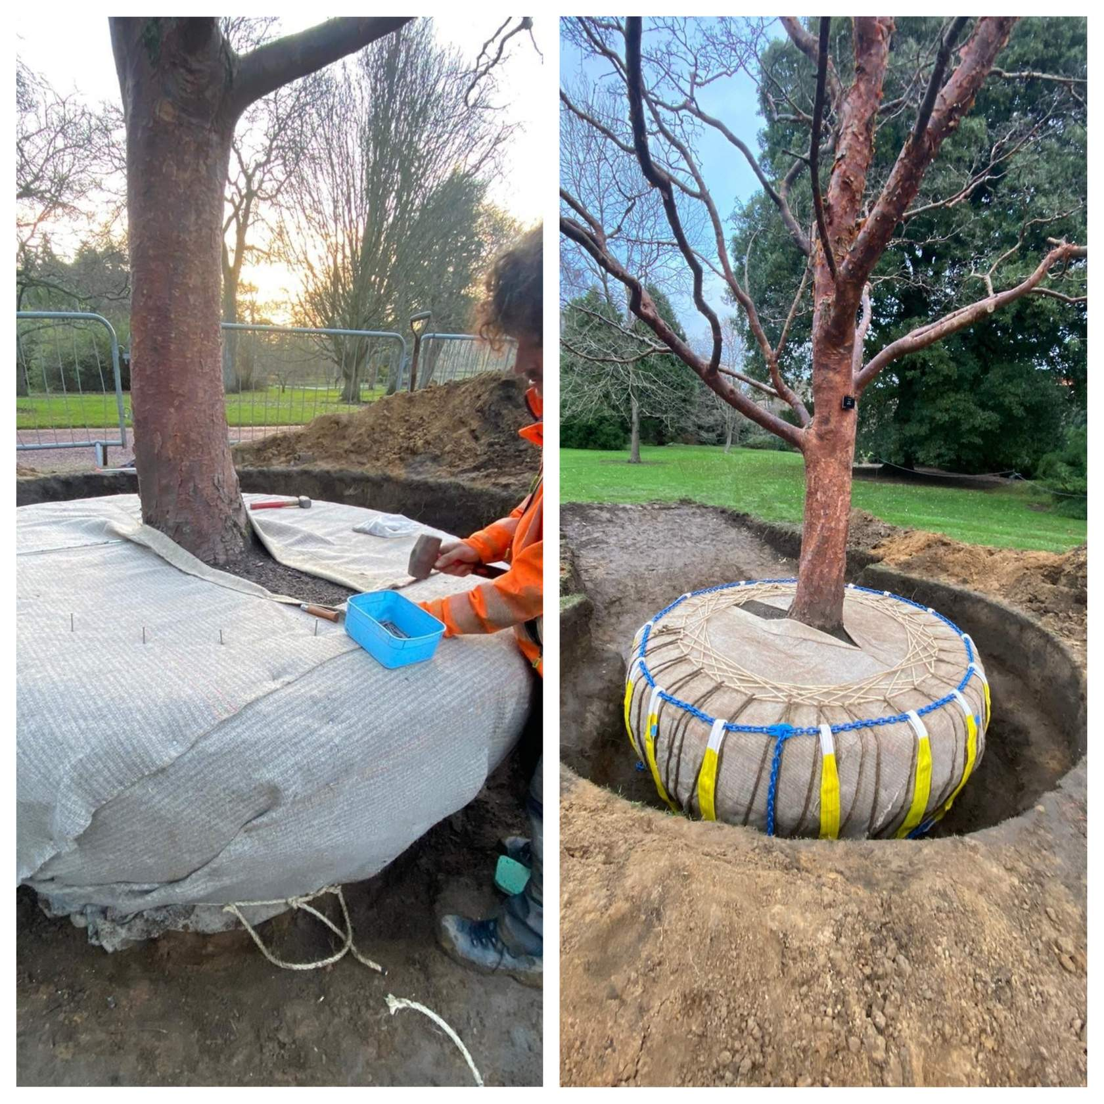

Step 3: Connecting to crane
Guide the crane operator to the trench using a radio. Connect the crane hook to the basket chains using slings. Double check everything is secure.
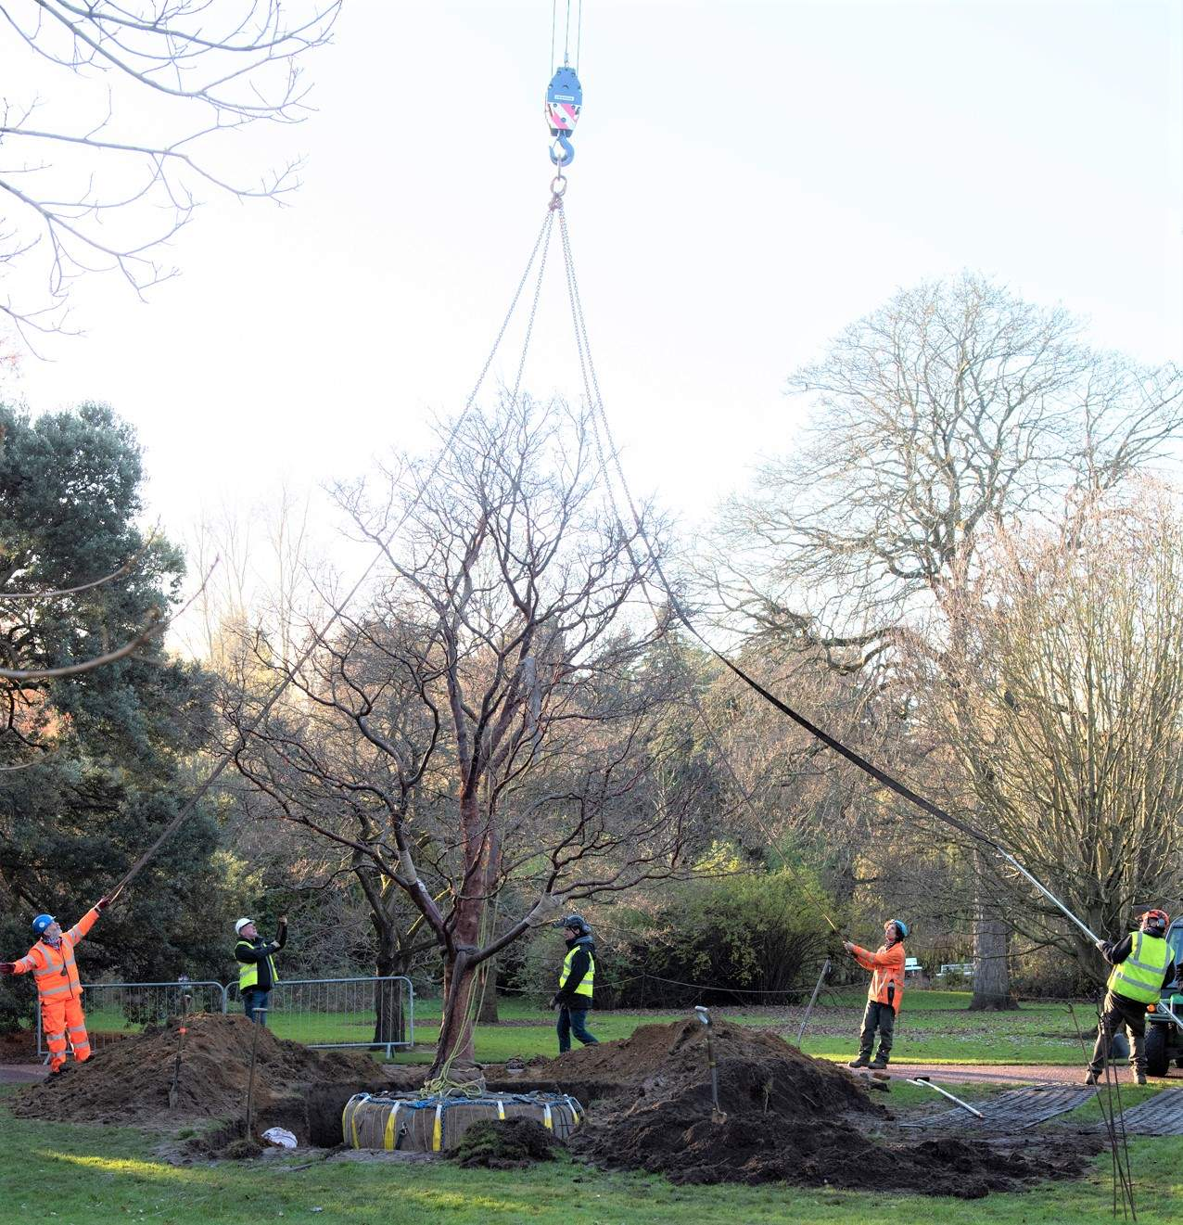

Step 4: Up she goes!
Stand in a safe area while the crane lifts the tree up from the ground, moves it and lowers it into the new hole.
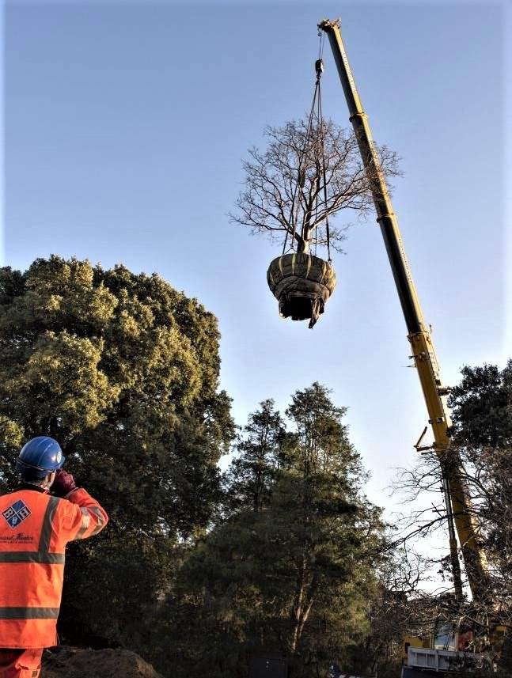

Step 5: In new home
Unfasten the straps and wrapping from the root ball. Fill in most of hole using the digger. Finish the job with spades, and firm and water the soil around the tree roots. Make the area safe and tidy before the visitors enter the garden at 10 am.
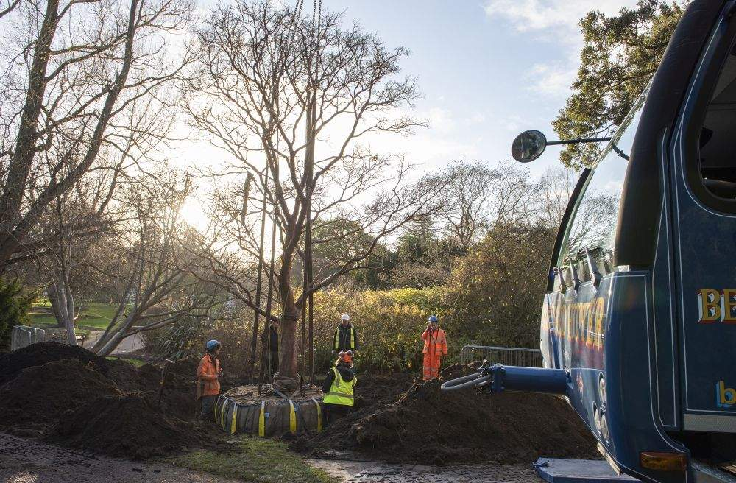

Summary
Knowing the steps in advance helps the team carry out the task efficiently and safely. In the workplace we call this a method statement.

What makes a good team member?
Let's hear from Will about the team they need for this task:
“So, for a task like this, it's really important that everybody's communicating really well together and understands the whole job or particularly their contribution to the whole job. So being a good communicator is really really important for team members. Then also being able to both take and follow instruction, but also come forward with ideas and be a good problem solver.

And then we're looking for people who've got the specific skills that we need to do the job. So not everyone needs to have the understanding of the weights and the loads, but we need one person in the team who understands that. Not everybody needs to understand the horticultural element of the job. But we do need one person of the team that understands that or some of them. I mean, it's great if everyone understands every element, but you make up your team of the specialists that you need for the job.”

Skills for the task
There is a team of skilled people ready to move the tree - see if you can manage the team by matching the activity to the skill or knowledge that is required.
See if you can match up the activity on the left of the table to the correct skill on the right.
Activity | Skill
Dig and fill the hole | Communication
Use a radio to guide the crane | Operating machinery
Fence off the area | Tying knots
Wrap the root ball | Problem solving
Calculate the weight of the tree | Health and safety

Correct answers:
Activity | Skill
Use a radio to guide the crane | Communication
Dig and fill the hole | Operating machinery
Wrap the root ball | Tying knots
Calculate the weight of the tree | Problem solving
Fence off the area | Health and safety

Reflection Stop: Skills
When the team leader asks for volunteers to do part of the task which ones will you choose and why?
Make a list of any skills you might already have or would want to develop in the future.

Section 4: A problem to solve
Problem solving is part of everyday life and every job.
Here is a problem that the team leader had to deal with - why don't you have a go?

The Challenge!
What? - Work out the weight of the root ball of the tree. The root ball is the bottom of the tree that is made up of roots and soil and it has been wrapped up ready to be lifted.
Why? - To order the right size of crane and lifting gear for the task.
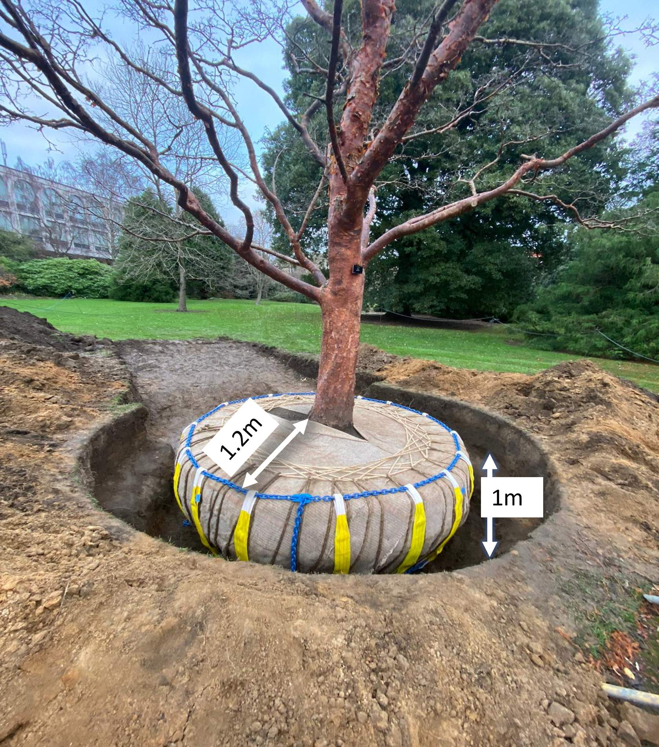
Top tips:
- Don’t worry if you find this hard – in a team you can ask someone to help that has those skills – we don’t have to be good at everything. You might be good at tying knots!
- If you haven't done a task like this before, do what our team leader did - ask someone who has this experience, and learn from them.

To take on the challenge download the worksheet and the answer sheet from the 'Accessible resources – linked content' back in the task section of the ‘Careers in Horticulture’ online area.

How do you work out the weight of a tree?
Time to head back to Will to see how he worked out the weight of the tree:
“The heaviest part of the lift is the root ball - the soil. So, to estimate the weight that you need to allow to lift, you need to estimate the volume of soil that you're going to lift. So, we assumed that the volume of soil would be like a cylinder.
So, we calculate the volume of that cylinder. So, you calculate the area of the circle on top using Pi r squared which gives the area of a circle and then you multiply it by the height of the cylinder or in this case the depth because you're digging down, that gives you the volume of the cylinder.
Then we know that the weight of a cubic meter of soil is 1.7 tonnes. So, you multiply the volume of the cylinder by 1.7 and that gives you the weight of the soil. The wood volume in this tree is not that great, so we give a rough estimation of that, add the two together and that gives us the weight that we allowed for the lift.”

Section 5: Health and safety - managing risks

Challenge - can you stay safe on the job?
At work, many tasks need to have a risk assessment to protect the workers and the people nearby. A risk assessment means thinking carefully about the possible dangers and planning how to minimise them.
Look carefully at the photo below as the crane started to lift the tree. Then discover the 6 points to find out questions to answer about assessing and managing risks - have a think about each and note down your thoughts.
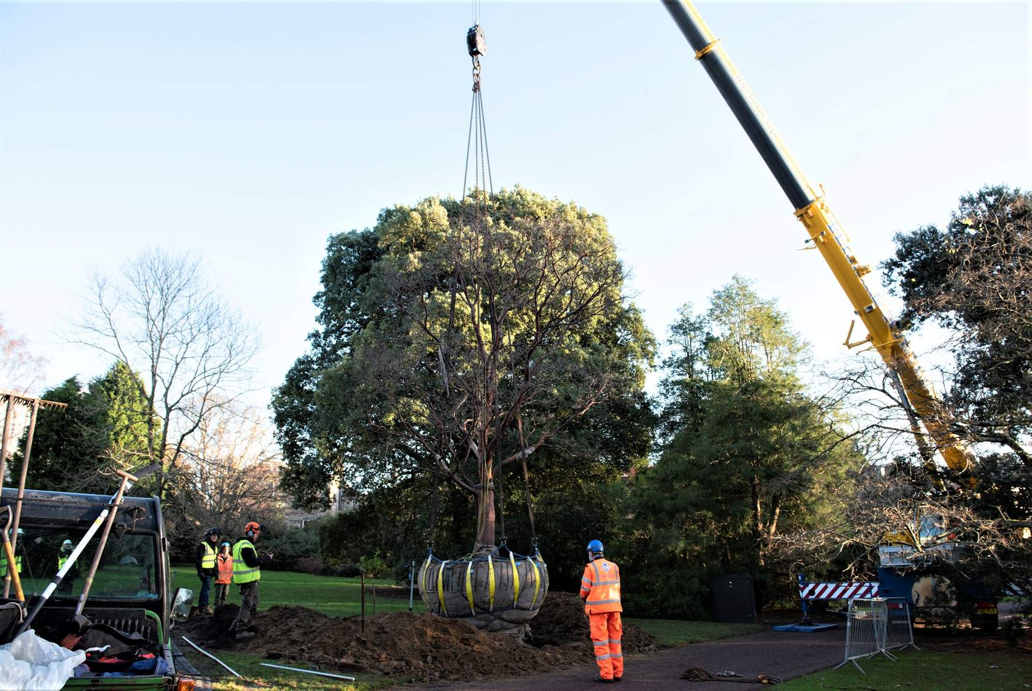
- Keeping visitors safe
The team did this job early in the morning before the garden opened to the public. What else could you do to keep visitors safe?

- Trip hazards
How can you avoid people tripping up or falling over on the job?

- Machinery
The crane operator has been trained to use the machine and careful planning went into the task. What do you need to think about when working near machinery to keep yourself safe?

- Equipment and tools
When planning this task it was important to choose the right crane for the job because the crane or tree could fall over. Look at the equipment in the picture above and think about how you could make the job as safe as possible.

- Weather
The team leader checked the weather before the job started - why? How could weather be a risk?

- PPE
PPE stands for Personal Protective Equipment. What protective clothing can you see the team wearing? What do you think they are wearing to protect their toes?

Well done for having a go at your first risk assessment on the job! Check your answers with Will and the team's risk assessment below.

Risk Assessment
Before this job Will and team did a risk assessment where they gave scores to possible risks depending on how likely something could happen and how serious the injury could be to someone. They then thought of ways to reduce these scores making the job safer.
Here are some of the things we spotted.
Weather
- strong wind could blow branches down and make lifting the tree using the crane dangerous
- heavy rain could make the area and tools slippery
- snow and ice would make the task harder due to frozen slippery ground

Equipment and tools
- leave tools that aren’t being used in the vehicle
- stand spades upright in soil rather than lying on the ground
- check ropes and harnesses for safety before you start the task
- park vehicles away from the task area
- use a registered company with good safety record when hiring equipment like a crane

Keeping visitors safe
- use barriers and warning signs to keep them away from the task area
- put diversion signs up to show them where to go

PPE (personal protective equipment)
- wear hi vis so people are visible
- wear helmets to protect heads
- wear ear defenders if the task is noisy
- wear steel toe capped boots to protect toes

Trip hazards
- Store tools carefully and not in the task area
- Tidy up regularly when digging roots out
- Be responsible for yourself – watch where you are going and don’t rush

Machinery
- Stay well back, particularly when machinery is moving
- Wearing hi vis helps the driver or operator see you better
- Agree in advance how you will communicate with the operator – will you use radios, mobile phones, or hand signals?

For further info on health and safety at work take a look at:
https://www.hse.gov.uk/simple-health-safety/risk/index.htm

Reflection Stop: Health and safety
When you apply for a job in horticulture (and many other jobs too) the interviewer might ask you what you know about health and safety.
At the moment how much care do you take to do things safely? You are assessing risks all the time - crossing a road, cooking, running around with mates.
Is there any way you can show you are good at this skill?

Section 6: Final Steps

Lifting the tree
All the ground work is in place, so it's time to lift the tree!
To watch the video to see the actual tree lift on the day go to the 'Accessible resources – linked content' back in the task section of the ‘Careers in Horticulture’ online area.

Lift complete!
But the work doesn't end there, it’s important to evaluate how the task went and understand what lessons were learnt.
Have a read below of Will's evaluation and what he learnt:
What was important for this task?
“Planning was really important for this task. So, to be able to break up the task into smaller components and work out what you need to do for each element of it. Then collaboration, you get to collaborate with crane companies to plan the lift. I also had to go to some other people who've done tasks like this in the past for advice.
Then the other really important element was problem solving, because you have to be able to adapt to the changing situation all of the time and nothing goes quite as you expect it to. You need to come up with solutions to the problems that occur.”

Were there any unexpected challenges?
“So, he positioned the crane midway between the landing point and where we were picking the tree up from and when we went to lift the tree the load alarm went off on the crane, which means that the load is heavier than you've got it rigged for. Obviously, we had done our calculations we had estimated the weight. We weren't quite sure had we underestimated the weight? Was the crane not rigged right? We didn't quite know. What it was, was the force that was required to detach the root ball from the ground at the very bottom wasn't completely severed underneath which meant that the crane needed more power than the tree actually weighed to lift it off the ground.
So, we had to reposition the crane bring it slightly closer to where it was lifting from which when it's slightly closer you can lift a higher weight. And that allowed us to lift it up and move it. So, if I was going to do it again, I would make an allowance for that extra amount of force that's going to be required to lift the tree up. And assume that the tree is going to be say 10% heavier than it actually is.”

What did you learn from this task?
“So, the task was on the sort of edge of what I thought was really possible with lifting trees. So, I was quite nervous about it. And I think what I've learned is that with good planning, good teamwork you can really achieve right up to the limits of what is possible. So, I think mostly, I learned confidence. It's given me quite a lot of confidence that with good planning and a good team you can achieve anything.”

“What I've learned ...it's given me quite a lot of confidence, that with good planning and a good team you can achieve anything.” - Will

Section 7: Summary
Great job!
Now you have looked closer at the role of a manager of an arboriculture team and helped the team complete the task.

Recap
We saw how the team leader needed to:
- plan the job
- solve problems
- find the best people to do tasks based on their skills
- involve other people like the digger driver and crane operator
- get everyone working as a team
- keep everyone (including the public) safe.

Next steps
If you enjoyed this task and are interested in a career in arboriculture check out the following links:
- The Arboricultural Association
- Royal Horticultural Society (RHS)
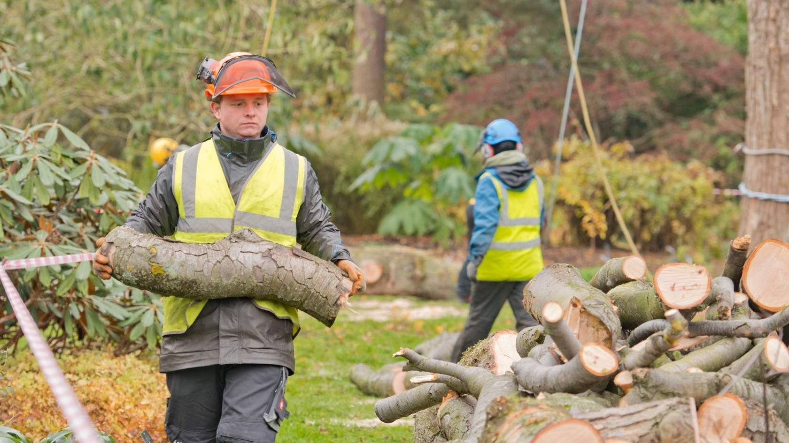

That's the end of the horticulture practical task!
If you are ﬁnished and would like to carry on exploring ‘Careers in Horticulture’ return to the online area on PropaGate Learning.

