Career Taster: Horticulture
Welcome to this introduction to horticulture!
This career taster is a great place to start to find out what horticulture is all about and the opportunities available for a career in horticulture.

Contents
Section 1: What is horticulture?
Section 2: Horticulture is…
Section 3: Meet a horticulturist

Section 1: What is horticulture?

Horticulture? Hort? Horticulturist? What does it mean?
What do all of these pictures have in common?
Look at them all first and make your guess.
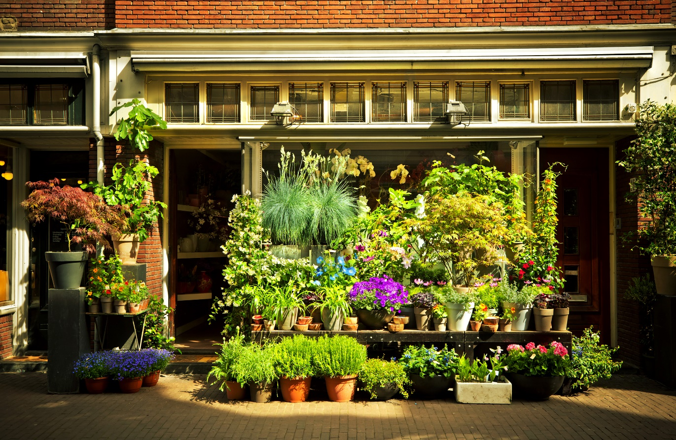

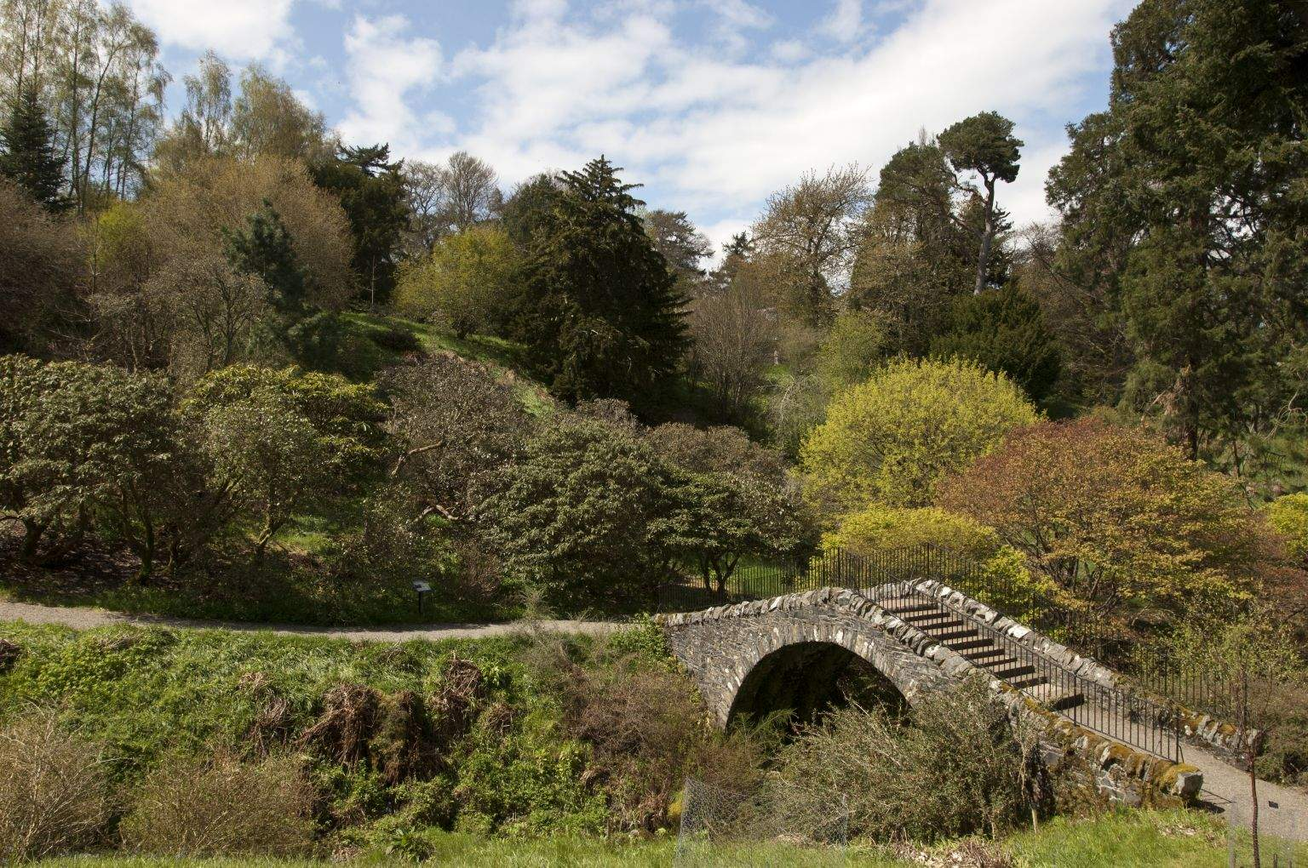

Have you got the answer? Go to the next page to check if you’re correct.

Section 2: Horticulture is...
If you said plants you got it!
Where there are plants there are often people that are paid to look after them. These people are called horticulturists or gardeners. Horticulture is all about growing plants. Keep scrolling to take a closer look.

Horticulture is...
growing food such as fruit, vegetables and herbs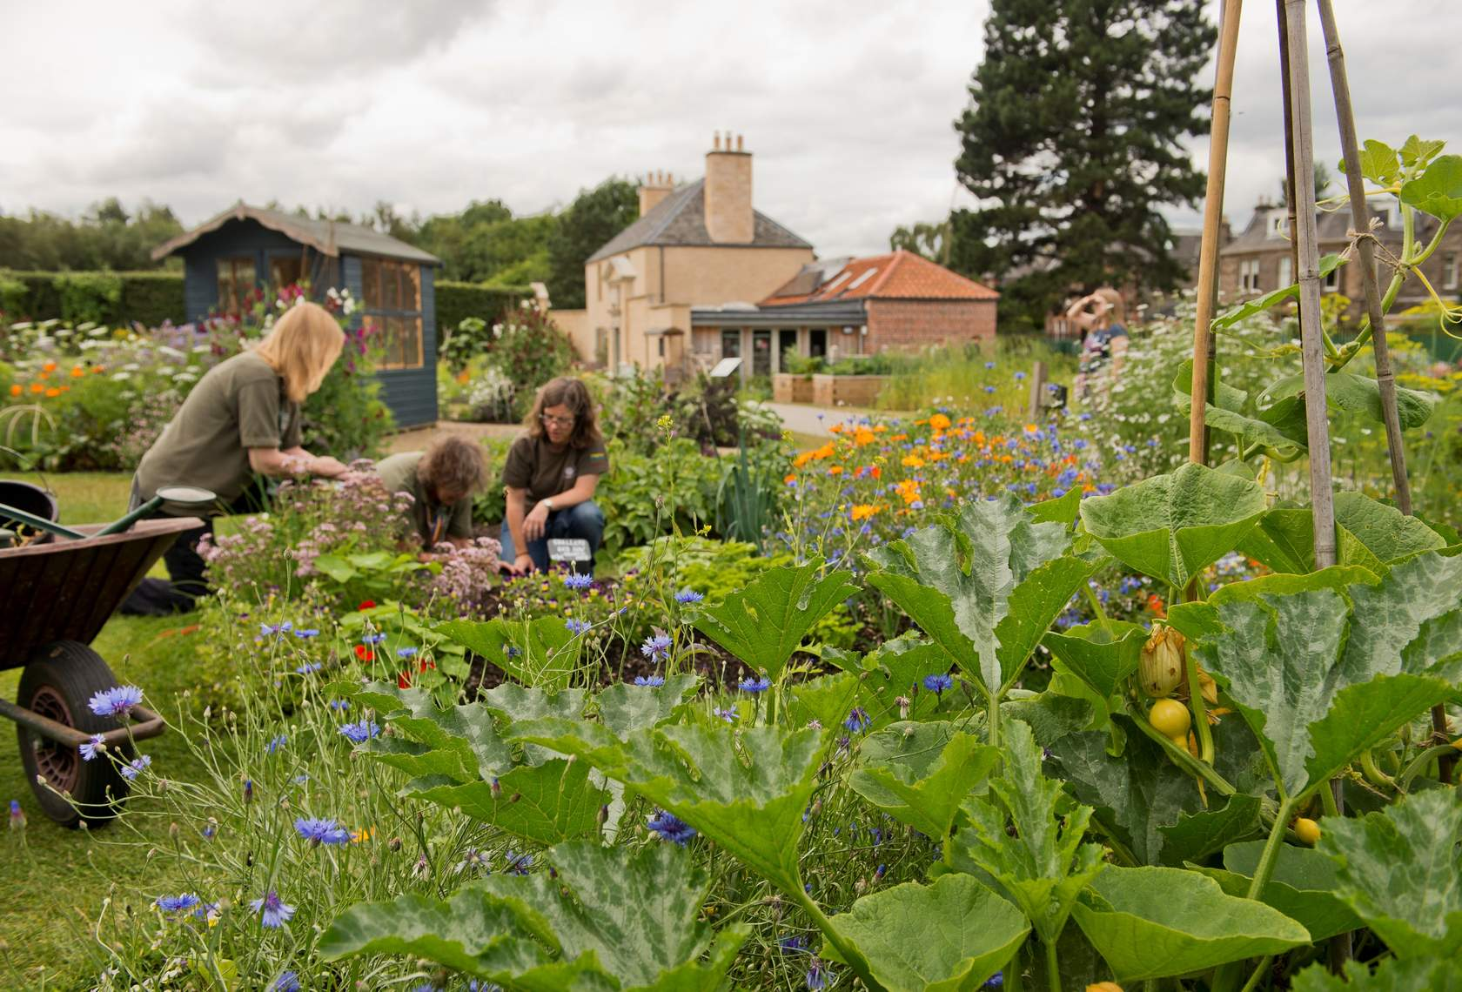

caring for flowers, shrubs and grass
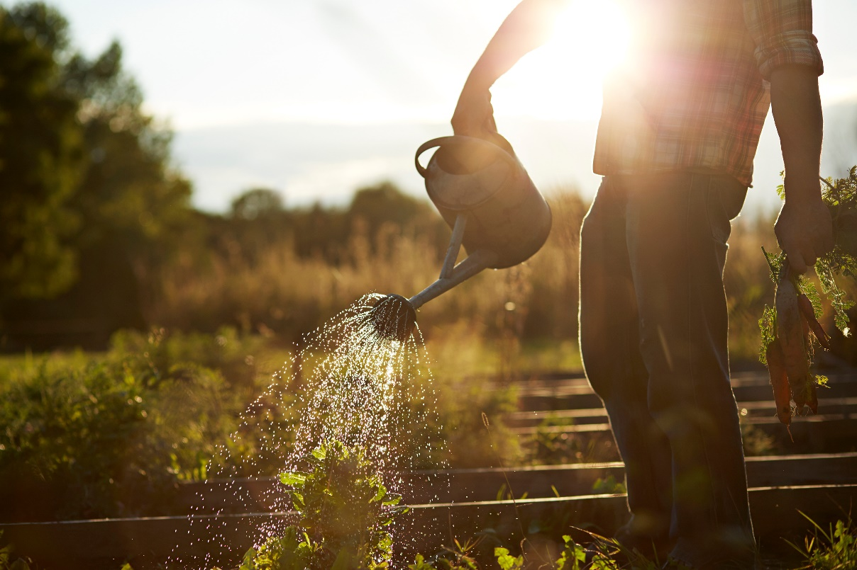

looking after trees (this is also called arboriculture)
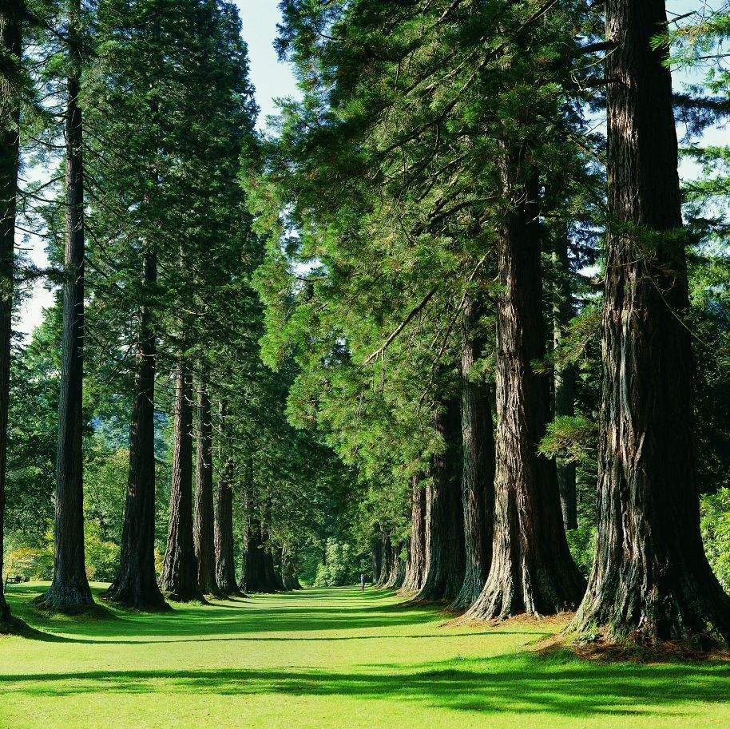

choosing the best place to put plants

building and mending paths, fences and walls
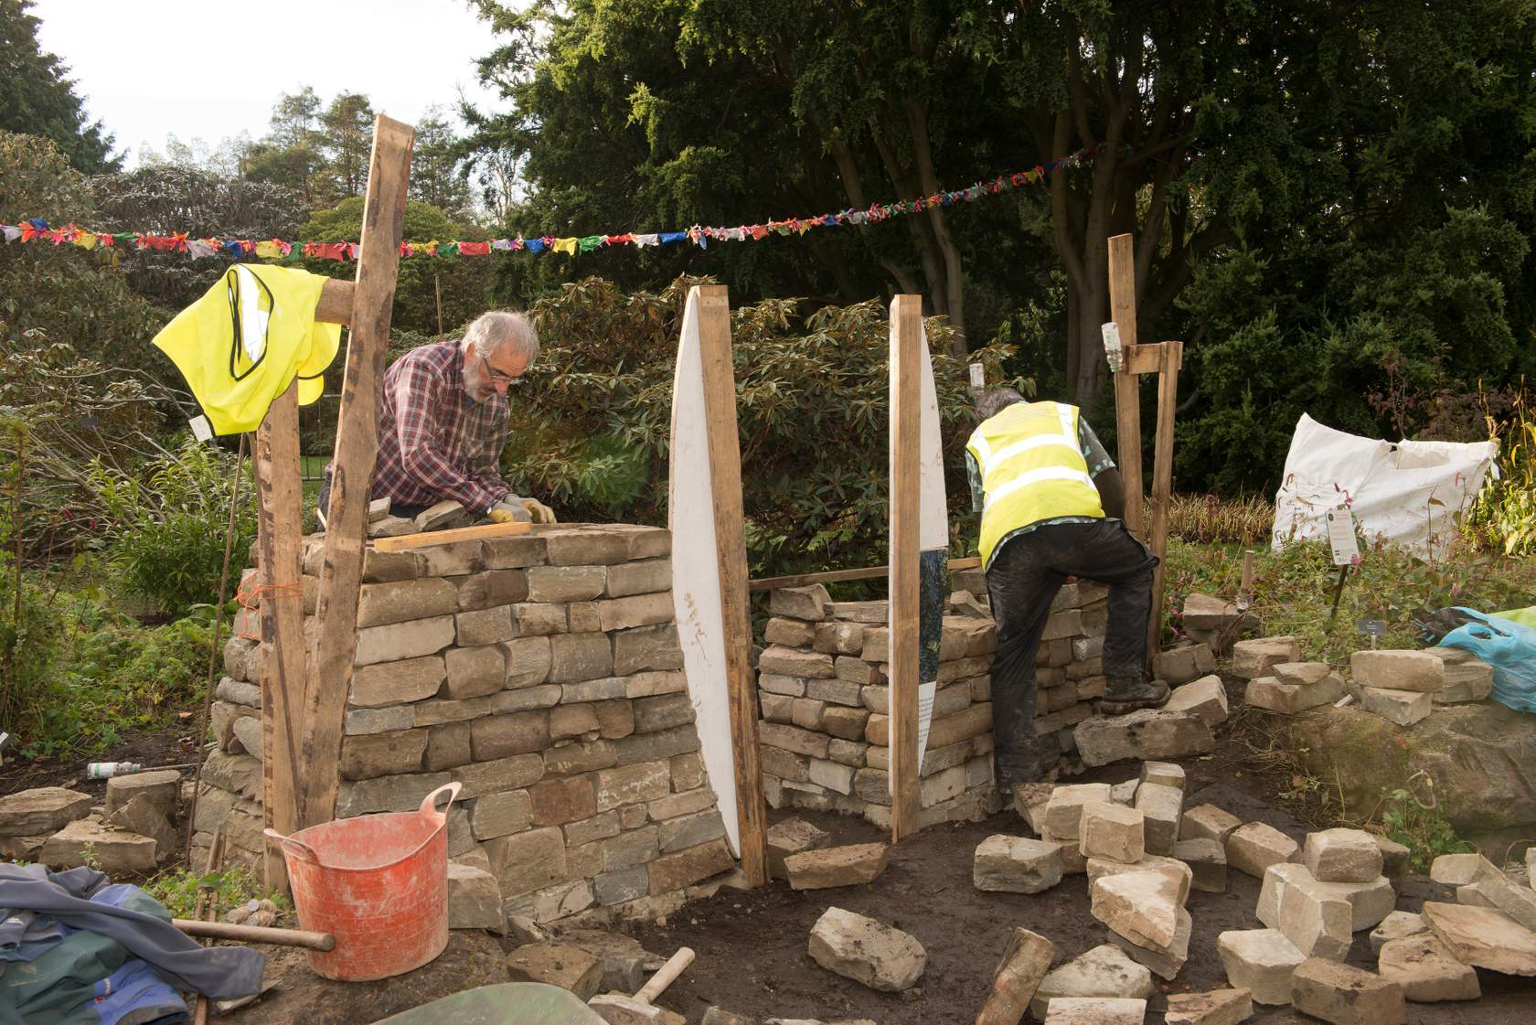

working with plants from all around the world
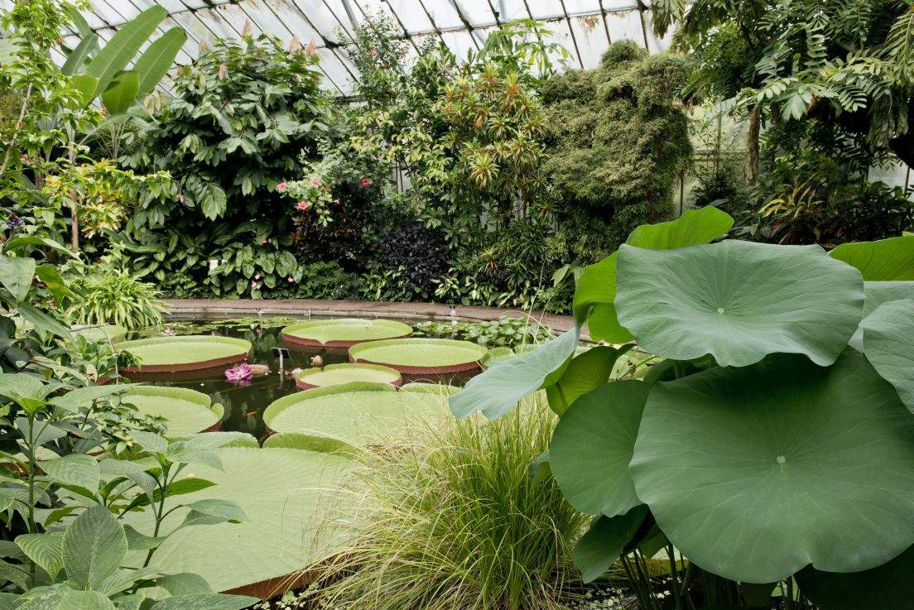

growing and selling young plants in a nursery or garden centre
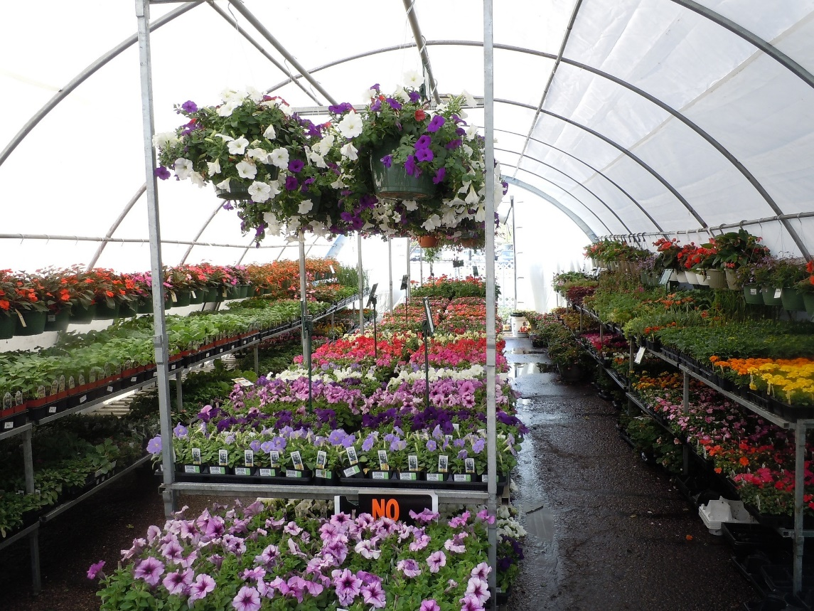
writing about plants for books, magazines and blogs

helping others learn how to grow plants
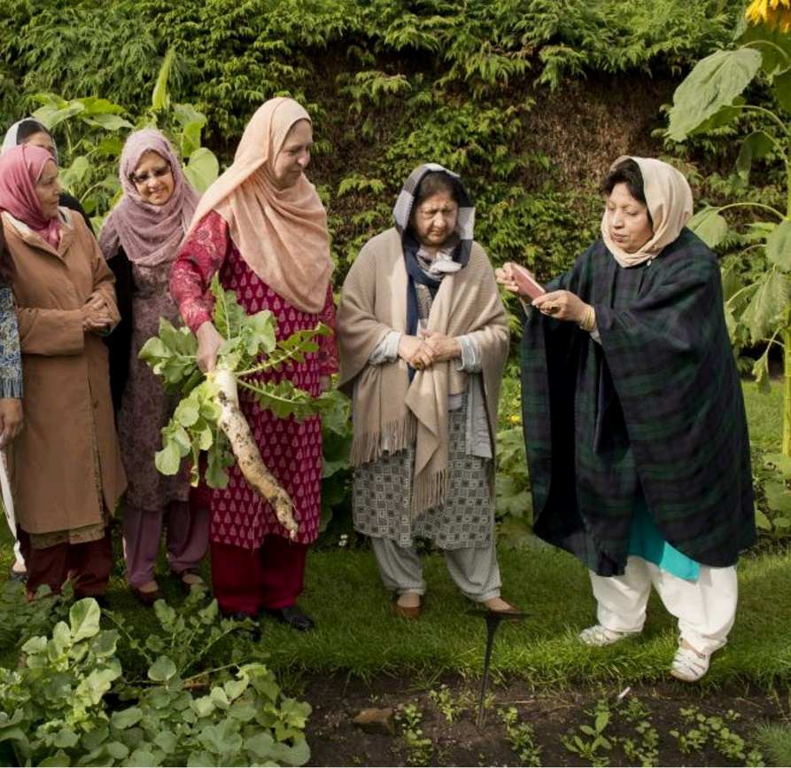
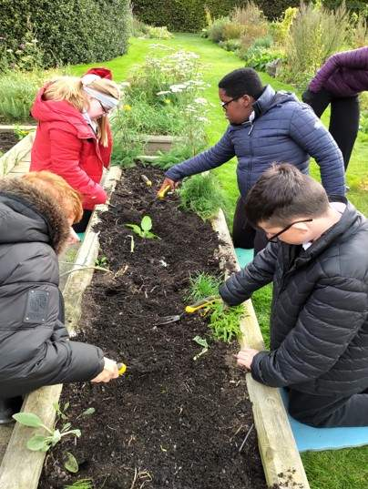
....and much more

As you can see there are so many places that need horticulturists! But it's not only about looking after plants. Continue to find out more.

Section 3: Meet a horticulturist
Horticulture involves much more than looking after plants. Let's meet a horticulturist whose job also involves looking after people, machines and the environment.
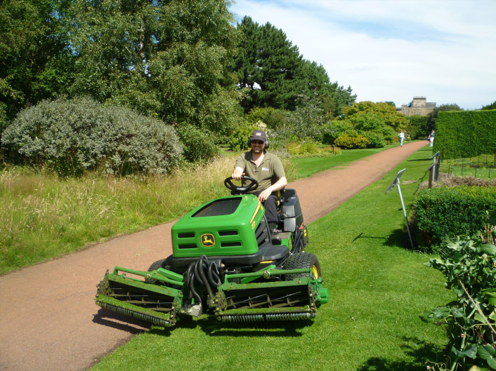
Hi, I'm a Senior horticulturist at Royal Botanic Garden Edinburgh. I manage three members of staff who look after the turf (grass), the garden paths, and the machinery.

What does my job involve?
- managing people in my team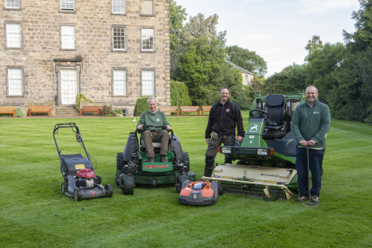

- creating compost heaps to recycle all the plant waste in the garden 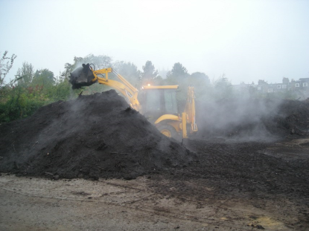
- looking after all the grass 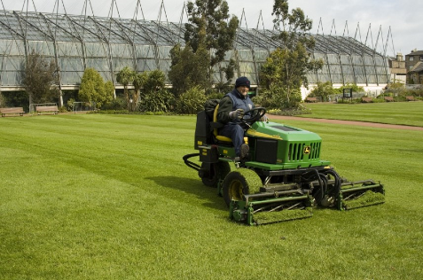

- making sure all the machines work and everyone can use them safely 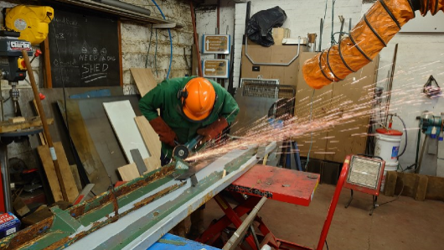
- moving large equipment like trailers around the garden 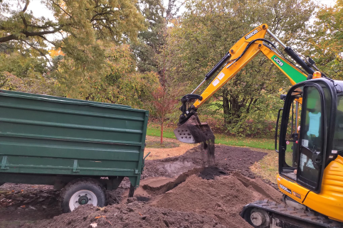

- making sure our garden badgers are protected 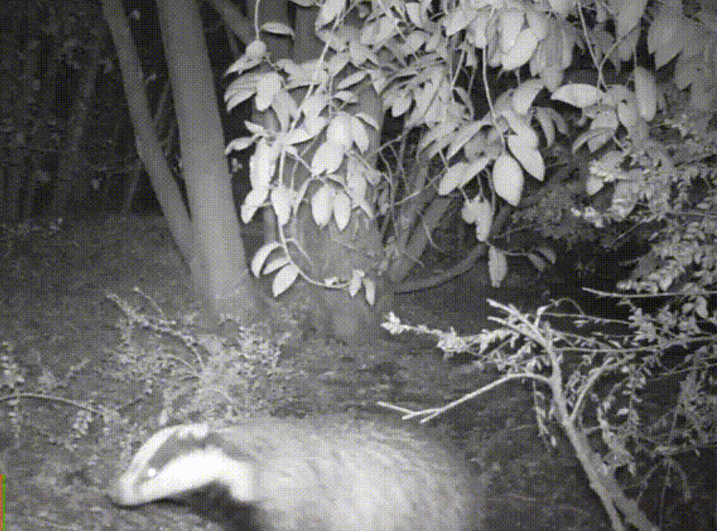

Top 3 skills for my job:
- Listen carefully and explain things clearly, especially teaching people how to use a machine.
- Problem solving, for example finding ways to reduce our carbon footprint in the garden.
- Careful planning, especially making sure all the team have tasks to do.

Tools of the trade
- An electric robot mower - It is programmed to cut the lawn by itself.
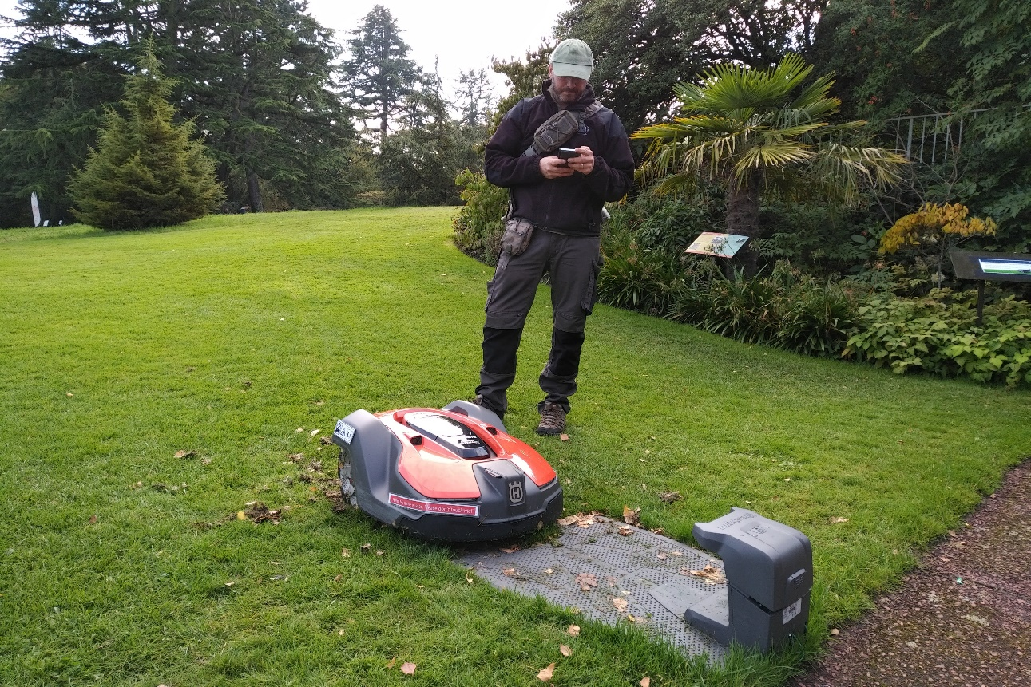
- Lawn care machinery 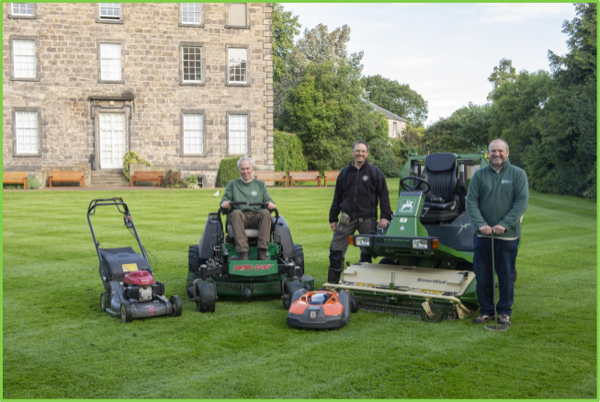
- Computers - using data bases and planning tools, as well as researching which machines are more environmentally friendly.

- Aerators have spikes to put air holes into lawns 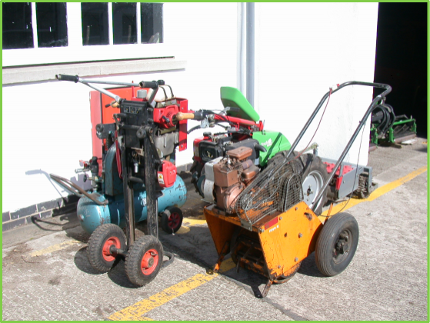
- Strimmers to trim grass edges 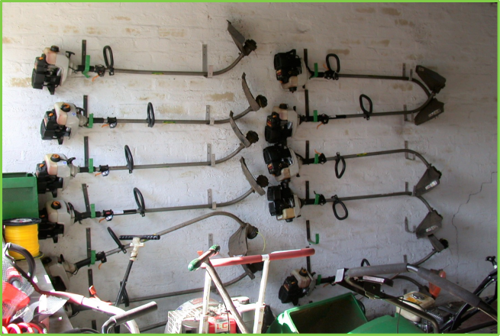
- Roller to level soil before laying turf 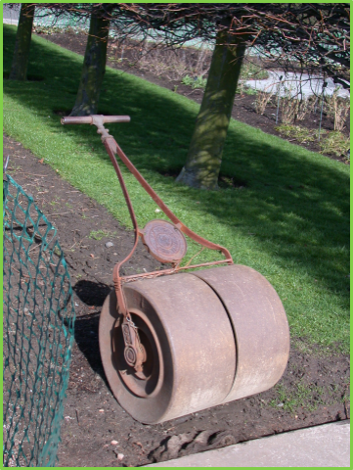
- Snow plough to keep the paths free of snow and ice 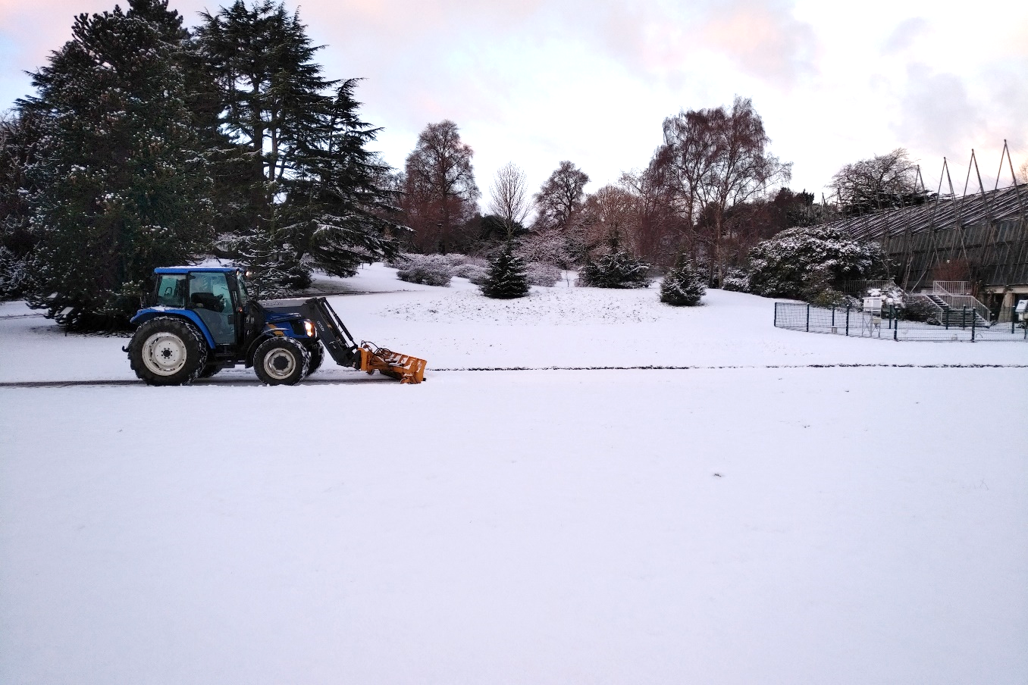

- Rotavator - turns soil over 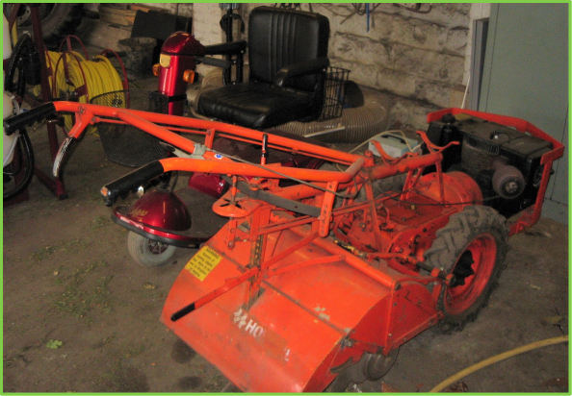

My favourite parts
Problem solving can be very satisfying. I also enjoy operating large machinery like the JCB.
“Horticulture might be for you if you love plants, enjoy being outdoors, you’re not afraid of physical work and you enjoy using machinery."
Continue below to the reflection stop to have a think about whether horticulture is for you…

Reflection Stop: Is it for me?
Does horticulture appeal to you?
Have a think about the different parts of the job, and the skills needed. Write your thoughts in a career file or journal.

That's the end of the career taster to horticulture!
If you are ﬁnished with this taster and would like to carry on exploring ‘Careers in Horticulture’ return to the online area on PropaGate Learning.

