Seed Spotter Expedition

Come on an expedition to look for different kinds of seeds!
Look around on plants and on the ground to see if you can spot different kinds of seeds. Look at the clues below and see if you can spot a seed that would fit that clue. Tick if you spot them. Can you guess how they get spread about so a new plant can grow?

Seeds with fluffy tufts or wings
Look for wings or parachutes
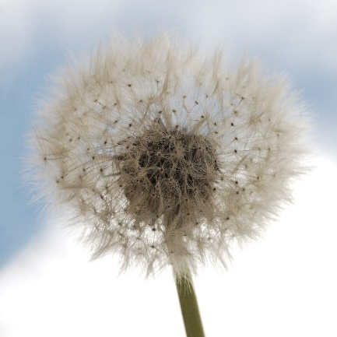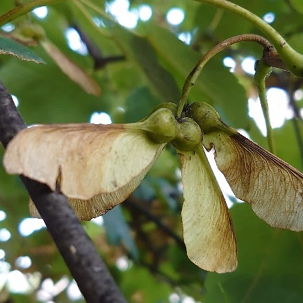

Seeds with a hard outer coat
Touch and give it a knock to find out
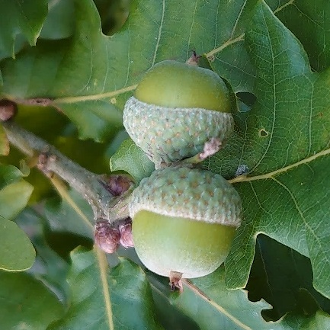

A seed which has been nibbled by an animal
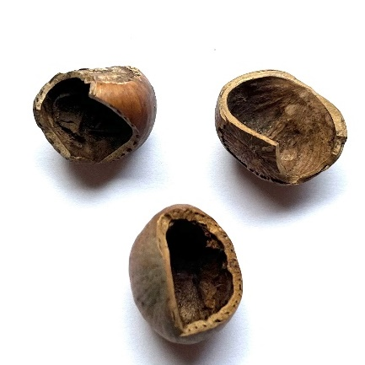

Seeds which are wrapped in juicy fruit
Look for colourful, juicy berries
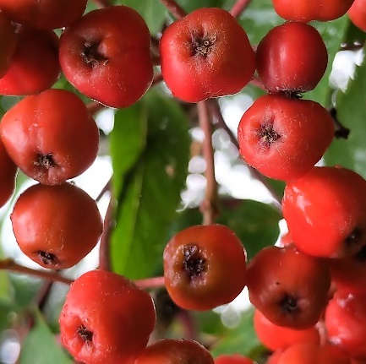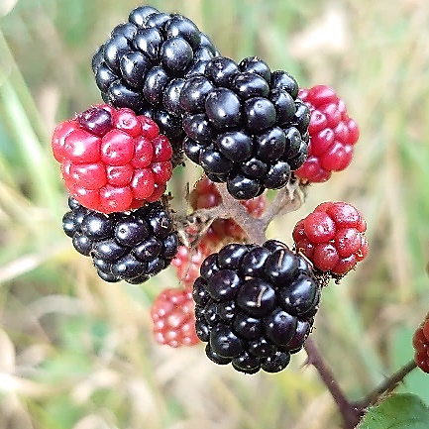

Seeds with hooks or sticky bristles
Touch carefully to find out!
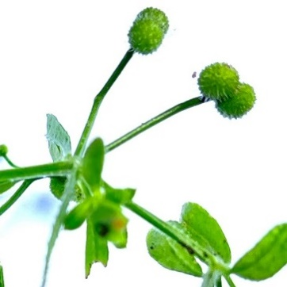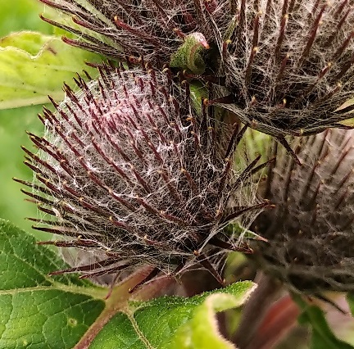

Seeds which roll easily
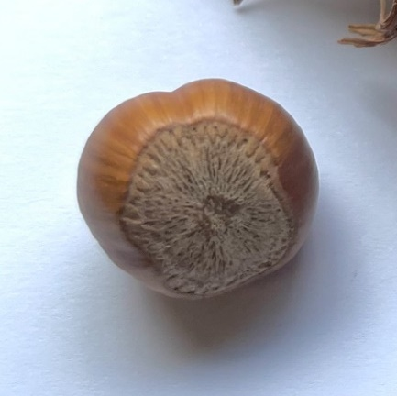

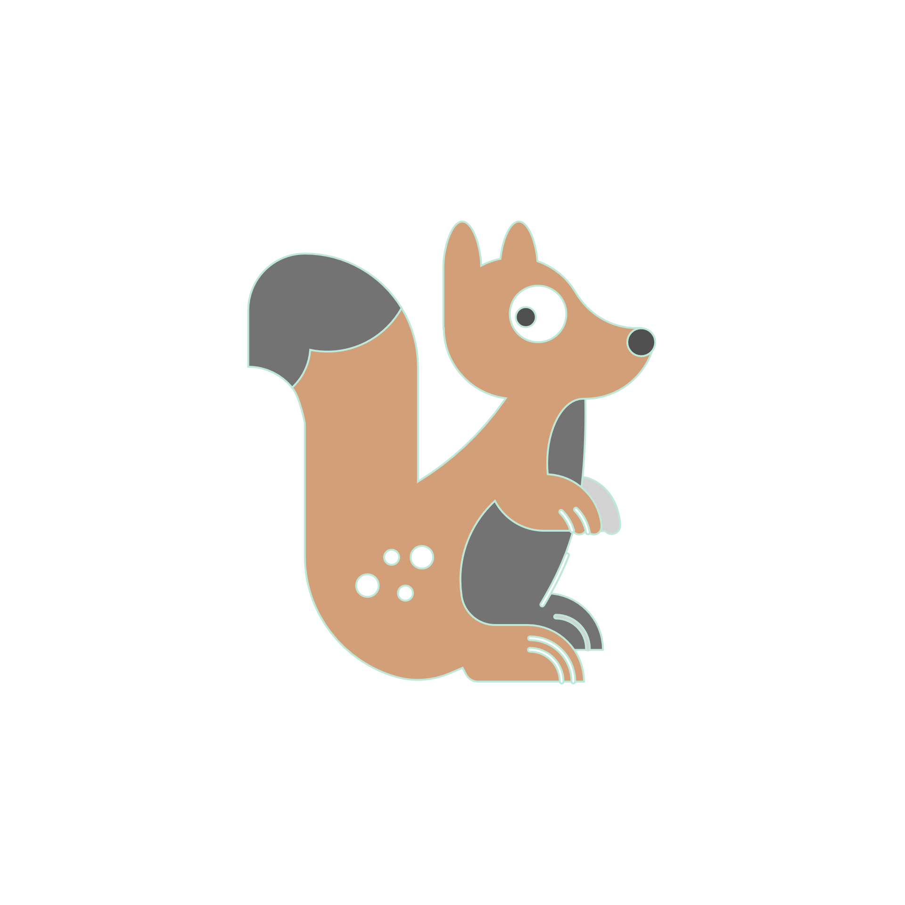
Seeds provide important nutritious food for many animals. While you are finding seeds, see if you notice any other creatures that are also looking for seeds.
Which animals do you think like eating seeds and fruit?

