Guide for Teachers
Castaway Teddies
  - Activity Description
Teddy Bears’ Trail is centred on a key concept of a secret code the teddies use for the 4 things they and all living things need to survive. This code is S.W.A.F. and has colour coding. It stands for:
S = Shelter (Green)
W= Water (Blue)
A= Air (Yellow)
F = Food (Red)
This creative outdoor activity enables the children to work as a team to design a mini-island from found natural objects where the teddies have the essential S.W.A.F. they need to survive.
Activity type: Teacher-led activity – outdoors in garden/park

Time needed: 20 – 30 minutes. Children work in teams of 4 - 6, ideally with an adult supporting each group.

  - Learning Outcomes
The children will learn:
- To increase understanding of S.W.A.F., putting their learning into practice
- To improve team work by making decisions and creating their island together
- To spend more time exploring nature through a sensory activity

  - Equipment
The activity requires an open space where there are lots of fallen natural materials to gather (e.g. sticks, leaves, nuts, pinecones, seeds etc.)
Each group needs - 1 x re-used plastic tub (e.g. ice cream/mushroom tub), 1 x set of four S.W.A.F. flags, 1 x blue wool/ribbon for water, 1 x white string for ‘drawing’ outline of island (1m), S.W.A.F. cards – in case children need a reminder.

  - Activity Introduction
“The teddies have landed on a desert island. There is nothing around and they are thirsty, hungry and cold. Your team is going to help to build a mini-island with all 4 S.W.A.F. to help your teddies to survive”.

  - Activity Method
Teacher will need to demonstrate the whole activity first, before the groups go off to find a suitable area to work and gather their natural objects.

- First demonstrate choosing where to make the island and what shape it might be, using the string. Will it be long and thin, round or wide? Will it be an unusual shape? What will the teddies need on the island to survive?
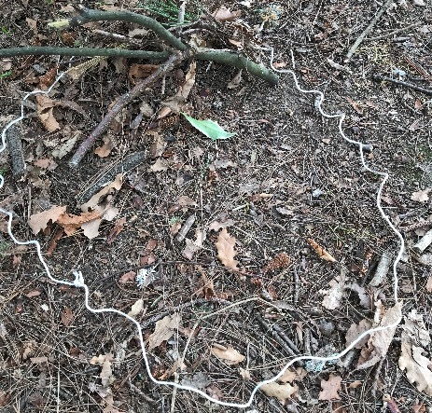

- Next demonstrate how to collect natural objects which may be useful. Gather them in the tub. Remind the children not to pick anything off the plants or trees, only things that have fallen onto the ground.

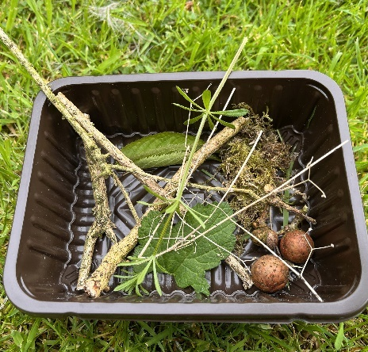

- Demonstrate some ways to make the 4 needs of life for all animals.

Shelter: show ways they might make a mini shelter from sticks and leaves. Encourage the children to use their own ideas, the shelter can be any shape.
Water: demonstrate how to use the blue string to make water. Is it a river or a pool? Is there a waterfall?
Air: our air comes from green leaves. Show the children how they can make mini trees by pushing leaves onto a stick and pushing the stick in the ground.
Food: Use nuts, seeds, leaves or anything else to make a little food store for the bears.
Demonstrate how to put the 4 S.W.A.F. flags next to their creations to show that their island has lots of S.W.A.F.
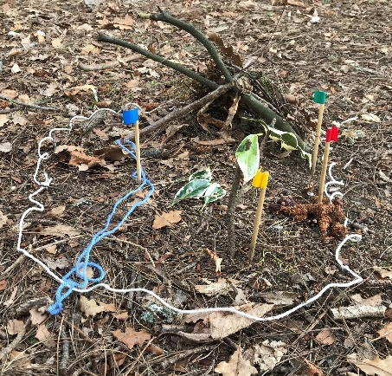

- Give the groups time to gather their objects and make their islands full of S.W.A.F. 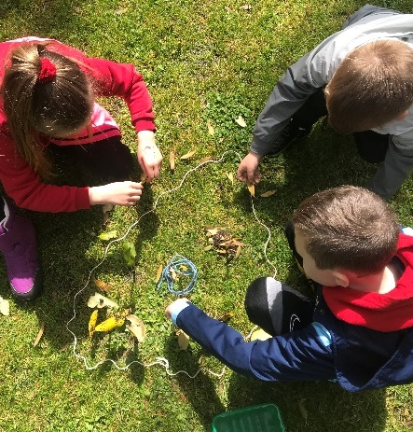

- If there is time, some groups might want to be even more creative and add some non-essentials such as gardens, play areas or other outdoor features.
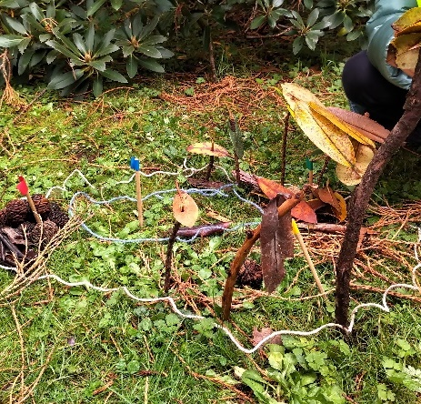

- At the end, if you have time, you can visit each island to admire, take photos and ‘swim’ between the islands.
Finally, the children will need to pack up the kit, and put all their gathered objects back into nature again, leaving no trace.
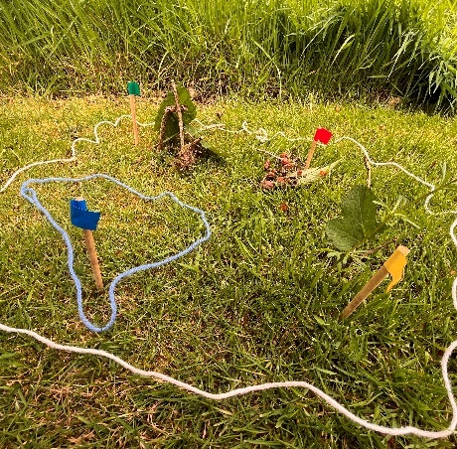
  - Health and Safety
Make sure your area has no hazards, that the boundaries are clear for the children and that you can see everyone. Wash hands afterwards, particularly before eating or drinking.

  - Next steps
Check out our other online resources available in the Teddy Bears' Trail online area on PropaGate Learning:
- Take the children on a walk with the S.W.A.F. spotters’ sheet. Can they spot examples of all 4 of the S.W.A.F. essential needs?

- Play the S.W.A.F. game to reinforce that bears need all four things to stay healthy and survive.

