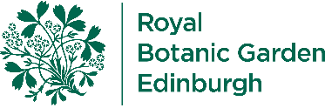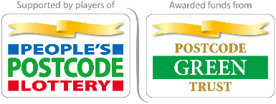

Pollination Mission

Welcome to this online lesson about the amazing relationship between plants and their pollinators.

Contents
Your Pollination Mission
Mission Stop 1: Shapes
Mission Stop 2: Colours and Patterns
Mission Stop 3: Smells
Mission Stop 4: Go and See!
Mission Complete!

Your Pollination Mission
Hello, we are botanists who work at the Botanic gardens in Edinburgh. Botanists are scientists who study plants. In the pictures below, you can see that we often go on expeditions to look at plants all around the world. We take photos, draw and measure plants to learn more about them and write our ﬁndings in our expedition notebooks. We would like you to help with a pollination mission.
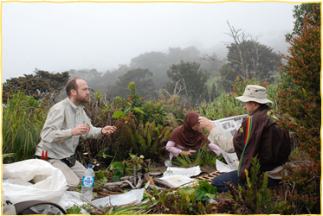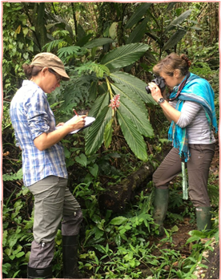

Your mission is to ﬁnd out why plants need pollinators and why different pollinators like bees need different plants in order to stay alive. You will meet some ﬂowers and pollinator friends along the way to hear about their own stories. There will be four stops to explore in the mission, including:
- Shapes
- Colours and Patterns
- Smells
- Go and See!
In each stop there will be a pollination fact and a discovery point to explore. When you complete a stop there will be a badge to collect - make sure you collect them all to complete the pollination mission. We hope that you accept this mission!

But ﬁrst, what is pollination?
Talk together to see if you can answer the question and then view the answer below to ﬁnd out if you're correct.

Answer:
The transfer of pollen from one ﬂower to another is called pollination. In some ﬂowers, the wind blows the pollen to other ﬂowers. In other ﬂowers, pollination can depend on animals, such as bees, which carry the pollen from ﬂower to ﬂower.

Which pollinator animals do you know?
There are many different pollinating creatures around the world. Before you accept the pollinator mission let's see how many pollinator animals you know – make a list and then check it against the pollinator animal images below.

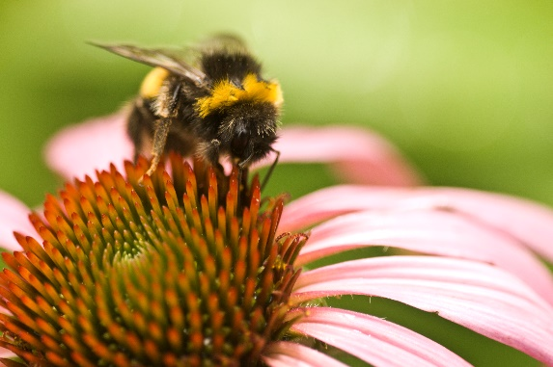 Bees
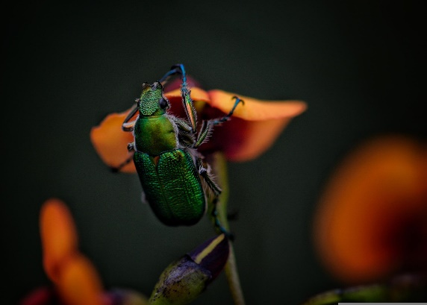 Beetles
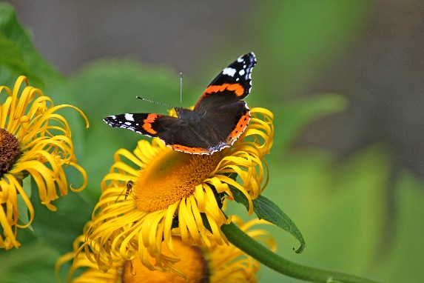 Butterflies
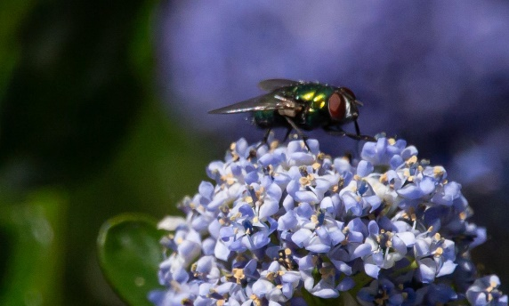 Flies
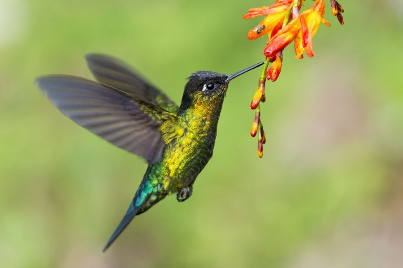 Hummingbirds
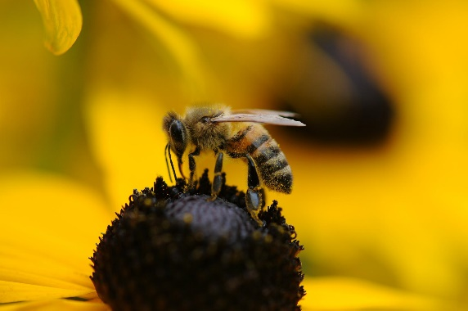 Wasps
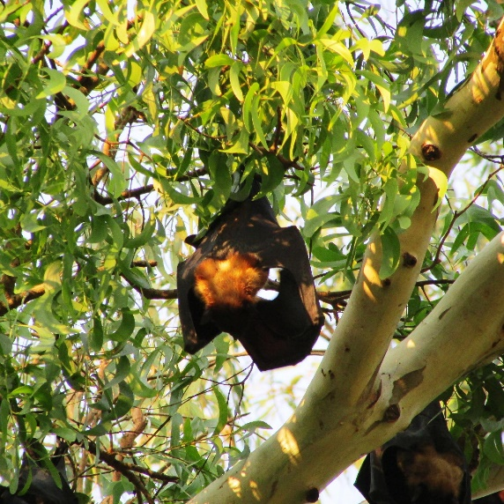 Bats
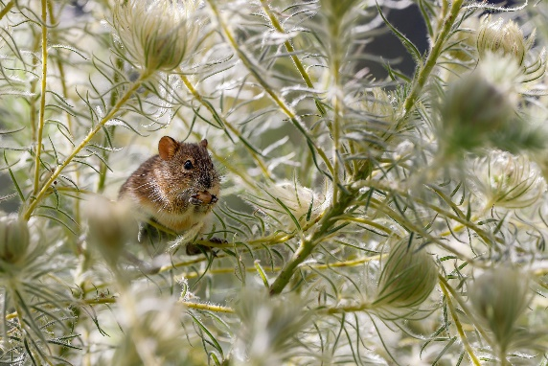 Small mammals (like mice)
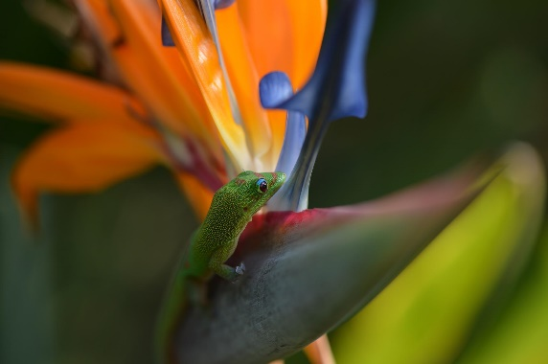 Geckos

Mission Stop 1: Shapes

Pollination Fact
Flowers come in many different shapes and sizes, and they often look very beautiful to humans.
Did you know that they have different shapes and sizes for a very good reason?
Take a guess why this might be and then view the answer below to ﬁnd out if you're correct!
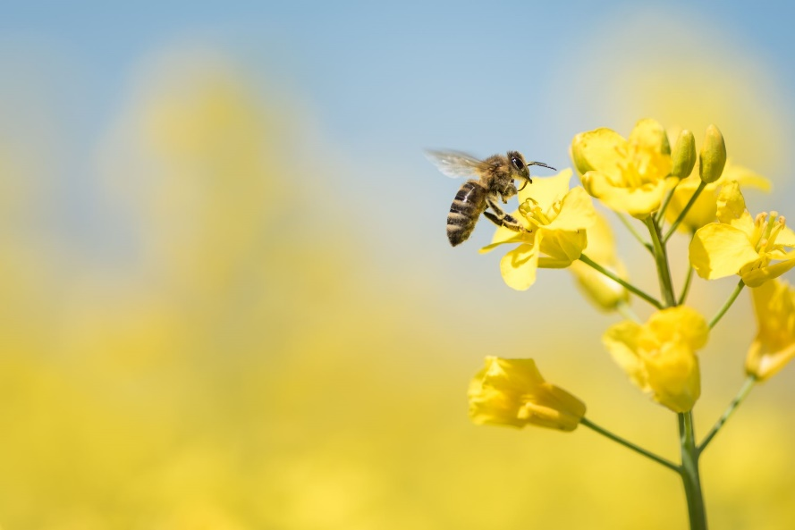Answer:
They want to attract a pollinator!
Pollen sticks to the pollinator's body and gets carried to other ﬂowers.
If ﬂowers receive pollen from other similar ﬂowers then they can make seeds. Some insects take pollen back to their young to feed them.

Shapes Discovery Point

Landing place
Many pollinators need a place to land when they arrive at a ﬂower. Different shapes of ﬂowers provide good landing places for different types of pollinators.
Let's explore two different shaped ﬂowers:

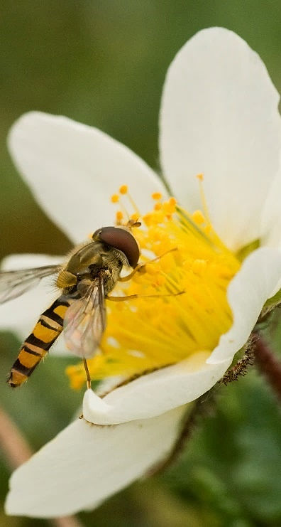
Open flowers
Pollinators such as this hoverﬂy can land on the petals of ﬂat, open and bowl-shaped ﬂowers.
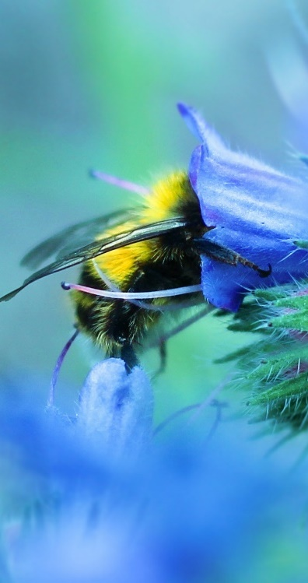
Tubular flowers
Some ﬂowers are bell or tube shaped, and the pollinators need to be able to reach deep inside to get the nectar.

You've earned the shapes pollination badge!
Mission stops 1 of 4 completed
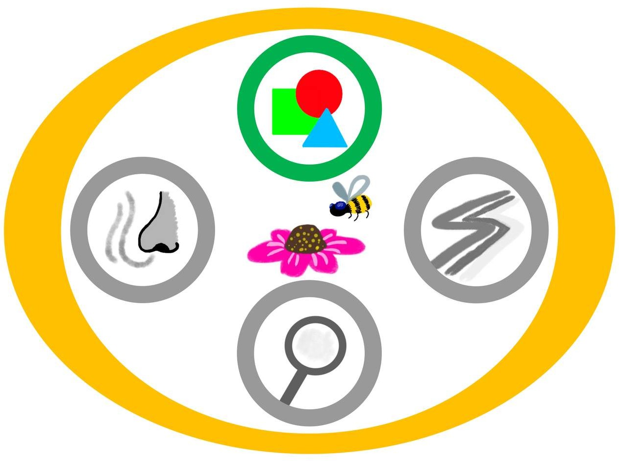

Mission Stop 2: Colours and Patterns

Pollination Fact
When pollinators see ﬂowers, the colours can look quite different to the way humans see them.
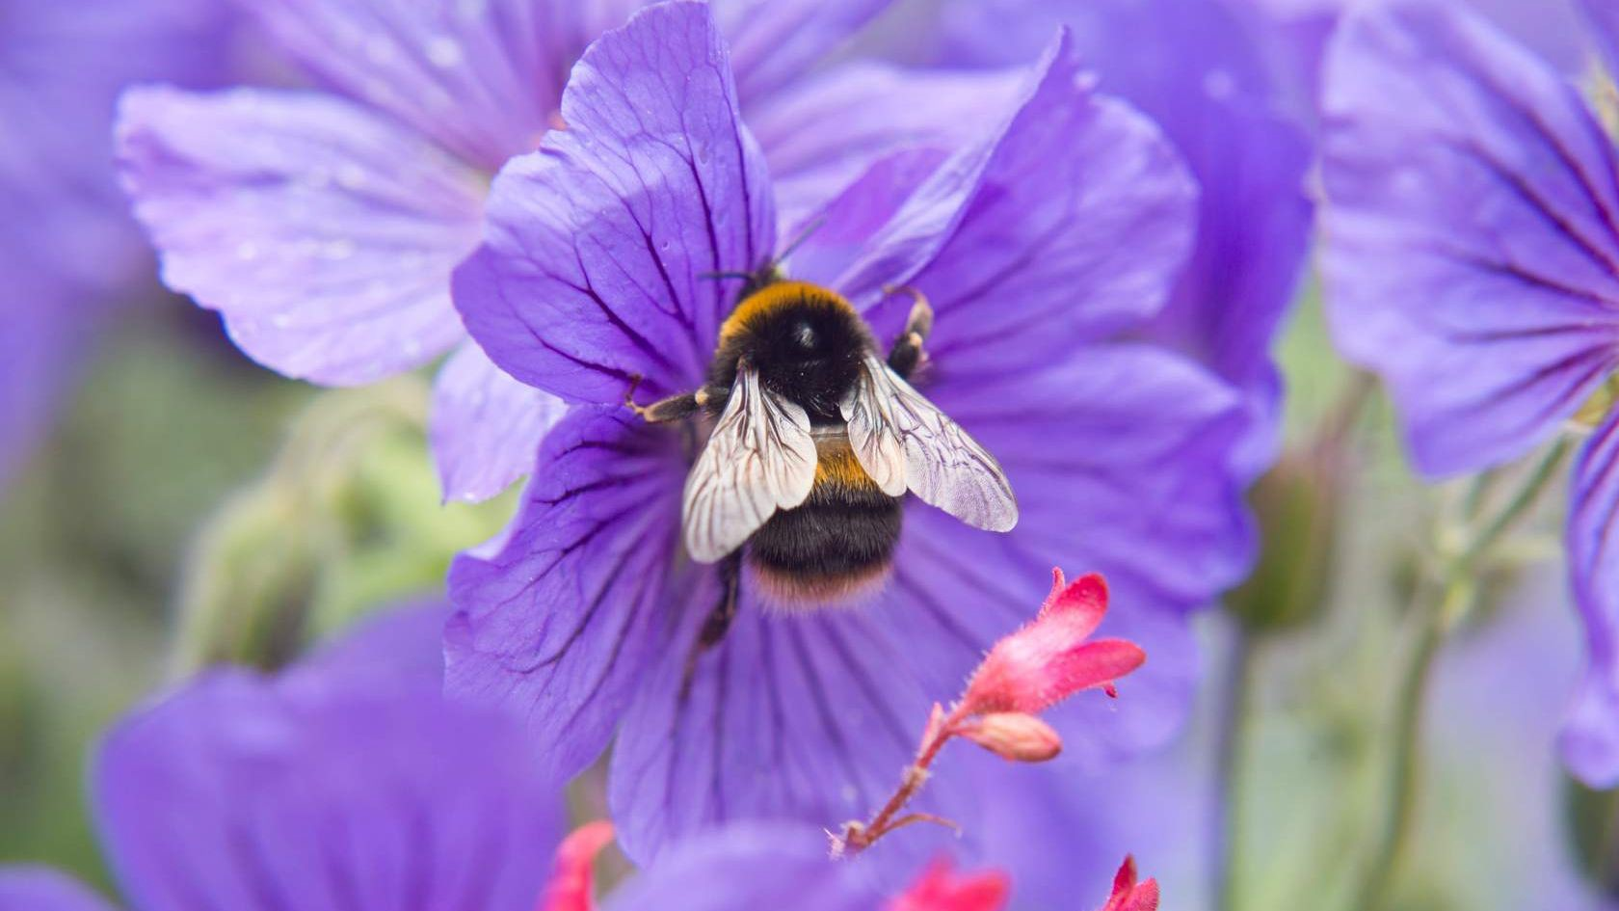Bees can’t see red colours but are good at seeing yellow and blue. They can see ultra-violet which is invisible to most humans.

Colours and Patterns Discovery Point

Nectar Guides
Nectar guides are colourful patterns on ﬂower petals which point the way to the centre of the ﬂower to the nectar, like the landing lights to guide planes on an airport runway. Pollinators drink the sweet liquid nectar to give them energy and some use it to feed their young.
Some pollinators can see patterns that human eyes can't! Can you spot the nectar guides on this ﬂower?
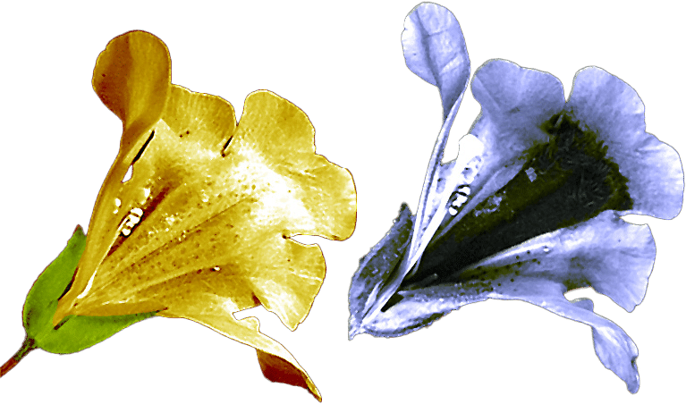
Image shows visible light (left) and ultraviolet light (right) showing a nectar guide visible to bees but not to humans.
Image by Plantsurfer, CC BY-SA 2.0 UK, via Wikimedia Commons

You've earned the colours and patterns pollination badge!
Mission stops 2 of 4 completed
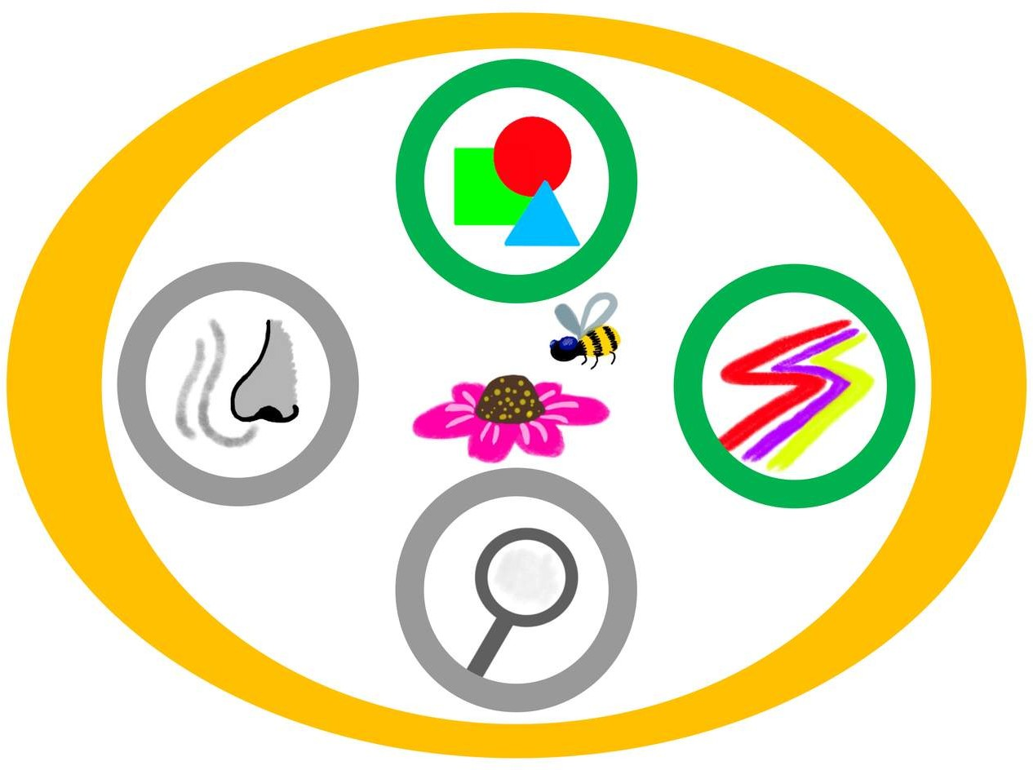

Mission Stop 3: Smells

Pollination Fact
One way to get a pollinator’s attention is to appeal to their sense of smell.
Have you ever noticed the smell of ﬂowers? What did they smell like?
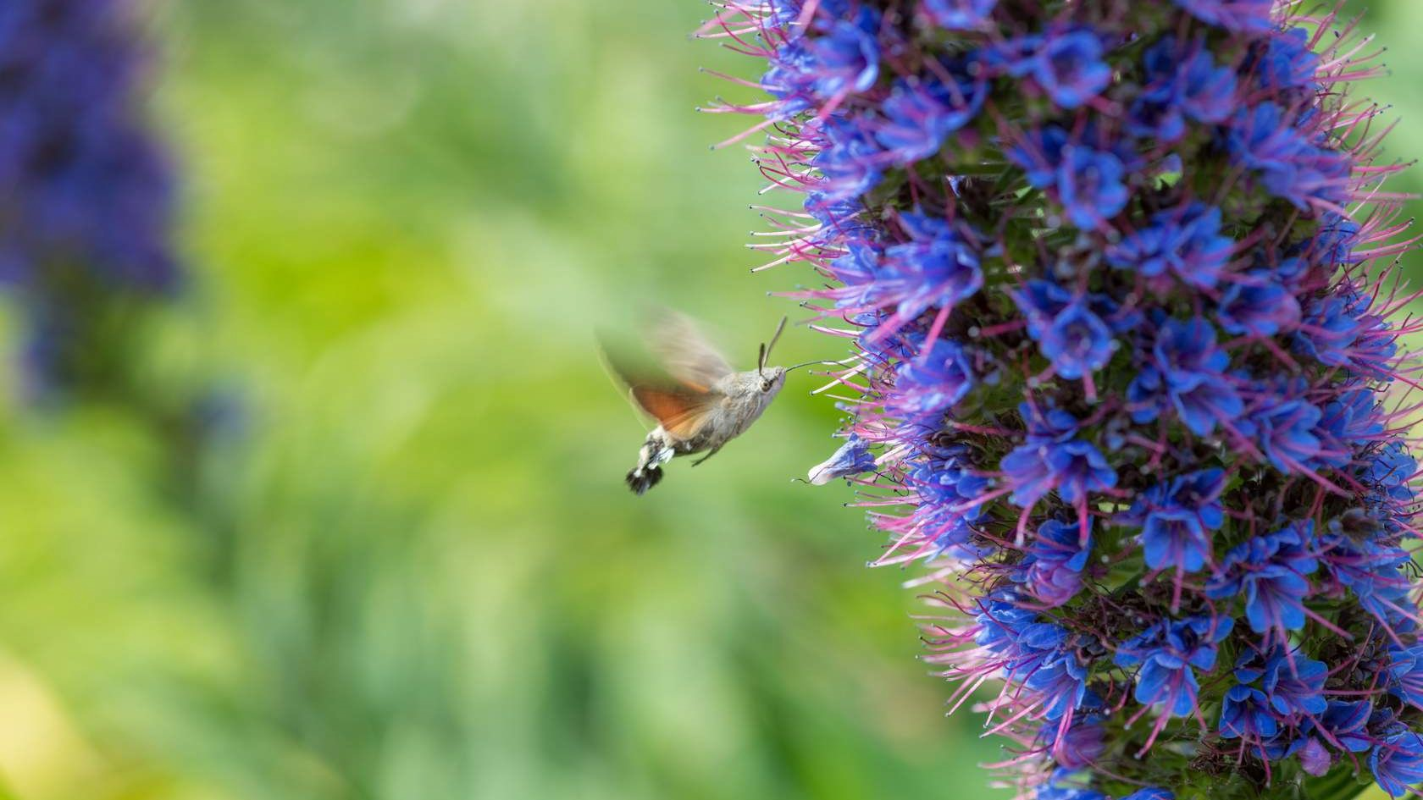
Image of hummingbird hawk moth by James Clugston
If you ever see an insect ﬂying towards a ﬂower, if they ﬂy in a straight line towards it, they are looking at the colours.
But if they ﬂy in a zig zag, they are following the scent on the wind.

Smells Discovery Point

What's that Smell?
Different smells attract different pollinators.
See below to learn more about different smells ﬂowers have:

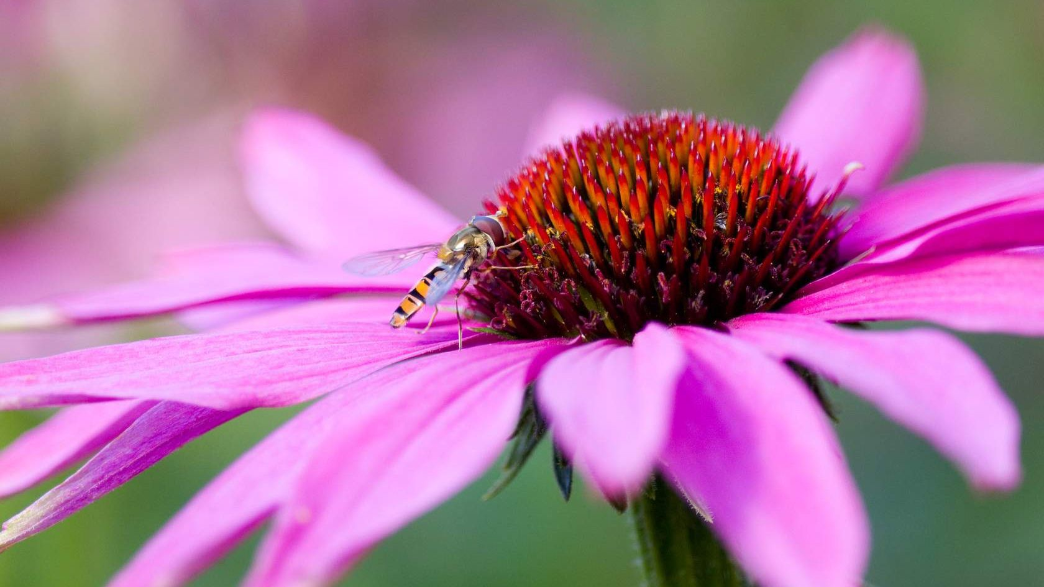Sweet Smells
Most ﬂowers release sweet smelling aromas in order to attract pollinators such as bees, hoverﬂies and butterﬂies.

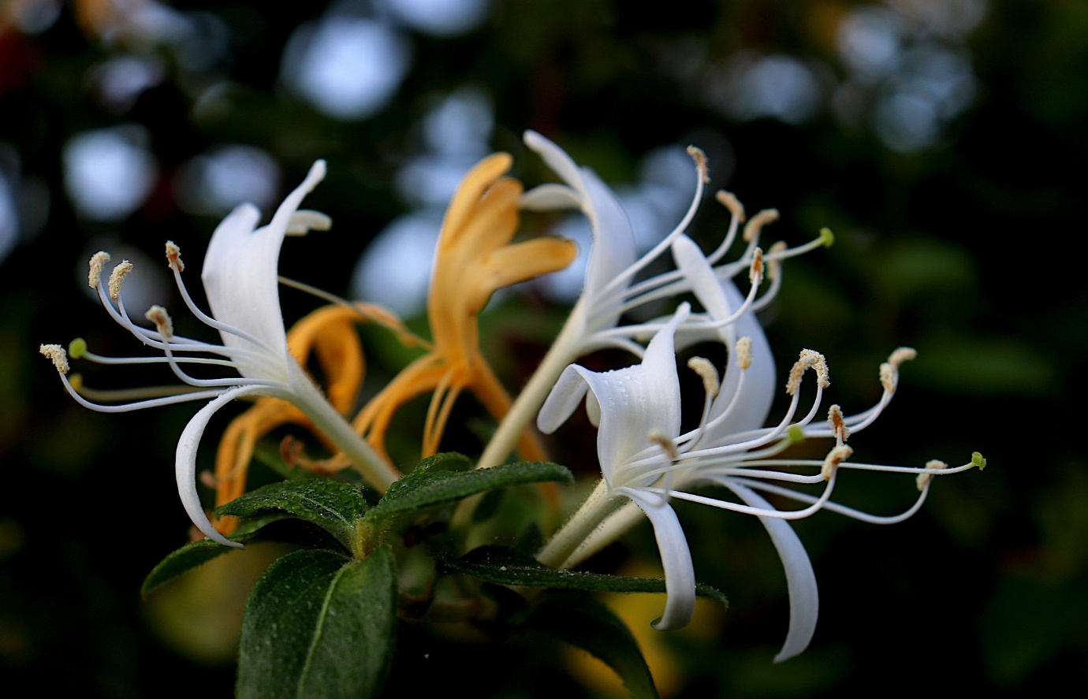
Night-time Smells
Flowers such as honeysuckle release their smells at night to attract nocturnal creatures such as moths.

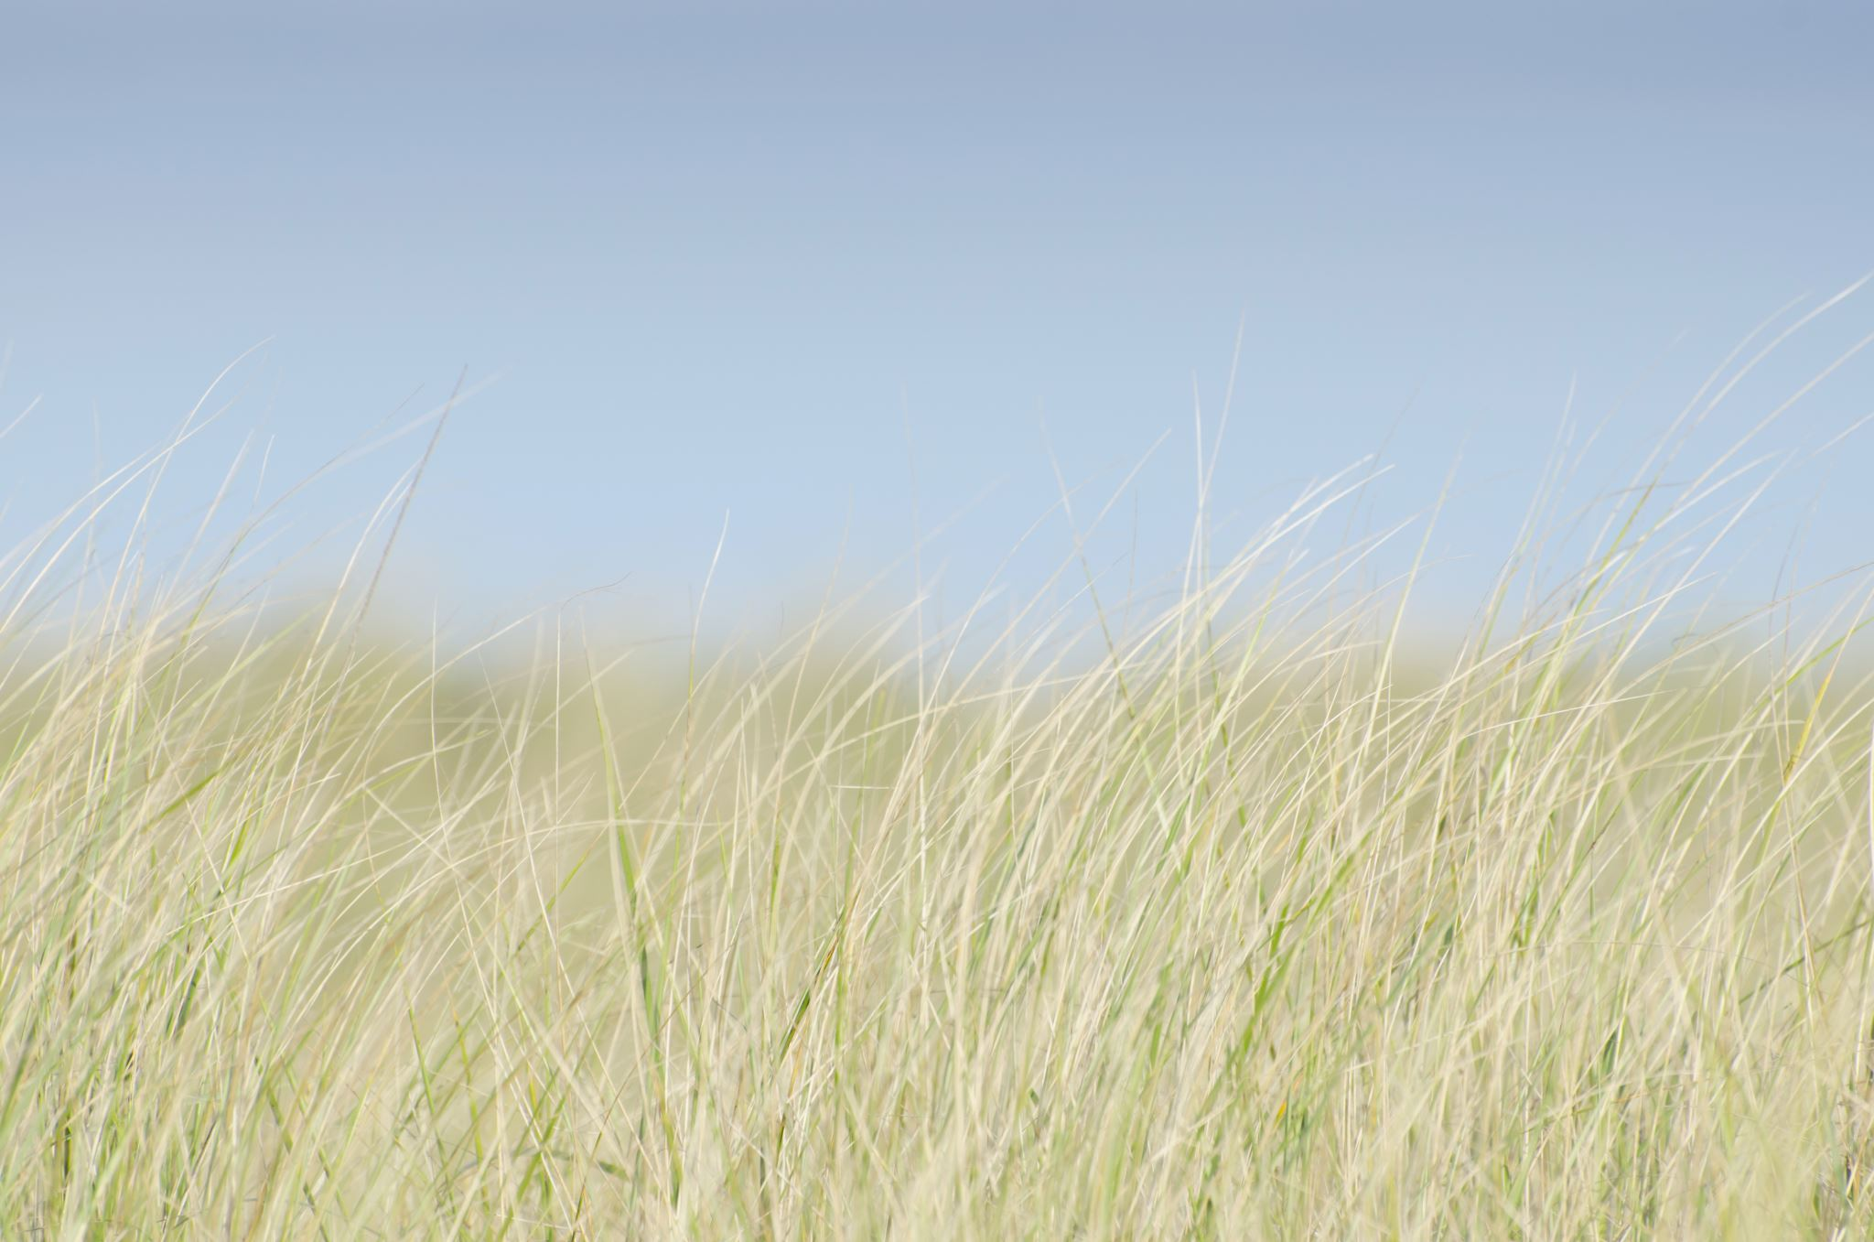
Zero Smell
Some ﬂowering plants have no smell at all!
The grass family relies on the wind to spread its pollen and has no need to attract pollinators.

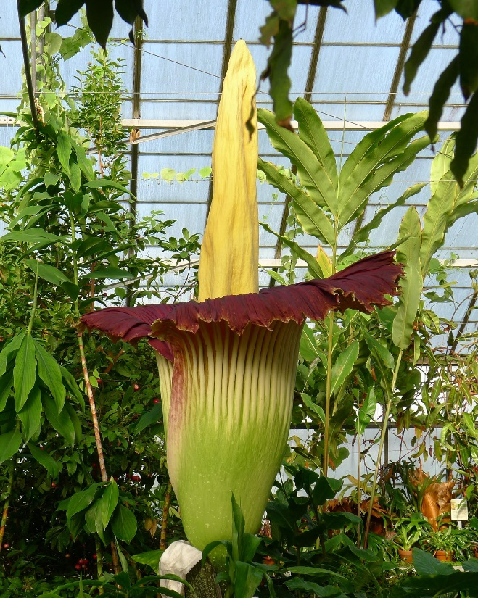
Putrid Smell
Some ﬂowers use a nasty stench (like dung or rotting meat) to attract pollinators such as ﬂies. The titan arum or "corpse ﬂower" is one of the smelliest ﬂowers in the world making it a putrid haven for certain pollinators.

You've earned the smells pollination badge!
Mission stops 3 of 4 completed
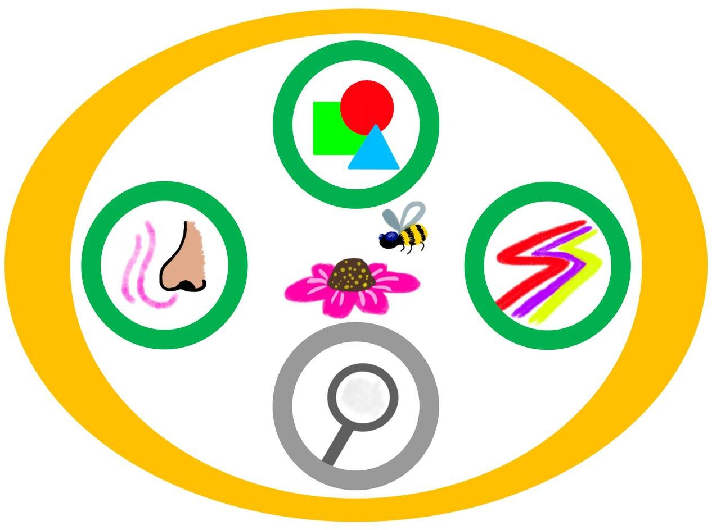

Mission Stop 4: Go and See!

The ﬁnal stop on your mission is to go and see for yourself!
An important part of being a botanist is to go out on expeditions to see how plants grow in the wild. Now it's time for your own expedition!

Have a look at some ﬂowering plants in your area and see which pollinators come to visit! What do you notice about the ﬂower? What is attracting the pollinator? You can write and draw your ﬁndings in an expedition notebook.
See some pages below that one of our botanists made while out on an expedition here in Scotland.
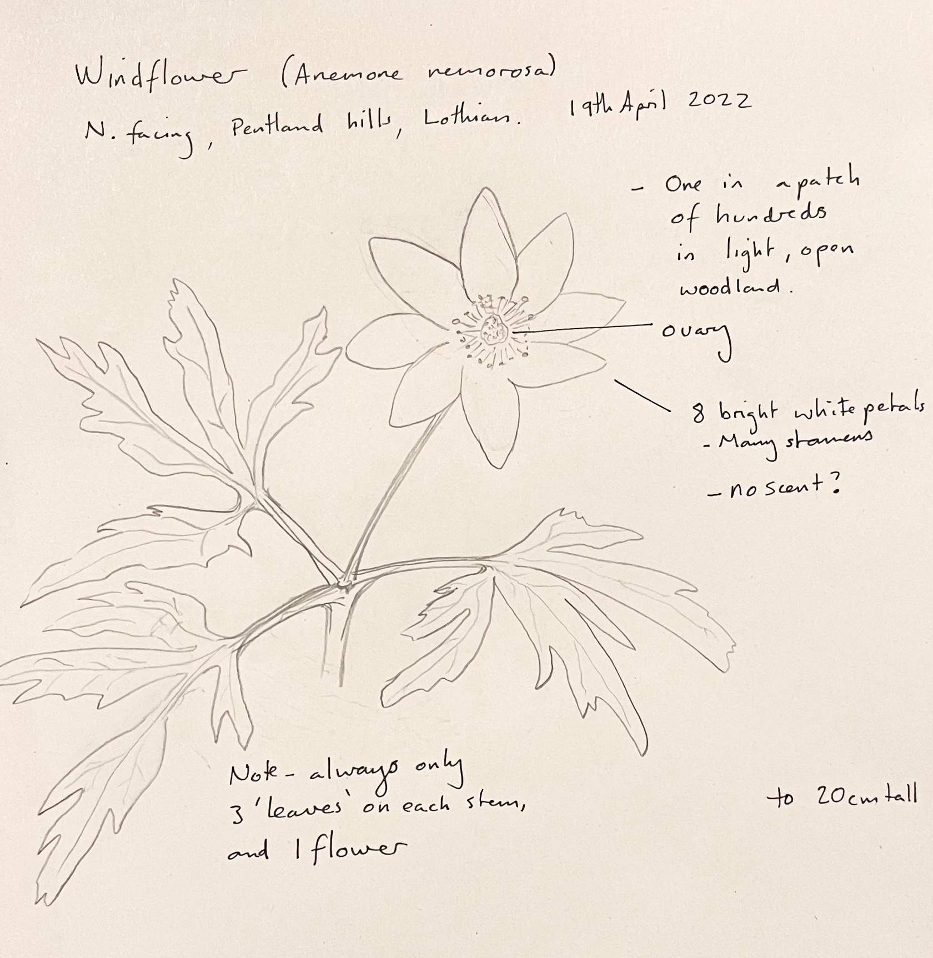
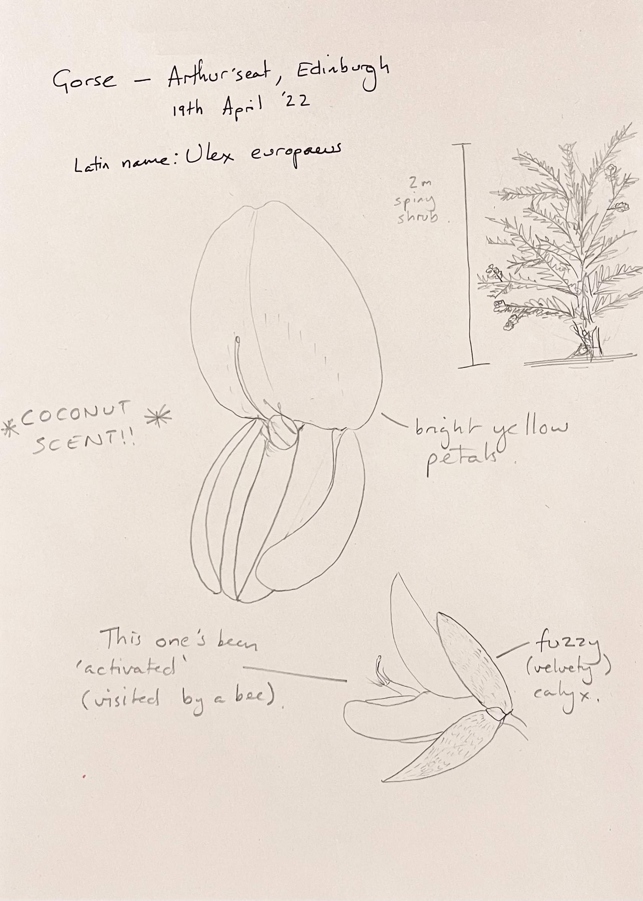

Remember to use all your senses! If you need a helping hand to get you going here is a recap of some of the things to look out for and think about:

Smell?
- What smell does the ﬂower have?
- What pollinators might be attracted to this smell?

Colours?
- What colour is this ﬂower?
- What pollinators might be attracted to these colours?

Shape?
- What shape is this ﬂower?
- What pollinators will this shape attract?

  - Teacher tip:
Before embarking on your expedition with your class make sure you check out the Pollination Mission: Expedition Notebook activity where you will ﬁnd a downloadable expedition notebook for your pupils to use and a teacher guide to help run this activity. This can be found in the outdoor activities section in the Life of Plants online area on PropaGate Learning.

You've earned the go and see pollination badge!
Mission stops 4 of 4 completed
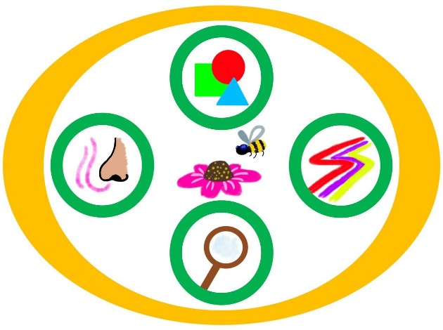

Mission Complete!

Mission Questions
Now you've completed all the mission stops let's see if you can answer the ﬁnal two pollination mission questions:
- Why do plants need pollinators?
- Why do pollinators need plants?

Once you think you know the answers view the answers below to check if you're correct.

Answers:
- Why do plants need pollinators?
To produce seeds

- Why do pollinators need plants?
To get food for themselves and their young (nectar and pollen)

Mission completed!
Amazing job, you have completed the pollination mission! We are so happy you could join us on this mission and we hope to see you on another plant adventure soon!
Badges collected:
1. Shapes

2. Colours and Patterns

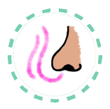3. Smells

4. Go and See

If you are ﬁnished with this lesson and would like to carry on with the next part of the activity return to the Life of Plants online area on PropaGate Learning.

