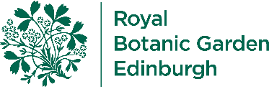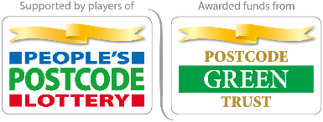
Guide for Teachers
Pollination Mission
  - Activity Description
Discover how flowers attract pollinators and learn how to be a botanist by observing and recording your findings on an outdoor expedition.
Activity type: Teacher-led activity – outdoors in garden/park
Time needed: 30-45 minutes
Children could work individually, in pairs or small groups.

  - Learning Outcomes
The pupils will learn:
- to look more closely at different flowers and pollinators,
- to describe in more detail what they see,
- be more able to suggest reasons why flowers look the way they do.

  - Equipment
This activity requires an outdoor area with several different kinds of flowers growing. Each child will need a pencil, clipboard and copy of the expedition notebook or blank paper (they could prepare their own notebook cover based on the one we provide). The sheet can also be accessed on tablets but this is a drawing activity so paper is best.

  - Activity Introduction
Introduce the children to the area selected for the expedition and explain that botanists are scientists who study flowers. Botanists go on expeditions to areas where flowers grow to learn more about them. Today the children will be botanists and practise some important skills to do that job: looking closely at flowers; making notes in a notebook to describe what they see.

  - Activity Method
Question: How many different flowers can you see?
- Children walk and look around and try to spot as many different types of flowers as possible.
- Introduce the children to the expedition notebook. Botanists record their findings here. The children could record how many different types of flowers they spotted.

Part One: Drawing the Flowers
  - Children select one flower to study and draw in detail.
  - Questions to think about: What colour is it? What shape is it? How many petals does it have? Are there any patterns on the petals? Does it have a smell?
  - If time, the children could select a second flower which is very different from the first and draw that one too. Ask them to look for the differences in colour, shape, patterns and smell.

Part Two: Observing the Pollinators
  - If there are pollinators around, the children could investigate which flowers are visited by them. Children could sit still and count every time they see a pollinator visit a flower. Some children might be able to name them.
  - If there are no pollinators, discuss why this might be. (What season is it? Are the flowers open or closed? Is the weather warm or cold? Is it rainy or windy?)

  - Follow-up/plenary questions
- Did they visit the flower(s) that you have drawn? Which flowers were the most popular among the pollinators? Why do you think this is?
- Do you know why the pollinators are visiting the flowers? (To get food for themselves and their young - nectar and pollen).

  - Health and Safety
Check for plant and bee/wasp allergies. Children should be reminded that when bees and wasps are around they should be quiet and still. Bees and wasps usually only sting when they feel threatened, so behaving quietly and calmly is the best way to prevent stings.
Children should be reminded not to put any plants in their mouths and wash hands afterwards.

  - Next steps
Check out our other online resources available on PropaGate Learning:
- ‘Pollination Mission’- online lesson before or after this activity. Repeat this activity at different times of the year or in different places – compare results. (Life of Plants online area)
- ‘Brilliant Bumblebees’ (Marley’s school of Garden Magic)

