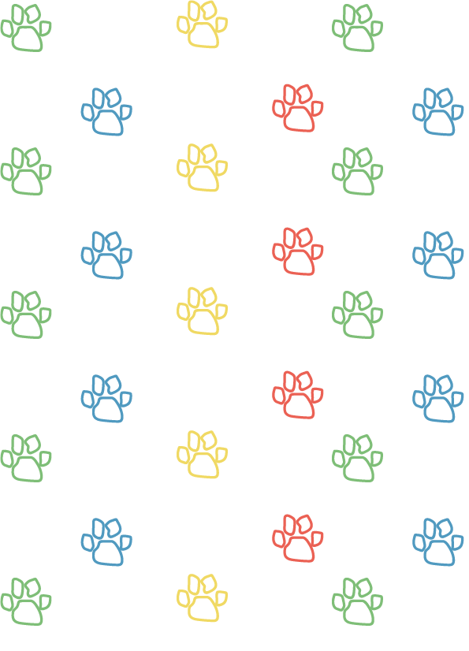

Teddy Bears’ Picnic:

Name Badges and Certificates Pack

If you wish to make a name badge for your children or award certificates after completing activities this pack has everything you need!
Pack contents:
- Name Badges
- Plant Care Certificate
- Caring for our Planet Certificate
- Caring for Myself Certificate
- Teddy Bear Guardian Certificate

Name Badges

If you wish to make a name badge for your children print or photocopy this page and your pupils can cut out and colour in.

Name
Name

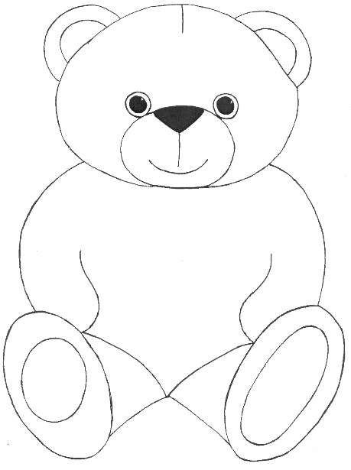
Name
Name

Plant Care Certificate

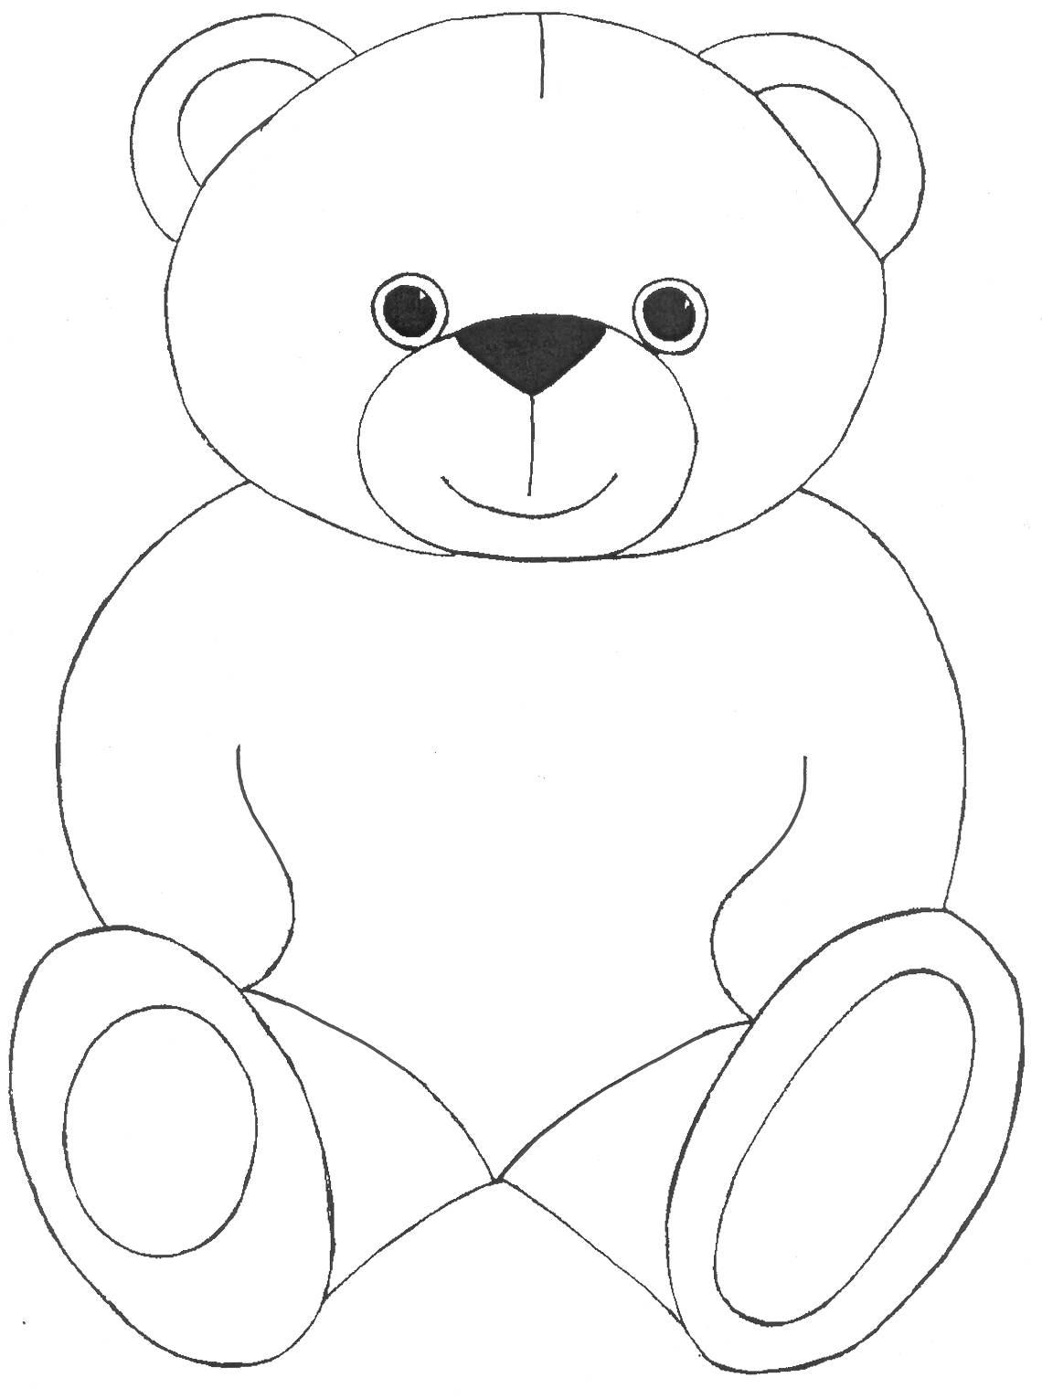
This certificate was awarded to

on

for taking excellent care of plants and making sure that they have:
Shelter Water Air Food

Caring for our Planet Certificate

This certificate was awarded to

on

for taking care of their shelter, helping to keep the air clean and not wasting food or water.

Caring for Myself Certificate

This certificate was awarded to

on

for taking excellent care of himself or herself and learning how to stay healthy.

Teddy Bear Guardian Certificate

This certificate was awarded to

on

for taking very good care of their bears and making sure that they have: Shelter Water Air Food

