Teddy Bears' Trail: S.W.A.F. Spotting

How much S.W.A.F. can you find?
Use this guide to help you spot examples of S.W.A.F. around the Botanic Garden, your school grounds or whichever greenspace you are exploring! When you spot one on this sheet put a tick next to it - see if you can collect them all! If you’re feeling extra adventurous give yourself a bonus point if you spot an example of S.W.A.F. that is not on this sheet.

Shelter
- 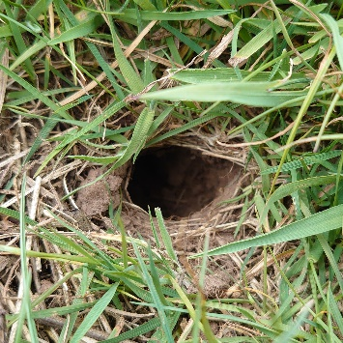 a hole in the ground or tree

- 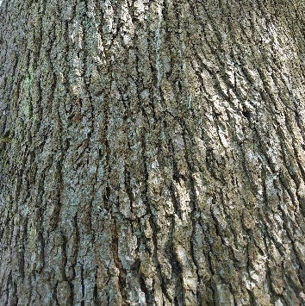 craggy bark

- 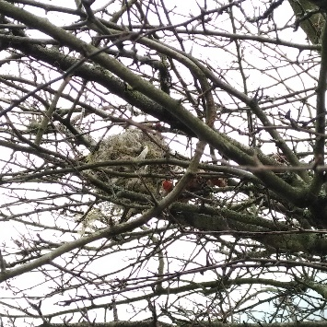 a nest

- 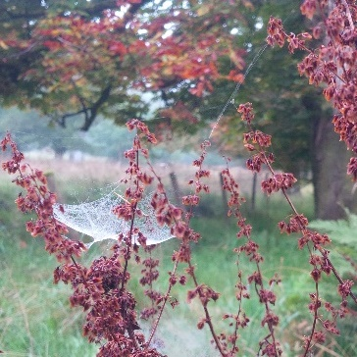 a spiders web

Water
- 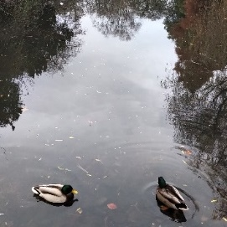 a pond

- 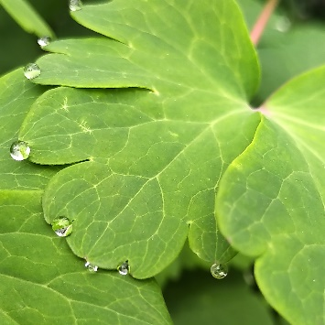 drops on leaf or grass

- 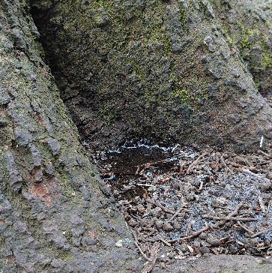 pool of water in roots of tree

- 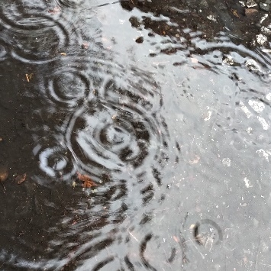 a puddle

Air
- 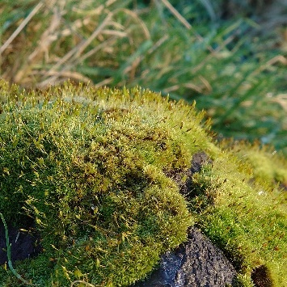 moss

- 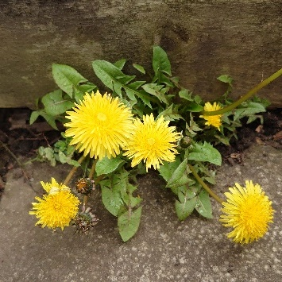 any small plant with green leaves

- 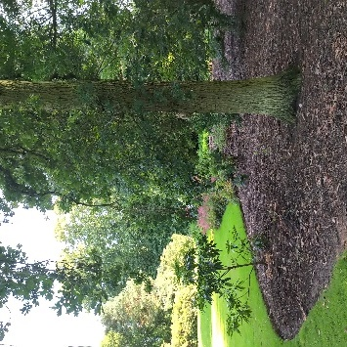 a tree

- 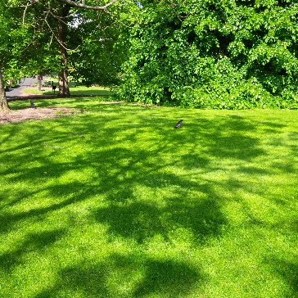 grass

Food
- 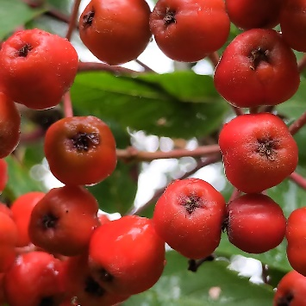 fruit/berries

- 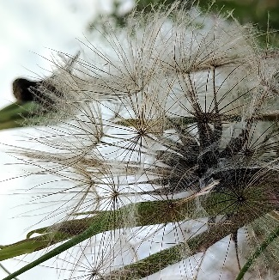 seeds

- 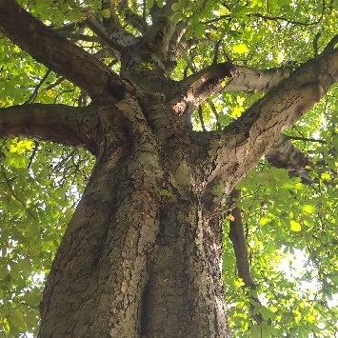 bark

- 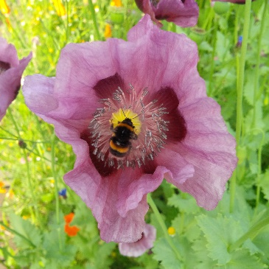 flowers (nectar)

